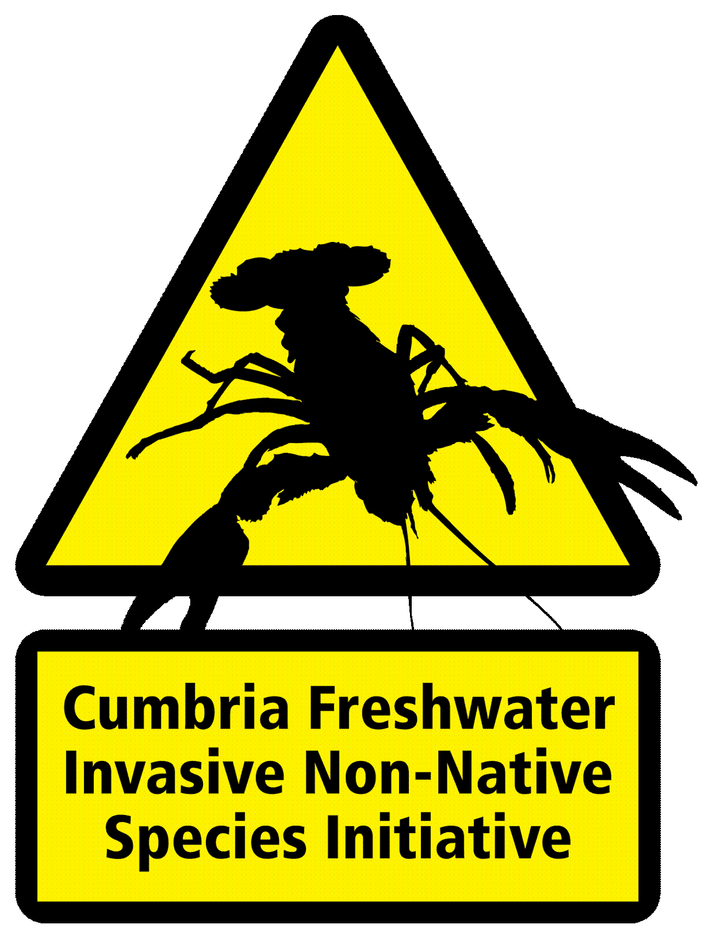
Event Biosecurity Risk Assessment

This table provides an assessment of biosecurity risk for your event and should be used in conjunction with the Event Biosecurity Support Pack.
You are an essential partner in helping us protect Cumbria from freshwater invasive non-native species and diseases. Given the devastating ecological consequences and high costs for control, the emphasis needs to be on preventing the introduction and spread through biosecurity measures before they become established.
Biosecurity measures are simple and inexpensive. Please help us to promote biosecurity in order to protect our incredible freshwaters we love to spend time in.

How to complete this Risk Assessment
Work your way down the list of check points, selecting and scoring an action from each row. Add up the total and compare it to the Risk Chart.

Check Points | Low risk | 1 Point | Medium risk | 5 Points | High risk | 10 Points | Any other measures in place – please describe
Access to water | Access limited to one site and entry restricted |  | Access limited to one site but entry not restricted |  | Multiple access points
Participants | Participants aware of invasive non-native species and biosecurity measures. Have received a copy of the advisory messages provided in the ‘Event Biosecurity Support Pack’. |  | Participants aware of invasive non-native species but not biosecurity measures. |  | Participants not aware of invasive non-native species or biosecurity measures
Signage | Information displayed about biosecurity measures in place at registration and around the site |  | Information displayed about biosecurity measures in place at registration only |  | No information displayed about biosecurity measures
Check Clean and Dry - Participants | All participants have checked cleaned and dried their kit prior to the event |  | Some participants have checked cleaned and dried their kit prior to the event |  | No participants have checked cleaned and dried their kit prior to the event
Equipment - Organisers | All equipment (including support vehicles and equipment) to be used in the water checked cleaned and dried before taken to site or newly purchased.  All equipment (including support vehicles and equipment) used in the water checked cleaned and dried after the event before use in another water body. |  | All equipment to be used in the water checked and cleaned on site at cleaning station.  All equipment used in the water checked cleaned after the event before use in another water body. |  | None of the equipment to be used in the water checked cleaned or dried prior to use/the event.  No equipment used in the water checked cleaned or dried after the event before use in another water body.
Cleaning station | Cleaning station facility provided on site. All participants clean equipment before signing out or leaving the event. |  | Cleaning station facility provided but not promoted |  | No cleaning station available on site

Risk Chart:
Score | Risk Level
6-10 | Low risk
10-30 | Medium risk
30-35 | High risk
35-60 | Very high risk
If your event scores 25 points or more, you will need to put in place further measures to reduce the risks of introducing or spreading invasive non-native species and diseases. Please see how you can improve on your event’s biosecurity by reading the ‘Event Biosecurity Support Pack’ or contact the CFINNS Initiative for advice.

I ……………………………………………………………………………………………….(name) on behalf of ………………………………………………………………………………………………..(event/organisation) certify that the biosecurity measures stated above have been put in place.
Date:

Please list below as bullet points, what biosecurity measures you will have in place for the event:

