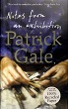 | GALE, Patrick  Notes from an Exhibition  When troubled artist Rachel Kelly dies painting obsessively in her attic studio in Penzance, her saintly husband and adult children have more than the usual mess to clear up. She leaves behind an extraordinary and acclaimed body of work - but she also leaves a legacy of secrets and emotional damage that will take months to unravel.
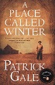 | GALE, Patrick  A Place called Winter  A privileged elder son, and stammeringly shy, Harry Cane has followed convention at every step. Even the beginnings of an illicit, dangerous affair do little to shake the foundations of his muted existence, until the shock of discovery and the threat of arrest cost him everything. Forced to abandon his wife and child, Harry signs up for emigration to the newly colonised Canadian prairies.
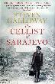 | GALLOWAY, Steven  The Cellist of Sarajevo  Tense and heartbreaking to its last page, 'The Cellist of Sarajevo' shows how life under siege creates impossible moral choices. When the everyday act of crossing the street can risk lives, the human spirit is revealed in all its fortitude - and frailty.
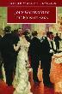 | GALSWORTHY, John  The Forsyte Saga  Charting the Forsyte dynasty from a thriving existence at the height of the Edwardian era through turbulent transition into the modern age, this novel paints a fascinating picture of early 20th century London life.
 | GASKELL, Elizabeth  The Life of Charlotte Bronte  Written in 1857, Elizabeth Gaskell's biography vividly recreates, through the use of letters, interviews, and travelling, the life and world of her friend, Charlotte Bronte.
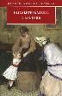 | GASKELL, Elizabeth  Cranford  In this poignant comedy of early Victorian life, Elizabeth Gaskell explores the effects of Victorian commerce and imperial expansion on the survival of customs from earlier times.
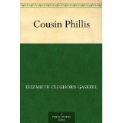 | GASKELL, Elizabeth  Cousin Phyllis  A beautifully controlled and haunting novella, 'Cousin Philips' is considered to be among the very best of Gaskell's shorter writings. In it she explores the tragedy of unfulfilled love to create a work of exquisite poignancy.
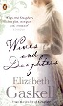 | GASKELL, Elizabeth  Wives and Daughters  Elizabeth Gaskell's brilliant study of English social customs is a novel that explores the relationship between two stepsisters who form an instant friendship that is put to the test when they become rivals in love.
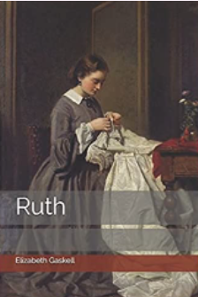 | GASKELL, Elizabeth  Ruth  Ruth Hilton is an orphaned young seamstress who catches the eye of a gentleman, Henry Bellingham, who is captivated by her simplicity and beauty. When she loses her job and home, he offers her comfort and shelter, only to cruelly desert her soon after. Nearly dead with grief and shame, Ruth is offered the chance of a new life among people who give her love and respect, even though they are at first unaware of her secret - an illegitimate child. When Henry enters her life again, however, Ruth must make the impossible choice between social acceptance and personal pride. In writing Ruth, Elizabeth Gaskell daringly confronted prevailing views about sin and illegitimacy with her compassionate and honest portrait of a ‘fallen woman’.
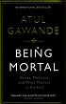 | GAWANDE, Atul  Being Mortal: illness, medicine and what matters in the end  Atul Gawande examines his experiences as a surgeon, as he confronts the realities of ageing and dying in his patients and in his family, as well as the limits of what he can do. He emerges with a story that crosses the globe and history, exploring questions that range from the curious to the profound.
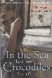 | GEDO, Fabio  Ten-year-old Enaiatollah has been left alone in Pakistan to fend for himself. In a book based on a true story, Italian novelist Fabio Geda describes Enaiatollah's remarkable five-year journey from Afghanistan to Italy, where he finally managed to claim political asylum.
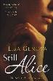 | GENOVA, Lisa  Still Alice  Alice Howland is proud of the life she worked so hard to build. A Harvard professor, she has a successful husband and three grown children. She soon finds herself in the rapidly downward spiral of Alzheimer's Disease. Her short-term memory may be hanging on by a couple of frayed threads, but she is still Alice.
 | GERAS, Adele and others  War Girls  1914: war has broken out across Europe and beyond. Nothing will ever be the same again for those caught up in the conflict. This collection of short stories explores how the First World War changed and shaped the lives of women forever.
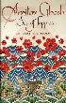 | GHOSH, Amitav  Sea of Poppies  The background to this historical adventure is the Opium Wars. The story revolves around the Ibis, an old slaving-ship voyaging across the Indian Ocean, its crew made up of sailors and stowaways, coolies and convicts, representing Westerners and Indians respectively. Slowly they start considering themselves as ship-brothers.
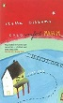 | GIBBONS, Stella  Cold Comfort Farm  When expensively educated Flora Poste is orphaned, she decides to descend on her relatives at Cold Comfort Farm, and put their lives in order. This is a popular comic classic, recently made into a BBC TV film.
 | GLADWELL, Malcolm  Outliers  Why are people successful? For centuries, humankind has grappled with this question, searching for the secret to accomplishing great things. In this book, Malcolm Gladwell takes us on an invigorating intellectual journey to show us what makes an extreme overachiever.
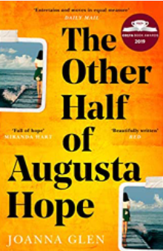 | GLEN, Joanna  The Other Half of Augusta Hope  At six, she’s memorising the dictionary. At seven, she’s correcting her teachers. At eight, she spins the globe and picks her favourite country on the sound of its name: Burundi.  And now that she's an adult, Augusta has no interest in the goings-on of the small town where she lives with her parents and her beloved twin sister, Julia.  When an unspeakable tragedy upends everything in Augusta's life, she's propelled headfirst into the unknown. She's determined to find where she belongs – but what if her true home, and heart, are half a world away?
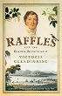 | GLENDINNING, Victoria  Raffles and the Golden Opportunity 1781-1826  Raffles remains a controversial figure, and in this biography Victoria Glendinning charts his prodigious rise within the social and historical contexts of his world. His domestic and personal life was vivid and shot through with tragedy. His own end was sad, though his fame immortal.
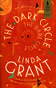 | GRANT, Linda  The Dark Circle  All over Britain life is beginning again now the war is over but for Lenny and Miriam, East End London teenage twins who have been living on the edge of the law, life is suspended - they've contacted tuberculosis.
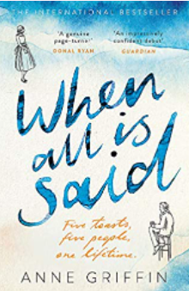 | GRIFFIN, Anne  When All Is Said  At the bar of a grand hotel in a small Irish town sits 84-year-old Maurice Hannigan. He's alone, as usual -though tonight is anything but. Pull up a stool and charge your glass, because Maurice is finally ready to tell his story.
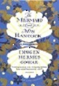 | GOWAR, Imogen  The Mermaid and Mrs Hancock  One September evening in 1785, the merchant Jonah Hancock hears urgent knocking on his front door. One of his captains is waiting eagerly on the step. He has sold Jonah's ship for what appears to be a mermaid. As gossip spreads through the docks, coffee shops, parlours and brothels, everyone wants to see Mr Hancock's marvel. Its arrival spins him out of his ordinary existence and through the doors of high society.
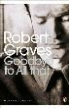 | GRAVES, Robert  Goodbye to all that  'Goodbye to all That' is Robert Graves' marvellously candid self-portrait of his childhood and his experiences as a young officer in the First World War.
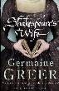 | GREER, Germaine  Shakespeare’s Wife  This is a biography of Ann Hathaway and a social history of Shakespeare's time by the redoubtable Germaine Greer.
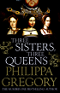 | GREGORY, Phillipa  Three Sisters, Three Queens  When Katherine of Aragon is brought to the Tudor court as a young bride, the oldest princess, Margaret, takes her measure. With one look, each knows the other for a rival, an ally, a pawn, destined - with Margaret's younger sister Mary - to a sisterhood unique in all the world. The three sisters will become the queens of England, Scotland and France. United by family loyalties and affections, they find themselves set against each other.
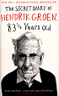 | GROEN, Hendrik  The Secret Diary of Hendrik Groen aged 83 ¼ years old  Hendrik Groen may be old, but he is far from dead and isn't planning to be buried any time soon. Granted, his daily strolls are getting shorter because his legs are no longer willing and he had to visit his doctor more than he'd like. Technically speaking he is elderly. But surely there is more to life at his age than weak tea and potted geraniums?
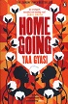 | GYASI, Yaa  Homegoing  Effia and Esi: two sisters with two very different destinies. One sold into slavery; one a slave trader's wife. The consequences of their fate reverberate through the generations that follow. Taking us from the Gold Coast of Africa to the cotton-picking plantations of Mississippi; from the missionary schools of Ghana to the dive bars of Harlem, spanning three continents and seven generations.
 | HADDON, Mark  Stop what you’re doing and read this.  Reading is not an innate human ability. Many people would rather read a newspaper, a magazine, a cereal packet, than a novel. But people have always needed stories. The essays in this book tell us about the experience of reading, why access to books should never be taken for granted, and how literature can save lives.
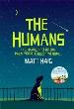 | HAIG, Matt  The Humans  Professor Andrew Martin of Cambridge University solves the world's greatest mathematical riddle. Then he disappears. When he is found walking naked along the motorway, Professor Martin seems different. Besides the lack of clothes, he now finds normal life pointless. His loving wife and teenage son seem repulsive to him. In fact, he hates everyone on the planet. Everyone, that is, except Newton. And he's a dog.
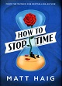 | HAIG, Matt  How To Stop Time  Tom Hazard has a dangerous secret. He may look like an ordinary 41-year-old, but he was born in 1581. Owing to a rare condition, he's been alive for centuries. From Shakespeare's England to jazz age Paris and voyaging the Pacific, Tom has seen a lot, and now craves an ordinary life. Always changing his identity to stay alive, Tom now has the perfect cover - working as a history teacher at a London school.
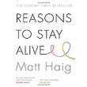 | HAIG, Matt  Reasons to Stay Alive  Aged 24, Matt Haig's world caved in. He could see no way to go on living.This is the true story of how he came through crisis, triumphed over an illness that almost destroyed him and learned to live again. A moving, funny and joyous exploration of how to live better, love better and feel more alive, this is more than a memoir: it is a book about making the most of your time on Earth.
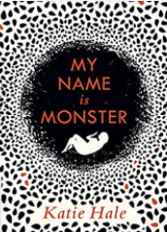 | HALE, Kate  My Name is Monster  After the Sickness has killed off her parents and the bombs have fallen on the last safe cities, Monster emerges from the arctic vault which has kept her alive. When she washes up on the coast of Scotland, everyone she knows is dead, and she believes she is alone in an empty world. Monster begins the long walk south, scavenging and learning the contours of this familiar land made new. Slowly, piece by piece, she begins to rebuild a life.
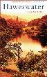 | HALL, Sarah  Haweswater  Sarah Hall's first novel tells the story of a remote dale in the old county of Westmorland. The story concerns the flooding of the dale to make way for a reservoir against the wishes of many of the local hill farmers.
 | HALL, Sarah  The Wolf Border  For almost a decade Rachel Caine has turned her back on home, kept distant by family disputes and her work monitoring wolves on an Idaho reservation. But now, summoned by the eccentric Earl of Annerdale and his controversial scheme to reintroduce the grey wolf to the English countryside, she is back in the peat and wet light of the Lake District.
 | HALLS, Stacey  The Familiars  Fleetwood Shuttleworth is 17 years old, married, and pregnant for the fourth time. But as the mistress at Gawthorpe Hall, she still has no living child, and her husband Richard is anxious for an heir. When Fleetwood finds a letter she isn't supposed to read from the doctor who delivered her third stillbirth, she is dealt the crushing blow that she will not survive another pregnancy.
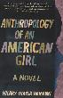 | HAMANN, Hilary  Anthropology of an American Girl  Falling in love, maintaining fragile family relationships and growing to understand the incremental effect of every experience, Hilary Thayer Hamann's coming-of-age novel is a depiction of sexual and intellectual awakening against the backdrop of East Hampton in the 1970s and high-pressured Manhattan in the 1980s.
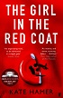 | HAMMER, Kate  The Girl in the Red Coat  Carmel Wakeford becomes separated from her mother at a local children's festival, and is found by a man who claims to be her estranged grandfather. He tells her that her mother has had an accident and that she is to live with him for now. As days become weeks with her new family, 8-year-old Carmel realises that this man believes she has a special gift. While her mother desperately tries to find her, Carmel embarks on an extraordinary journey, one that will make her question who she is - and who she might become.
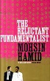 | HAMID, Mohsin  The Reluctant Fundamentalist  At a cafe table in Lahore, a Pakistani man converses with a stranger. As dusk deepens to dark, he begins the tale that has brought him to this fateful meeting.
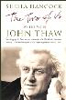 | HANCOCK, Sheila  The Two of Us  When John Thaw died in 2002, a nation lost one of its finest actors and Sheila Hancock lost a beloved husband. In this double biography she chronicles their lives, from the Second World War to the Iraq War, from rationing to affluence, together and apart.
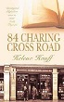 | HANFF, Helene  84 Charing Cross Road  Told in a series of letters in '84 Charing Cross Road' and then in diary form in the second part 'The Duchess of Bloomsbury Street', this true story has touched the hearts of thousands.
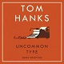 | HANKS, Tom  Uncommon Type: some stories  A gentle Eastern European immigrant arrives in New York City after his family and his life have been torn apart by his country's civil war. A man who loves to bowl rolls a perfect game - and then another and then another and then many more in a row until he winds up ESPN's newest celebrity, and he must decide if the combination of perfection and celebrity has ruined the thing he loves.
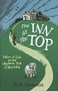 | HANSON, Neil  The Inn at the Top: Tales of Life at the Highest pub in Britain  This title tells the delightful tale of a young couple who in the late 1970s, on impulse, became the new landlords of the most remote, bleak and lonely pub, The Tan Hill Inn, located in the most remote, bleak and lonely part of the Yorkshire Dales.
 | HARDACH, Sophie  Confessions with Blue Horses  Tobi and Ella's childhood in East Berlin is shrouded in mystery. Now adults living in London, their past is full of unanswered questions. Both remember their family's daring and terrifying attempt to escape which ended in tragedy, but the fall-out from that single event remains elusive. Where did their parents disappear to, and why? What happened to Heiko, their little brother? And was there ever a painting of three blue horses?
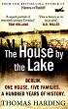 | HARDING, Thomas  The House by the Lake  In the summer of 1993, Thomas Harding travelled to Germany with his grandmother to visit a small house by a lake on the outskirts of Berlin. It had been her 'soul place' as a child, she said - a holiday home for her and her family, but much more - a sanctuary, a refuge. In the 1930s, she had been forced to leave the house, fleeing to England as the Nazis swept to power.
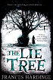 | HARDINGE, Frances  The Lie Tree  Faith's father has been found dead under mysterious circumstances, and as she is searching through his belongings for clues she discovers a strange tree. The tree only grows healthy and bears fruit if you whisper a lie to it. The fruit of the tree, when eaten, will deliver a hidden truth to the person who consumes it. The bigger the lie, the more people who believe it, the bigger the truth that is uncovered.
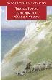 | HARDY, Thomas  Far from the Madding Crowd  In a story which both upholds and questions rural values with a modern sensibility, three suitors vie for the hand of the beautiful and spirited Bathsheba Everdene. While their fates depend upon the choice Bathsheba makes, she discovers the terrible consequences of an inconstant heart.
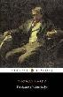 | HARDY, Thomas  The Mayor of Casterbridge  On a drunken impulse, Michael Henchard, a hay-trusser by trade, sells his wife Susan and their child to a sailor. Years later, Susan returns to Casterbridge a widow, to seek her legal husband who is, surprisingly, now the Mayor.
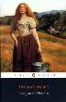 | HARDY, Thomas  Tess of the d’Urbervilles  Cruelly seduced by her relative, the cynical Alec D'Urberville, betrayed by the moral Angel Clare and haunted by her guilt and shame, Tess becomes Hardy's indictment of all the crimes and hypocrisies of 19th century England.
 | HARMAN, Charlotte  Charlotte Bronte: a life  Charlotte Bronte's life contained all the drama and tragedy of the great Gothic novels it inspired. She was raised motherless on remote Yorkshire moors and sent away to brutally strict boarding school at a young age. She watched helpless growing up as, one by one, her five beloved siblings sickened and died; by the end of her short life, she was the only child of the Bronte clan remaining.
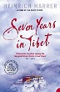 | HARRER, Heinrich  Seven Years in Tibet  Interned in India at the outbreak of World War II, Austrian mountaineer and Olympic ski champion Harrer escaped on his third attempt and fled to the forbidden city of Lhasa where he spent the next 7 years, and where he befriended the young Dalai Lama
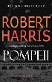 | HARRIS, Robert  Pompeii  Harris recreates in spellbinding detail one of the most famous natural disasters of all time. And by focusing on the characters of an engineer and a scientist, he offers an entirely original perspective on the Roman world.
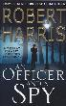 | HARRIS, Robert  An Officer and a Spy  Paris, January 1895. Army officer Georges Picquart witnesses a convicted spy, Captain Alfred Dreyfus, being humiliated in front of 20,000 spectators baying 'Death to the Jew!' The officer is promoted and put in command of shadowy intelligence unit, the Statistical Section. The spy is shipped off to a lifetime of solitary confinement on Devil's Island and his case seems closed forever. But gradually Picquart comes to believe there is something rotten at the heart of the Statistical Section.
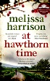 | HARRISON, Melissa  At Hawthorn Time  Howard and Kitty have recently moved to Lodeshill after a life spent in London; now, their marriage is wordlessly falling apart. Custom car enthusiast Jamie has lived in the village for all of his nineteen years and dreams of leaving it behind, while Jack, a vagrant farm-worker and mystic in flight from a bail hostel, arrives in the village on foot one spring morning, bringing change.
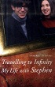 | HAWKING, Jane  Travelling to Infinity: My Life with Stephen  'Travelling to Infinity' is a moving and engaging memoir written by Stephen Hawking's first wife about the turbulent years of her marriage with the astro-physics genius, her traumatic divorce and their recent reconciliation.
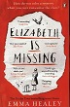 | HEALEY, Emma  Elizabeth is Missing  'Elizabeth is missing', reads the note in Maud's pocket in her own handwriting. Lately, Maud's been getting forgetful. She keeps buying peach slices when she has a cupboard full, forgets to drink the cups of tea she's made and writes notes to remind herself of things. But Maud is determined to discover what has happened to her friend, Elizabeth, and what it has to do with the unsolved disappearance of her sister Sukey, years back, just after the war.
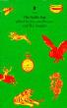 | HEANEY, Seamus(ed)  Rattle Bag  Selected poems
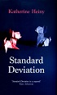 | HEINY, Katherine  Standard Deviation  Graham Cavanaugh's second wife, Audra, is everything his first wife was not. She considers herself privileged to live in the age of the hair towel, talks non-stop through her epidural, labour and delivery, invites the doorman to move in and the eccentric members of their son's Origami Club to Thanksgiving.
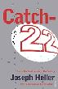 | HELLER, Joseph  Catch 22  At the heart of Joseph Heller's bestselling novel is a satirical indictment of military madness and stupidity, and the desire of the ordinary man to survive it. It is the tale of Captain Yossarian who spends his time plotting to survive.
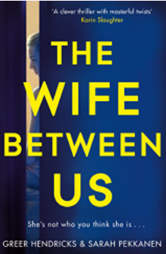 | HENDRICKS, Greer  The Wife Between Us  Marrying a man with a past was always going to come with problems, but you never expect to become the focus of another woman’s obsession.  Nellie just wanted to live the life she’d always dreamed about with Richard. But who is his ex-wife, Vanessa? Wasn’t she a total disaster, in all aspects of their marriage? Nellie thinks she knows everything about his previous marriage and their troubled past, but as secrets are unearthed, she starts to think there's more to the wife before her . . .
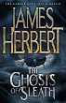 | HERBERT, James  Ghosts of Sleath  Sleath is a village hidden away in the Chiltern hills, nothing ever seems to happen here - that is until the ghosts start to appear. A psychic investigator is called in but the events which unfold in front of him drive him to the edge of his sanity.
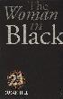 | HILL, Susan  The Woman in Black  When Arthur Kipps attends the funeral of Alice Drablow he is unaware of the tragic secrets which lie hidden behind her house. It is not until he glimpses a woman dressed all in black at the funeral that a creeping sense of unease begins to take hold.
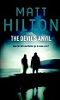 | HILTON, Matt  The Devil’s Anvil  Accepting the task of protecting Billie Womack is a no-brainer for ex-counterterrorist soldier Joe Hunter, but it comes with its own set of complications. Billie's husband, Richard, stole $30 million from some violent people. He apparently died in a car crash with Billie's daughter, Nicola, during a desperate attempt to elude his pursuers. But his enemies don't believe him dead. They think he escaped the plunge into the icy river that killed Nicola and has now decided to come back for the money.
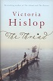 | HISLOP, Victoria  The Thread  Thessaloniki, 1917. As Dimitri Komninos is born, a devastating fire sweeps through the Greek city where Christians, Jews and Muslims live side by side. 5 years later, Katerina Sarafoglou's home in Asia Minoris destroyed by the Turkish army. Losing her mother in the chaos, she flees across the sea to an unknown destination in Greece.
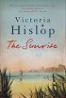 | HISLOP, Victoria  The Sunrise  In 1972, Famagusta in Cyprus is the most desirable resort in the Mediterranean. Tourism and commerce boom in the city, with Greek and Turkish Cypriots living and working harmoniously side by side. Elsewhere on the island, there has been a decade of unrest and violence between the communities and in 1974, following a Greek military coup, Turkey invades the island to protect the Turkish Cypriot minority.
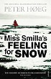 | HOEG, Peter  Miss Smilla’s Feeling for Snow  Smilla Jaspersen, the resourceful, tenacious and bloody-minded Greenlander heroine, has won the hearts of readers the world over in her quest to find the truth behind the death of a six year-old boy
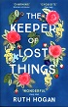 | HOGAN, Ruth  The Keeper of Lost Things  Once a celebrated author of short stories now in his twilight years, Anthony Peardew has spent half his life lovingly collecting lost objects, trying to atone for a promise broken many years before. Realising he is running out of time, he leaves his house and all its lost treasures to his assistant Laura, the one person he can trust to fulfil his legacy and reunite the thousands of objects with their rightful owners.
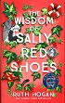 | HOGAN, Ruth  The Wisdom of Sally Red Shoes  Masha is drowning. Once a spirited, independent woman with a rebellious streak, her life has been forever changed by a tragic event 12 years ago. Unable to let go of her grief, she finds solace in the silent company of the souls of her local Victorian cemetery and at the town's lido, where she seeks refuge underwater - safe from the noise and the pain.
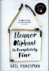 | HONEYMAN, Gail  Eleanor Oliphant is Completely Fine  Eleanor Oliphant leads a simple life. She wears the same clothes to work every day, eats the same meal deal for lunch every day and buys the same two bottles of vodka to drink every weekend. Eleanor Oliphant is happy. Nothing is missing from her carefully timetabled life. Except, sometimes, everything. One simple act of kindness is about to shatter the walls Eleanor has built around herself.
 | HOOKER, Richard  Mash  The doctors who worked in the Mobile Army Surgical Hospitals (MASH) during the Korean War were well trained but, like most soldiers sent to fight a war, too young for the job. This is the original novel that inspired the hit movie and TV series.
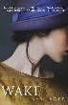 | HOPE, Anna  Wake  Five Days in November, 1920. As the people of London await the arrival of the Unknown Soldier from France, three women are dealing with loss in their own way: Hettie, who dances for sixpence a waltz at the Hammersmith Palais; Evelyn, who toils at a lowly job in the Pensions Office; and Ada, a housewife who is beset by visions of her dead son.
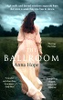 | HOPE, Anna  The Ballroom  1911: Inside an asylum at the edge of the Yorkshire moors, where men and women are kept apart by high walls and barred windows, there is a ballroom both vast and beautiful. For one bright evening every week they come together and dance. And, when John and Ella meet, it is a dance that will change two lives forever.
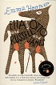 | HOOPER, Emma  Etta and Otto  Etta is starting to forget. But Otto loves her and if he remembers, then surely they can balance things out? Their neighbour Russell remembers too, but differently - and he still loves Etta as much as he did more than 50 years ago, before she married Otto. Etta's greatest unfulfilled wish, living in the rolling farmland of Saskatchewan, is to see the sea.
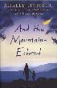 | HOSSEINI, Khaled  And the Mountains Echoed  A multi-generational family story revolving around brothers and sisters, 'And the Mountains Echoed' explores the ways in which they love, wound, betray, honour and sacrifice for each other.
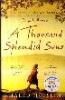 | HOSSEINI, Khaled  A Thousand Splendid Suns  This is a breathtaking story set against the volatile events of Afghanistan’s last thirty years—from the Soviet invasion to the reign of the Taliban to the post-Taliban rebuilding—that puts the violence, fear, hope, and faith of this country in intimate, human terms. It is a tale of two generations of characters brought jarringly together by the tragic sweep of war, where personal lives—the struggle to survive, raise a family, find happiness—are inextricable from the history playing out around them.
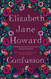 | HOWARD, Elizabeth  Confusion  The long, dark days of struggle provide the background to this book in the Cazalet Chronicle. As the war enters its fourth year, chaos has become a way of life, as the family find the battle for survival echoes the confusion in their lives.
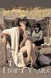 | HOWARD, Elizabeth  The Light Years  Three generations of Cazalets spend each summer in their family house. For two unforgettable summers they are safe from the storm clouds of World War II. These are sunlit days of childish games, lavish family meals and picnics on the beach.
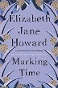 | HOWARD, Elizabeth J  Marking Time  By 1939, the sunlit days of childish games are over as the shadows of war cloud the lives of an English family. At the family home, the windows are blacked out, food is scarce, and a new generation of Cazalets take up the story.
 | HUCKNELL, Joseph  Life’s Tales  A Life’s Tales is the story of a life lived in a vanished age; a life lived with compassion, insight, ambition and an adventurous spirit; a life fighting against discrimination against gays, and a constant search for self improvement.
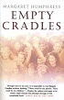 | HUMPHREYS, Margaret  Empty Cradles  This is a true story of a Nottingham social worker who, in 1986, uncovered a secret government policy of deporting British children to other parts of the Empire , the last case occurring as recently as 1967.
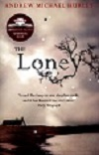 | HURLEY, Andrew  The Loney  If it had another name, I never knew, but the locals called it the Loney - that strange nowhere between the Wyre and the Lune where Hanny and I went every Easter time with Mummer, Farther, Mr and Mrs Belderboss and Father Wilfred, the parish priest. It was impossible to truly know the place. It changed with each influx and retreat, and the neap tides would reveal the skeletons of those who thought they could escape its insidious currents.
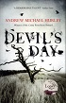 | HURLEY, Andrew  Devil’s Day  The Oxbarrows live in a small village on the Lancashire moors. The father, Richard, has recently died, but his 13-year-old daughter Rosie refuses to believe it. When a recently retired psychiatrist is persuaded by an old colleague to try to help the family through their grief, he finds himself caught up in the customs of the remote community, and an older way of doing things.
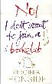 | IRONSIDE, Virginia  No! I don’t want to join a Book Club  Too young to get whisked away by a Stannah Stairlift, or to enjoy the luxury of a walk-in-bath (but not so much that she doesn't enjoy comfortable shoes) Marie, is all the same, getting on in years - and she's thrilled about it. This fictionalised diary is what happens when grumpy old women meet Bridget Jones.
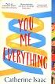 | ISAAC, Catherine  You, Me, Everything  Jess and her ten-year-old son William set off to spend the summer at Chateau de Roussignol, deep in the rich, sunlit hills of the Dordogne. There, Jess's ex-boyfriend and William's father, Adam, runs a beautiful hotel in a restored castle. Jess is bowled over by what Adam has accomplished, but she's in France for a much more urgent reason: to make Adam connect with his own son.
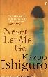 | ISHIGURO, Kazuo  Never Let me Go  Kathy, Ruth and Tommy were pupils at Hailsham - an idyllic establishment situated deep in the English countryside. The children there were tenderly sheltered from the outside world, brought up to believe they were special, and that their personal welfare was crucial. But for what reason were they really there?
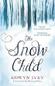 | IVEY, Eowyn  The Snow Child  Jack and Mabel have staked everything on making a fresh start in the raw Alaskan wilderness. In a moment of tenderness, the pair build a snowman - or rather a snow girl - together. The next morning, all trace of her has disappeared. But Jack can't shake the notion that he glimpsed a small figure running in the trees in the dawn light.
 | IVEY, Eowyn  To the Bright Edge of the World  Lieutenant Colonel Allen Forrester receives the commission of a lifetime when he is charged to navigate Alaska's hitherto impassable Wolverine River, with only a small group of men. The Wolverine is the key to opening up Alaska and its rich natural resources to the outside world, but previous attempts have ended in tragedy.

