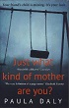 | DALY, Paula  Just what kind of Mother are you?  She's gone and it's your fault. You were supposed to be watching your best friend's 13-year-old daughter, and now she's missing. But you know that she's not just missing - she's been taken. Because Lucinda is the second girl to be abducted within a fortnight.  .
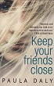 | DALY, Paula  Keep Your Friends Close  Natty and Sean Wainwright are happily married. So when Natty's oldest friend, Eve Dalladay, appears just as their daughter collapses on a school trip in France ,Natty has no qualms about leaving Eve with Sean to help out at home. Two weeks later and Natty finds Eve has slotted into family life too well. Natty's husband has fallen in love with Eve.
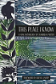 | DARBISHIRE, Kerry  This Place I Know: Cumbrian Poetry Anthology  A new anthology of Cumbrian poetry.
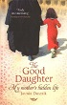 | DARZNIK, Jasmin  The Good Daughter  One day shortly after her fathers death, when Jasmin Darznik is helping her mother move house, a photograph falls from a stack of old letters. The girl in it is her mother. She is wearing a wedding veil, and at her side stands a man whom Jasmin has never seen before.
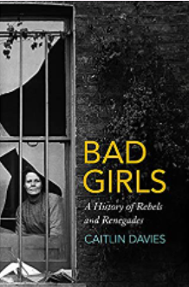 | DAVIES, Caitlin  Bad Girls  Society has never known what to do with its rebellious women.  Those who defied expectations about feminine behaviour have long been considered dangerous and unnatural, and ever since the Victorian era they have been removed from public view, locked up and often forgotten about. Many of these women ended up at HM Prison Holloway, the self-proclaimed 'terror to evil-doers' which, until its closure in 2016, was western Europe's largest women's prison
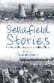 | DAVIES, Hunter  Sellafield Stories  Through the personal life stories of 30 people who lived, worked and built the complex 'Sellafield Stories' tells the true story of the nuclear plant that has been at the heart of the nation's story for the last 60 years.
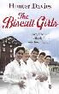 | DAVIES, Hunter  The Biscuit Girls  Ivy, Dulcie, Barbara, Ann, Dorothy and Jean all had different reasons for applying to work at Carr's biscuits, but once they had put on their overalls and walked through the factory gates they discovered a community full of life, laughter and friendship. Beginning in the 1940s, these heartwarming and vividly-remembered stories have all been told by the women themselves to Hunter Davies.
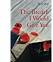 | DAY, Barrie  The Breath I Would Give You  Nightmares, obsession, sexual fantasies - these are what threaten to devastate the life of Matthew Selkirk. He is a passionate teacher, a good husband and a good father.  But being good isn't enough when your daughter is bent on rebellion and your students weave you into their fantasies.
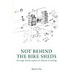 | DAY, Barrie  Not Behind the Bike Shed  This lively memoir covers the author's teaching career from the chalk and talk of the Seventies to the digital wizardry of the Noughties. We share the author's journey as a teacher in classrooms in the English Midlands, Jamaica, Miami Florida and north west England where his school was destroyed by the Carlisle floods of 2005.
 | DE WAAL, Kit  My Name is Leon  A brother chosen. A brother left behind. And a family where you'd least expect to find one. Leon is nine, and has a perfect baby brother called Jake. They have gone to live with Maureen, who has fuzzy red hair like a halo, and a belly like Father Christmas. But the adults are speaking in low voices, and wearing pretend faces. They are threatening to give Jake to strangers, since Jake is white and Leon is not.
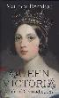 | DENNISON, Matthew  Queen Victoria  Queen Victoria is Britain's queen of contradictions. In her combination of deep sentimentality and bombast; cultural imperialism and imperial compassion; fear of intellectualism and excitement at technology; romanticism and prudishness, she became a spirit of the age to which she gave her name. This is a compelling assessment of Victoria's mercurial character and indelible impact.
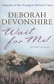 | DEVONSHIRE, Lady Deborah  Wait for Me  Deborah Devonshire is a natural writer with a knack for the telling phrase and for hitting the nail on the head. She tells the story of her upbringing, lovingly and wittily describing her parents, she talks candidly about her brother and sisters, finally setting the record straight.
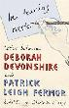 | DEVONSHIRE, Lady Deborah  In Tearing Haste  In 1956, Deborah, Duchess of Devonshire - youngest of the six Mitford sisters - invited the writer and war hero Patrick Leigh Fermor to visit Lismore Castle, in Ireland. This halcyon visit sparked off a deep friendship and a lifelong exchange of highly entertaining letters.
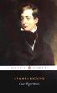 | DICKENS, Charles  Great Expectations  An unknown benefactor provides Philip Pirrip with the chance to escape his poor upbringing. Aspiring to be a gentleman, and encouraged by his expectations of wealth, he abandons his friends and moves to London. His expectations prove to be unfounded however, and he must return home penniless.
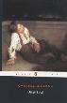 | DICKENS, Charles  Oliver Twist  Dickens's classic morality tale of a starving orphan caught between opposing forces of good and evil is a powerful indictment of Victorian England's Poor Laws. Oliver begins life in the workhouse, graduates to the criminal underworld of London and learns to survive.
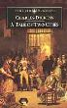 | DICKENS, Charles  A Tale of Two Cities  Dr Manette has been confined for 18 years in the Bastille because he found out the Marquis de Evremonde and his brother had ill treated a girl and mortally wounded a young boy. He has just been released and brought to England
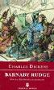 | DICKENS, Charles  Barnaby Rudge  A novel of individuals caught in the horrors of mass activity, Barnaby Rudge dramatises two of Dicken's major preoccupations - private murder and public violence
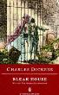 | DICKENS, Charles  Bleak House  'Bleak House', Dickens's most daring experiment in the narration of a complex plot, challenges the reader to make connections - between the fashionable & the outcast, the beautiful & the ugly, the powerful & the victims. Nowhere in Dickens's later novels is his attack on an uncaring society more imaginatively embodied.
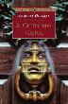 | DICKENS, Charles  A Christmas Carol  When the miserly Scrooge is visited by the ghost of his old partner, Jacob Marley, he decides to change his ways - for Christmas and for ever.
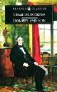 | DICKENS, Charles  Dombey and Son  London in the 1840s worships money at the expense of love. Mr Dombey pins all his hopes and affections on his son, Paul, and cruelly neglects his loving daughter, Florence. This novel charts Dombey's progress, through tragedy to enlightenment.
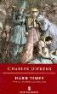 | DICKENS, Charles  Hard Times  'Hard Times' is Dickens's portrait of a Lancashire mill town in the 1840s. Through the characters of Gradgrind & Bounderby he examines the ethos of 19th century industrialization which allows human beings to be enslaved to machines.
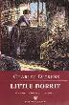 | DICKENS, Charles  Little Dorrit  In Little Dorrit, Dickens paints a portrait of a prison world in which the shadow of the Marshalsea reaches far beyond its high enclosing walls.
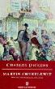 | DICKENS, Charles  Martin Chuzzlewit  Long convinced that his family are only after his money, Martin Chuzzlewit takes in an orphaned girl - Mary Graham - to be his nursemaid. But when Martin's grandson - young Martin - falls in love with Mary, he is disowned. Cast out, young Martin travels to the American west to build his fortune. However, his journey has unforeseen consequences.
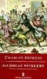 | DICKENS, Charles  Nicholas Nickleby  Mixing comedy and horror, melodrama and acid satire, Dickens depicts a world in which the exploitation and abuse of youth and innocence cannot ever fully vanquish kindness, affection and the joyful energies of life.
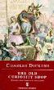 | DICKENS, Charles  The Old Curiosity Shop  For the character of Little Nell, the beautiful child thrown into a shadowy, terrifying world, Dickens drew upon the tragedy in his own life. His characters are startlingly powerful, especially Quilp, the antithesis of Little Nell.
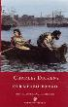 | DICKENS, Charles  Our Mutual Friend  Our Mutual Friend represents Dickens' final novel, and is set in 1860s London, peopled by characters as diverse as wealthy dustmen, idle lawyers, shady financiers and businessmen, a murderous teacher, and a mercenary young beauty
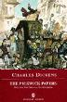 | DICKENS, Charles  Pickwick Papers  This was the comic masterpiece that carried the 24-year-old Dickens to fame as it appeared in monthly instalments in 1836-7. It records the 'perambulations, perils, travels, adventures' of the Pickwick Club's members.
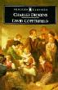 | DICKENS, Charles  David Copperfield  David Copperfield, Dickens's most celebrated novel, is the classic account of one boy growing up in a world which is by turns magical, fearful and grimly realistic.
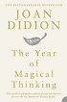 | DIDION, Joan  The Year of Magical Thinking  'The Year of Magical Thinking' is an intensely personal and harrowing memoir from revered American essayist and prose stylist Joan Didion.
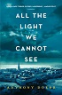 | DOERR, Anthony  All The Lights We Cannot See  Marie-Laure has been blind since the age of six. Her father builds a perfect miniature of their Paris neighbourhood so she can memorise it by touch and navigate her way home. But when the Nazis invade, they flee with a dangerous secret. Werner is a German orphan, destined to labour in the same mine that claimed his father's life, until he discovers a knack for engineering.
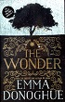 | DONOGHUE, Emma  The Wonder  An eleven-year-old girl stops eating, but remains miraculously alive and well. A nurse, sent to investigate whether she is a fraud, meets a journalist hungry for a story. Set in the Irish Midlands in the 1850s, 'The Wonder' - inspired by numerous European and North American cases of 'fasting girls' between the 16th and the 20th centuries - is a psychological thriller about a child's murder threatening to happen in slow motion before our eyes
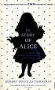 | DOUGLAS-FAIRHURST, Robert  The Story of Alice: Carroll and the Secret History of Wonderland  Drawing on previously unpublished material, this work illuminates the tangled history of two lives and two books, examining the peculiar friendship between Oxford mathematician Charles Dodgson, Lewis Carroll, and Alice Liddell, the child for whom he invented the Alice stories.
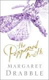 | DRABBLE, Margaret  The Peppered Moth  The Peppered Moth explores inheritance, DNA, the individual's place in history and fate. It begins with Bessie Bawtry, a small child living in Yorkshire in 1905, and ends with her granddaughter, listening to a lecture on genetic inheritance.
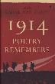 | DUFFY, Carol Ann  1914  The First World War holds a unique place in the nation's history; the poetry it produced, a unique place in the nation's hearts. To mark the centenary of the First World War in 2014, the Poet Laureate, Carol Ann Duffy, has engaged the most eminent poets of the present to choose the writing from the Great War that touched them most profoundly: their choices are here in this powerful and moving assembly.
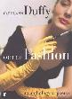 | DUFFY, Carol Ann  Out of Fashion  In 'Out of Fashion', Carol Ann Duffy selects the best and freshest contemporary poets and asks them in turn to select their favourite poem, from another time or culture, which looks at how we dress, or undress, how we cover up or reveal.
 | DUFFY, Carol  The World’s Wife  In Carol Ann Duffy's latest collection of poems, the stories of famous men - Midas, Darwin, Quasimodo, Pontious Pilate, King Kong - are presented from the perspective of the lesser-known wife.
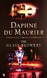 | DU MAURIER, Daphne  The Glass Blowers  This is Daphne du Maurier's warm, human saga of a family of craftsmen in 18th century France - with the violence and terror of the Revolution as a clamouring background against which their loves and their hopes are played out.
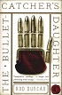 | DUNCAN, Rod  The Bullet Catcher’s Daughter  This is a novel of alternate history set in a divided England. The land is divided, following the Luddite revolution, into the puritan, progress-hating north and the decadent, Royalist south. Living right on the border and flitting between the two nations Elizabeth Barnabus lives a precarious double life - as both herself and posing as her own brother, the daring private detective. Now she is trying to solve the mystery of a disappearing aristocrat and a hoard of arcane machines.
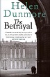 | DUNMORE, Helen  The Betrayal  A gripping and moving portrait of life in post-war Soviet Russia, 'The Betrayal' shows the epic struggle of ordinary people to survive in a time of violence and terror
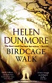 | DUNMORE, Helen  Birdcage Walk  It is 1792 and Europe is seized by political turmoil and violence. Lizzy Fawkes has grown up in Radical circles where each step of the French Revolution is followed with eager idealism. But she has recently married John Diner Tredevant, a property developer who is heavily invested in Bristol's housing boom, and he has everything to lose from social upheaval and the prospect of war.
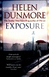 | DUNMORE, Helen  Exposure  London, November, 1960: the Cold War is at its height. Spy fever fills the newspapers, and the political establishment knows how and where to bury its secrets. When a highly sensitive file goes missing, Simon Callington is accused of passing information to the Soviets, and arrested. His wife, Lily, suspects that his imprisonment is part of a cover-up, and that more powerful men than Simon will do anything to prevent their own downfall.
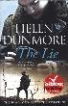 | DUNMORE, Helen  The Lie  Cornwall, 1920, early spring. A young man stands on a headland, looking out to sea. He is back from the war, homeless and without family. Behind him lie the mud, barbed-wire entanglements and terror of the trenches. Behind him is also the most intense relationship of his life. He is about to step into the unknown. But will he ever be able to escape the terrible, unforeseen consequences of a lie?
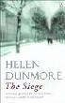 | DUNMORE, Helen  The Siege  Whilst German tanks surround Leningrad during September 1941, two families struggle to stay alive. As winter grips the city first the furniture is burnt, then the books, but some may not live to see another day.
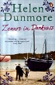 | DUNMORE, Helen  Zennor in Darkness  'Zennor in Darkness' is a fictional account of the lives of people living in Cornwall during the First World War. The central characters are D.H. Lawrence and his German wife Frieda, who become the butt of much scorn and gossip during the spring of 1917.
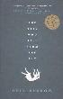 | DURROW, Heidi  The girl who fell from the sky  Following in the footsteps of Jamaica Kincaid’s ‘Annie John’ and Toni Morrison’s ‘The Bluest Eye’, comes the haunting portrait of a young girl and the inspiring tale of her survival against all odds.
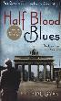 | EDUGYAN, Esi  Half Blood Blues  Esi Edugyan's atmospheric novel weaves the horror of betrayal, the burden of loyalty and the possibility that, if you don't tell your own story, someone else might tell it for you. And they just might tell it wrong.
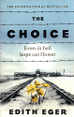 | EGER, Edith  The Choice  In 1944, 16-year-old Edith Eger was sent to Auschwitz. There she endured unimaginable experiences, including being made to dance for the infamous Josef Mengele. Over the coming months, Edith's bravery helped her sister to survive, and led to her bunkmates rescuing her during a death march. When their camp was finally liberated, Edith was pulled from a pile of bodies, barely alive. In 'The Choice', Dr Edith Eger shares her experience of the Holocaust and the remarkable stories of those she has helped ever since.
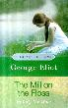 | ELIOT, George  The Mill on the Floss  As Maggie Tulliver approaches maturity she enters into conflict with family and community over her desire for self-fulfillment. Eliot's exploration of Maggie's dilemma makes this novel as relevant today as it was in the 19th century.
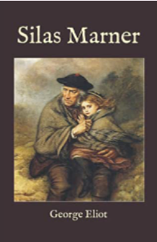 | ELIOT, Goerge  Silas Marner  In the days when the spinning-wheels hummed busily in the farmhouses—and even great ladies, clothed in silk and thread-lace, had their toy spinning-wheels of polished oak—there might be seen in districts far away among the lanes, or deep in the bosom of the hills, certain pallid undersized men, who, by the side of the brawny country-folk, looked like the remnants of a disinherited race.
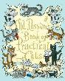 | ELIOT, T, S  Old Possum’s Book of Practical Cats  First published in 1939, T.S. Eliot's collection of cat poems, written originally to amuse his godchildren and friends, has become one of the all-time favourites of children's literature.
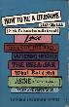 | ELLIS, Samantha  How to be a Heroine: or, what I’ve learned from reading too much.  On a pilgrimage to 'Wuthering Heights' with her best friend, Samantha Ellis found herself arguing about which heroine she liked best: Jane Eyre or Cathy Earnshaw. She was all for wild, free, passionate Cathy, but her friend found Cathy silly, a snob who betrays Heathcliff for Edgar and makes them all unhappy - while Jane makes her own way. Jane. So she decided to look again - and harder - at all the heroines.
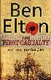 | ELTON, Ben  The First Casualty  Flanders, June 1917. A British officer and celebrated poet is shot dead, killed not by German fire, but while recuperating from shell shock well behind the lines. A young English soldier is arrested and, although he protests his innocence, charged with his murder.
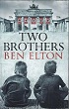 | ELTON, Ben  Two Brothers  Berlin, 1920. Two babies are born. Two brothers. United and indivisible, sharing everything. Twins in all but blood. As Germany marches into its Nazi Armageddon, the ties of family, friendship and love are tested to the very limits of endurance. And the brothers are faced with an unimaginable choice. Which one of them will survive?
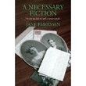 | EMERSON, Jane  A Necessary Fiction  Laura Driscoll's uncomplicated life is thrown into confusion when she discovers her father lied to secure an advantageous marriage and advance his career. Determined to uncover the secrets of his past, Laura's single-minded pursuit of answers leads her to make choices that have far-reaching consequences both for herself and those who love her.
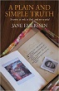 | EMERSON, Jane  A Plain and Simple Truth  Three men whose lives are inextricably linked to one woman meet at her funeral, an event which has profound consequences for them all. For Robert Moray there is the unwelcome revelation of a secret he has kept hidden for years; for John Rufford, the anguish of learning the truth; and for twenty-four-year-old Tom, the shattering of all the comfortable certainties of life.
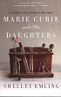 | EMLING, Shelley  Marie Curie and her Daughters  This title focuses on the relationship between famed scientist Marie Curie and her two remarkable daughters. Drawing on personal interviews with Curie's descendants, as well as revelatory new archives, this is a wholly new story about Marie Curie - and a family of women inextricably connected to the dawn of nuclear physics.
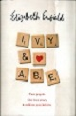 | ENFIELD, Elizabeth  Ivy and Abe  Two people. One love story. A million possibilities. They're soulmates. Ivy and Abe were inseparable as children until an accident tore them apart. Several decades later, when both are in their seventies, a chance encounter reunites them. But time is not on their side. What if they'd met in a different time and place?
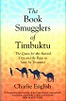 | ENGLISH, Charlie  The Book Smugglers of Timbuktu  Two tales of a city: The historical race to reach one of the world's most mythologised places, and the story of how a contemporary band of archivists and librarians, fighting to save its ancient manuscripts from destruction at the hands of al Qaeda, added another layer to the legend.
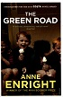 | ENRIGHT, Anne  The Green Road  The children of Rosaleen Madigan leave the west of Ireland for lives they never could have imagined in Dublin, New York and various third-world towns. In her early old age their difficult, wonderful mother announces that she's decided to sell the house and divide the proceeds. Her adult children come back for one last Christmas, with the feeling that their childhoods are being erased, their personal history bought and sold.
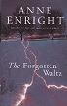 | ENRIGHT, Anne  The Forgotten Waltz  In Terenure, a pleasant suburb of Dublin, in the winter of 2009, it has snowed. Gina Moynihan, girl about town, recalls the trail of lust and happenstance that brought her to fall for the love of her life.
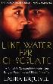 | ESQUIVEL, Laura  Like Water for Chocolate  This novel is a romantic, poignant tale, touched with moments of magic, graphic earthiness and bittersweet wit. A sumptuous feast of a novel, it relates the bizarre history of the all-female De La Garza family.
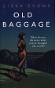 | EVANS, Lisa  Old Baggage  It is 1928. Matilda Simpkin, rooting through a cupboard, comes across a small wooden club - an old possession of hers, unseen for more than a decade. Mattie is a woman with a thrilling past and a chafingly uneventful present. During the Women's Suffrage Campaign she was a militant. Jailed five times, she marched, sang, gave speeches, smashed windows and heckled Winston Churchill, and nothing - nothing - since then has had the same depth, the same excitement.
 | EVANS, Lissa  Their Finest  It is 1940. France has fallen, and only a narrow strip of sea lies between Great Britain and invasion. The war could go either way and everyone must do their bit. Young copy writer Catrin Cole is drafted into the Ministry of Information to help write women in propaganda films - something that the men aren't very good at.
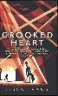 | EVANS, Lisa  Crooked Heart  When Noel Bostock, aged ten, with no family is evacuated from London to escape the Blitz, he ends up living in St Albans with Vera Sedge, a thirty-six year old drowning in debts and dependents. Always desperate for money, she's unscrupulous about how she gets it. The war's thrown up new opportunities for making money but what Vee needs (and what she's never had) is a cool head and the ability to make a plan. On her own, she's a disaster. With Noel, she's a team. Together they cook up an idea.
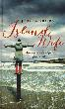 | FAIRBAIRNS, Judy  Island Wife  'Island Wife' tells the story of Judy, who at 19, met her wild pioneer. He whisked her off into an adventure, a marriage of 40 years, and a life on a remote Hebridean island. Along the way she bears 5 children, learns how to run a rocky hill farm, a recording studio and the first whale watching business in the UK - all the while inventively making fraying ends meet.
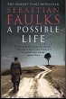 | FAULKS, Sebastian  A Possible Life  Terrified, a young prisoner in the Second World War closes his eyes and pictures himself going out to bat on a sunlit cricket ground in Hampshire. Across the courtyard in a Victorian workhouse, a father too ashamed to acknowledged his son. A skinny girl steps out of a Chevy with a guitar; her voice sends shivers through the skull. Soldiers and lovers, parents and children, scientists and musicians risk their bodies and hearts in search of connection - some key to understanding the people we become.
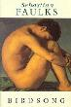 | FAULKS, Sebastian  Birdsong  This is the story of Stephen who arrives in Amiens in 1910. His life goes through a series of traumatic experiences, from the clandestine love affair that tears apart the family with whom he lives, to the unprecedented experience of the war itself.
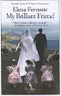 | FERRANTE, Elena  My Brilliant Friend  This novel is a rich, intense, and generous-hearted story about two friends, Elena and Lila. Ferrante's inimitable style lends itself perfectly to a meticulous portrait of these two women that is also the story of a nation and a touching meditation on the nature of friendship.
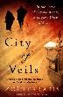 | FERRARIS, Zoe  City of Veils  The burkha-clad body of a young woman is discovered on Jeddah beach; soon afterwards, an American woman finds herself alone and afraid when her husband disappears. Investigating policeman Osama Ibrahim, forensic scientist Katya Hijazi and her friend, Nayir Sharqi, search out the truth in the city streets and the desert beyond.
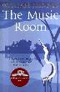 | FIENNES, William  The Music Room  William Fiennes spent his childhood growing up in awe of his brother Richard. 11 years older and a magnetic presence, Richard suffers from severe epilepsy. His energy influences the rhythms of the family and the house's internal life, and his story inspires a journey, interwoven with loving recollection, towards an understanding of the mind.
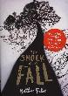 | FILER, Nathan  The Shock of the Fall  'The Shock of the Fall' is an extraordinary portrait of one man's journey through the spinning vortex that is mental illness. It is a brave and groundbreaking novel from one of the most exciting new voices in fiction.
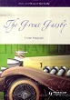 | FITZGERALD, F. Scott  The Great Gatsby  A social satire and a milestone in 20th century literature, 'The Great Gatsby' peels away the layers of the glamorous twenties in the U.S. to display the coldness and cruelty at its heart.
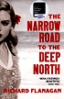 | FLANAGAN, Richard  The Narrow Road to the Deep North  In the despair of a Japanese POW camp on the Burma Death Railway, surgeon Dorrigo Evans is haunted by his love affair with his uncle's young wife two years earlier. Struggling to save the men under his command from starvation, from cholera, from beatings, he receive a letter that will change his life forever.
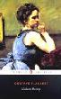 | FLAUBERT, Gustave  Madame Bovary  Finding herself stifled by marriage, Emma Bovary throws herself into a desperate love affair and by doing so, sows the seeds of her own downfall.
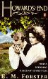 | FORSTER, E.M.  Howards End  When impetuous Helen Schlegel believes herself to be in love with Paul, the youngest of the Wilcox sons, she sparks off a connection between the two families that leads to collision.
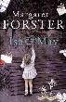 | FORSTER, Margaret  Isa and May  The curiously named Isamay, a would-be academic, is trying to write a coherent thesis about grandmothers in history from Sarah Bernhardt and George Sand to the matriarchal Queen Victoria and other influential grannies while constantly ambushed by the secrets her own family has been keeping.
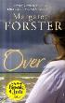 | FORSTER, Margaret  Over  What happens after a tragedy in the family? A teenager has died in mysterious circumstances and the different ways in which the mother and father respond to this and how it affects the other siblings are at the heart of this novel.
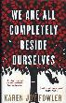 | FOWLER, Karen J  We are all Completely Beside Ourselves  Rosemary's young, just at college, and she's decided not to tell anyone a thing about her family. Rosemary is now an only child, but she used to have a sister the same age as her, and an older brother. Both are now gone - vanished from her life. There's something unique about Rosemary's sister, Fern. So now she's telling her story: full of hilarious asides and brilliantly spiky lines.
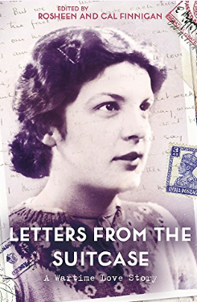 | FRANCIS, David  Letters From a Suitcase  LETTERS FROM THE SUITCASE reveals the vivid, poignant and hugely detailed wartime correspondence between David and Mary Francis from 1938 to 1943, and a unique love story, sure to appeal to readers of Roald Dahl's LOVE FROM BOY, Sheila Hancock's MISS CARTER'S WAR or Helen Simonson's MAJOR PETTIGREW'S LAST STAND
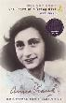 | FRANK, Anne  Diary of a Young Girl  A timeless story rediscovered by each new generation, The Diary of a Young Girl continues to bring to life the experiences of Anne Frank, who for a time survived the worst horror the modern world had seen.
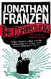 | FRANZEN, Jonathan  The Corrections  From the author of 'Strong Motion', this novel offers a panoramic vision of America at the beginning of the 21st century, as seen through the turbulent lives of the Lambert family.
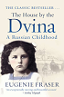 | FRASER, Eugenie  The House by the Dvina: a Russian Childhood  A unique and moving account of life in Russia before, during and immediately after the Revolution, 'The House by the Dvina' is the fascinating story of two families, separated in culture and geography, but bound together by a Russian-Scottish marriage.
 | FRANZEN, Jonathan  Freedom  Patty and Walter Berglund were hands-on parents at the avant-garde of the whole foods generation. But now, in the new millennium, the Berglunds have become a mystery. Why has their teenage son moved in with a Republican family? Why is Walter working with Big Coal? And why has Patty become 'a very different kind of neighbour?'
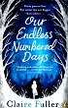 | FULLER, Claire  Our Endless Numbered Days  1976: Peggy Hillcoat is eight. She spends her summer camping with her father, playing her beloved record of 'The Railway Children' and listening to her mother's grand piano, but her pretty life is about to change. Her survivalist father, who has been stockpiling provisions for the end which is surely coming soon, takes her from London to a cabin in a remote European forest. There he tells Peggy the rest of the world has disappeared.

