SERVICE SPECIFICATION

Service:- | LOT 1) PROVISION OF THE NATIONAL NHS HEALTH CHECK PROGRAMME
Implementation date:- | 1st October 2018

- OVERVIEW

Cardiovascular disease (CVD) is one of the conditions most strongly associated with health inequalities, with deaths from CVD three times higher among people in the most deprived communities compared to those in the most affluent. Most premature deaths from CVD (among people aged less than 75) are preventable. Additionally, the cost of social and health care from the rise in levels of obesity, type 2 diabetes and dementia makes the prevention and risk reduction strategies of these conditions a priority.

The national NHS Health Check programme was launched in 2009 and is a five year rolling programme aimed at adults aged 40-74 without existing vascular disease. The programme aims to prevent heart disease, stroke, type 2 diabetes and kidney disease and to raise awareness of dementia across the population and within high risk and vulnerable groups. It is one of the largest public health programmes in the world, with nearly 5 million people in England receiving an NHS Health Check since the programme became a statutory function for local authorities in 2013.

Department of Health modelling estimates the national cost of the programme as £332m each year at full roll out with a benefit of £3.7bn and a cost per quality adjusted life year (QALY) of around £3,000. Modelling shows that each year the NHS Heath Check could prevent 1,600 heart attacks and strokes and 4,000 cases of diabetes. At least 20,000 cases of diabetes or kidney disease could also be diagnosed earlier.
The Legal Obligation
In April 2013, the Health and Social Care Act 2012 set out the Local Authority statutory responsibilities for delivering and commissioning Public Health services. This included provision of the NHS Health Check Programme. The legal obligation regarding the NHS Health Check programme is:-
- For each eligible individual aged 40-74 to be offered an NHS Health Check once in every five years and for each individual to be recalled every five years if they remain eligible
- For the risk assessment to include specific tests and measurements
- To ensure the individual having their NHS Health Check is told their cardiovascular risk score, and other results are communicated to them
- For specific information and data to be recorded and, where the risk assessment is conducted outside of the individual’s GP practice, for that information to be forwarded to the individual’s GP for entry on the patient record, thus, enabling clinical follow up as required.

Local authorities are also required to continuously improve the percentage of eligible individuals having an NHS Health Check.
Where individuals require clinical follow up and intervention following a NHS Health Check, this is the responsibility of the NHS.
Where individuals would benefit from lifestyle or behaviour change interventions, these are deemed an appropriate use of the ring fenced public health grant available to local authorities.
The NHS Health Check is represented in flow chart format in Appendix 1.
Health Check Content
Local authorities have a legal duty to ensure that the following specific tests and measures are completed during the NHS Health Check and that the results are recorded on the patient record:-
- Age
- Gender
- Ethnicity
- Family history of cardiovascular disease
- Smoking status
- Body mass index (BMI) using height and weight
- Blood pressure (BP) and a pulse check for atrial fibrillation (AF)
- Physical activity level (General Practice Physical Activity Questionnaire – GPPAQ)
- Alcohol use disorders identification test (AUDIT) score
- Cholesterol level (blood test)
- Validated diabetes risk assessment (diabetes filter or Leicester score) followed up by HbA1C (blood test) for those identified as high risk

Monitoring and data
Local authorities are required to collect information on the number of NHS Health Checks offered and received each quarter and return this data to PHE.
Submitted data is used to populate the Public Health Outcomes Framework Indicators:-
- Number of people offered an NHS Health Check
- Number of people receiving an NHS Health Check
- Number of people offered an NHS Health Check receiving an NHS Health Check

Local authorities are expected to offer 20% of the eligible population an NHS Health Check each year and aim for an uptake rate of 65%.

2. SERVICE DESCRIPTION

The aims of this service

- To enable the systematic identification of patients who are eligible for a NHS Health Check, using GP held patient lists
- To invite eligible patients to attend for a NHS Health Check in the GP practice
- To provide NHS Health Checks to eligible patients
- To ensure that results of NHS Health Checks undertaken in the practice are recorded on patient records, in line with the national minimum dataset

Identification of Eligible Patients

NHS Health Checks is a five year rolling programme. 20% of the eligible population is expected to be invited to attend for a NHS Health Check each year.

The eligible population comprises all patients aged 40 -74, but excludes:-

- Patients with established hypertension
- Patients with established Kidney disease
- Patients with type 1 or 2 diabetes
- Patients with existing cardiovascular disease including: heart disease, stroke, transient ischaemic attack and peripheral vascular disease.
- Patients with a TC:HDL ratio>6.0
- Patients identified as having familial hypercholesterolaemia
- Patients receiving treatment for atrial fibrillation or heart failure (related to ischaemia)
- Patients with a known ten year CVD risk ratio> 20%

The PRIMIS team are able to provide individual practices with support to identify the practice population eligible for a NHS Health Check.

Inviting Patients to Attend

Practices may choose to prioritise invitations to patients based age, post code or existing evidence of CVD risk including lifestyle risk factors.

An sample invitation letter that has been evaluated to promote maximum uptake has been developed by PHE and is available in template form from the Council.

Additional Promotional Materials

A leaflet for patients which may be included with invitation letters is available to order from the Department of Health.
https://www.orderline.dh.gov.uk/ecom_dh/public/saleproduct.jsf?staticSearchRef=topFiveAccessedDocs%2C2

It is also available to download in a variety of languages via the link below:-

https://www.orderline.dh.gov.uk/ecom_dh/public/saleproducts.jsf

Targeted local social marketing may also be undertaken to increase programme uptake in selected communities. This will be undertaken in consultation with local programme providers to ensure capacity is available.

Clinical Assessment

The following is intended for outline guidance only. The full clinical assessment should comply with the appropriate NICE guidance and the revised NHS Health Check best practice guidance document:-.

https://www.healthcheck.nhs.uk/commissioners_and_providers/guidance/national_guidance1/

In line with national guidance the minimum assessment included as part of the NHS Health Check should include:-
- Age
- Gender
- Smoking Status
- General Practice Physical Activity Questionnaire - GPPAQ
- Family History
- Ethnicity
- Body Mass Index
- Random Cholesterol Test
- Blood Pressure Measure and pulse check for Atrial Fibrillation (AF)
- Calculation of a CVD risk score using Framingham, QRisk or JBS.
- Screening for alcohol use disorder using either FAST or AUDIT-C

Brief Interventions and Lifestyle Advice

All patients attending should be provided with information about the links between lifestyle and the risk of vascular disease, including vascular dementia.

All patients should be provided with general information about how to reduce their risk of vascular disease through changes to their lifestyle

All patients who smoke should be provided with a brief intervention and referral to a stop smoking service if appropriate

All patients identified as sedentary using the GPPAQ (i.e. inactive or moderately inactive) should be provided with a brief intervention regarding the benefits of physical activity and provided with information regarding local opportunities for increasing physical activity e.g. Walking the Way to Health, or referred to an exercise on referral scheme if appropriate.

All patients identified as overweight or obese should be provided with information on diet and physical activity. Patients may be referred to the Slimming World on Referral programme commissioned by Cumbria County Council.

Primary care clinicians should not endorse or signpost patients to weight management programmes which promote rapid weight loss using food replacement products or dietary supplements, unless they are prepared to provide additional clinical support (as indicated in NICE guidance).

Obese patients with complex needs or significant co-morbidities should be referred for specialist dietetic assessment or NHS funded specialist weight management programmes where these are available.

Patients who drink alcohol should receive a brief intervention focusing on understanding alcohol units, understanding their own level of risk, and tips for cutting down. Patients identified with an alcohol use disorder should be signposted or referred to support services as appropriate.

Patients identified as high risk (a 10 year cvd risk >20%) or diagnosed with a vascular disease as a result of an NHS Health Check should still be advised of the benefits of lifestyle change and signposted or referred to appropriate lifestyle programmes to complement any clinical interventions required. These may include self management programmes for patients with or at risk of specific clinical conditions.

Notifying Patients of Results

Everyone who has an NHS Health Check should have their results and their vascular risk explained to them, alongside information regarding what they can do to manage that risk and an indication of any further assessment or clinical treatment required.
A sample results leaflet is included as Appendix 3.

An updated version of this leaflet will be available in printed form from Cumbria County Council prior to 1st October 2018.

Recall of Patients

Patients with a CVD risk < 20 should be recalled every five years under the NHS Health Check programme for a full face to face assessment. (This should not preclude interim use of specific lifestyle interventions aimed to improve general and vascular health e.g. referral to stop smoking or physical activity programmes if indicated).

Patients with a CVD risk > 20 should be added to the CVD high risk register or appropriate disease registers and provided with support and treatment in line with national guidance and local clinical pathways. These patients should not be recalled under the NHS Health Check programme.

Recording Data

Cumbria County Council will be using the national NHS Dataset to monitor the local programme and to enable data to be collated by the Department of Health.

All providers of NHS Health Checks are required to enter data on to practice held patient records. PRIMIS will issue revised NHS Health Check templates, containing claimable READ/SNOMED codes before 1st October 2018.

Additional clinical assessment as indicated

Patients with blood pressure greater than 140/90 should be tested for hypertension and have serum creatinine levels checked to indicate risk of CKD. Patients diagnosed with hypertension or CKD should be added to the appropriate disease register.

Either a validated diabetes assessment tool or BP and BMI should be used to identify those at high risk of diabetes.
- Patients with a BMI in the obese range (BMI>27.5 for individuals in Indian, Pakistani, Bangladeshi, other Asian and Chinese categories or BMI>30 for other ethnic groups) should be provided with a fasting blood glucose test or HBA1c test.
- Patients with a BP at, or above, 140/90mmHg, or where the SBP or DBP exceeds 140mmHg or 90mmHg respectively, should be offered a fasting blood glucose test or HBA1c test.

Patients with an HbA1C in the pre diabetic range should be offered a referral to the National Diabetes Prevention Programme (NDPP).

Patients diagnosed with diabetes should be added to the diabetes disease register and provided with appropriate treatment.

Patients with high cholesterol reading should be offered a fasting cholesterol test before lipid modification therapy is offered

National Guidance

Providers should be familiar with and follow guidance contained within the following documents:-
- DH (2018) NHS Health Check: Best Practice Guidance (updated)
- UK National Screening Committee (2012) The Handbook for Vascular Risk Assessment, Risk Reduction and Risk Management (updated).
- NICE (2012) Guidance on the prevention of type 2 Diabetes.
- Department of Health (2009) Putting Prevention First: NHS Health Check: Vascular Risk Assessment and Management Best Practice Guidance.
- NICE (2006) Management of hypertension in primary care. NICE CG34
- NICE (2008) Management of Chronic Kidney Disease in primary care. NICE CG73
- NICE (2006) Guidance on the prevention, identification and management of obesity in adults and children NICE CG43
- NICE (2006) Brief interventions and referrals for smoking cessation in primary care and other settings. NICE PHIG1
- NICE (2008) Identification and management of familial hypercholesterolaemia. NICE CG71
- NICE (2006) Four commonly used methods to increase physical activity. NICE PHIG2

Practitioner Competence

Practices should ensure that all staff undertaking aspects of the NHS Health Check are assessed in terms of the competences outlined in ‘Vascular Risk Assessment: Workforce Competences.

Quality Guidance

Providers may choose to provide Health Checks within general surgery or within dedicated clinics.

All patients are expected to attend at least one face to face consultation at which the purpose of the Health Check is explained and they are provided with general lifestyle information, tailored brief interventions and referral or signposting to lifestyle services, as appropriate. This may be included as part of the initial clinical assessment or within a dedicated feedback consultation.

Face to face consultations for either assessment or feedback should be undertaken in a setting which allows a private conversation in order to focus on the individuals’ needs and preferences and to maximise the support provided to that individual to help them maintain their risk and stay well for longer.

Any decisions made regarding tests to be undertaken and treatment to be provided should be in partnership with the patient and with the patient’s informed consent. Interventions provided should, wherever possible, incorporate the principles of self management. Behaviour change programmes should incorporate individual goal setting and monitoring.

Payment

For each completed* NHS Health Check the practice will receive £22.00

* To be counted as a completed NHS Health Check an individual patient should have coding on their patient record indicating that they have a) received an NHS Health Check and b) received a QRisk score, within a period of two weeks.

NHS Health Check is a 5 year rolling programme. Annual payment for patients receiving NHS Health Checks will be capped at 20% of the practice eligible population, as identified in April 2017.

Payments will be made based on data extracted quarterly from practice records. The Council cannot guarantee retrospective payment for any NHS Health Check activity which has been coded erroneously.

Documentation

Participating practices are required to record data on all patients invited for a NHS Health Check and to record data on Health Checks provided in line with the national minimum data set.

PRIMIS will provide practices with lists of READ/SNOMED codes that meet national minimum dataset requirements prior to 1st October 2018.

Appendix 1: Flow Chart of NHS Health Check pathway:

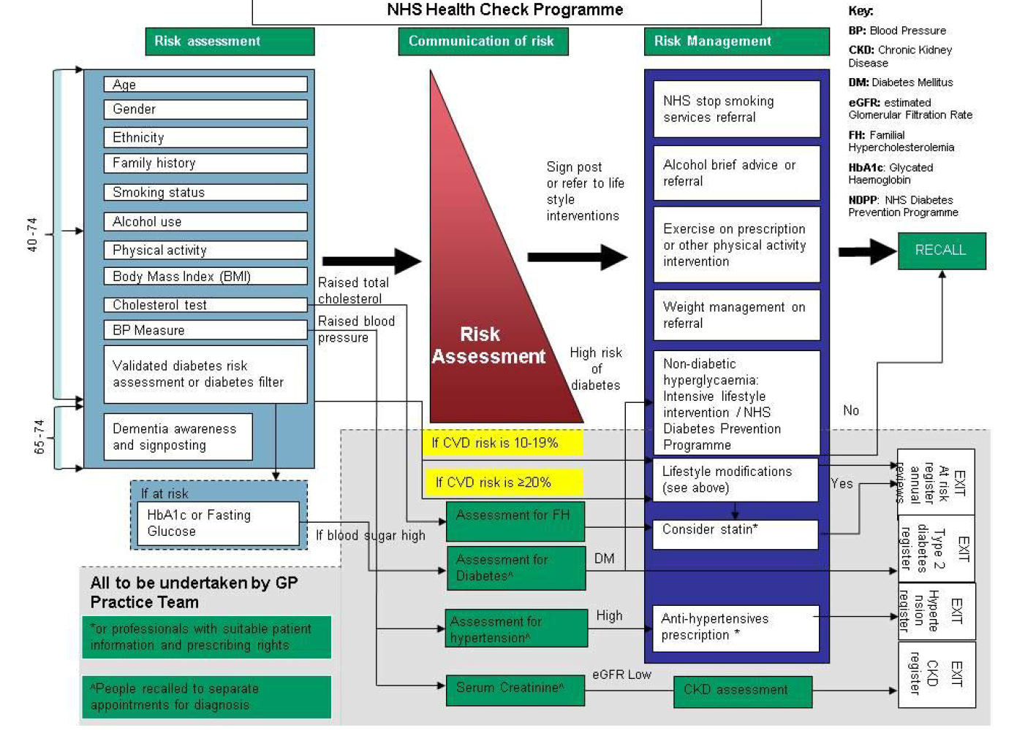
APPENDIX 2: Sample of effective invitation letter.
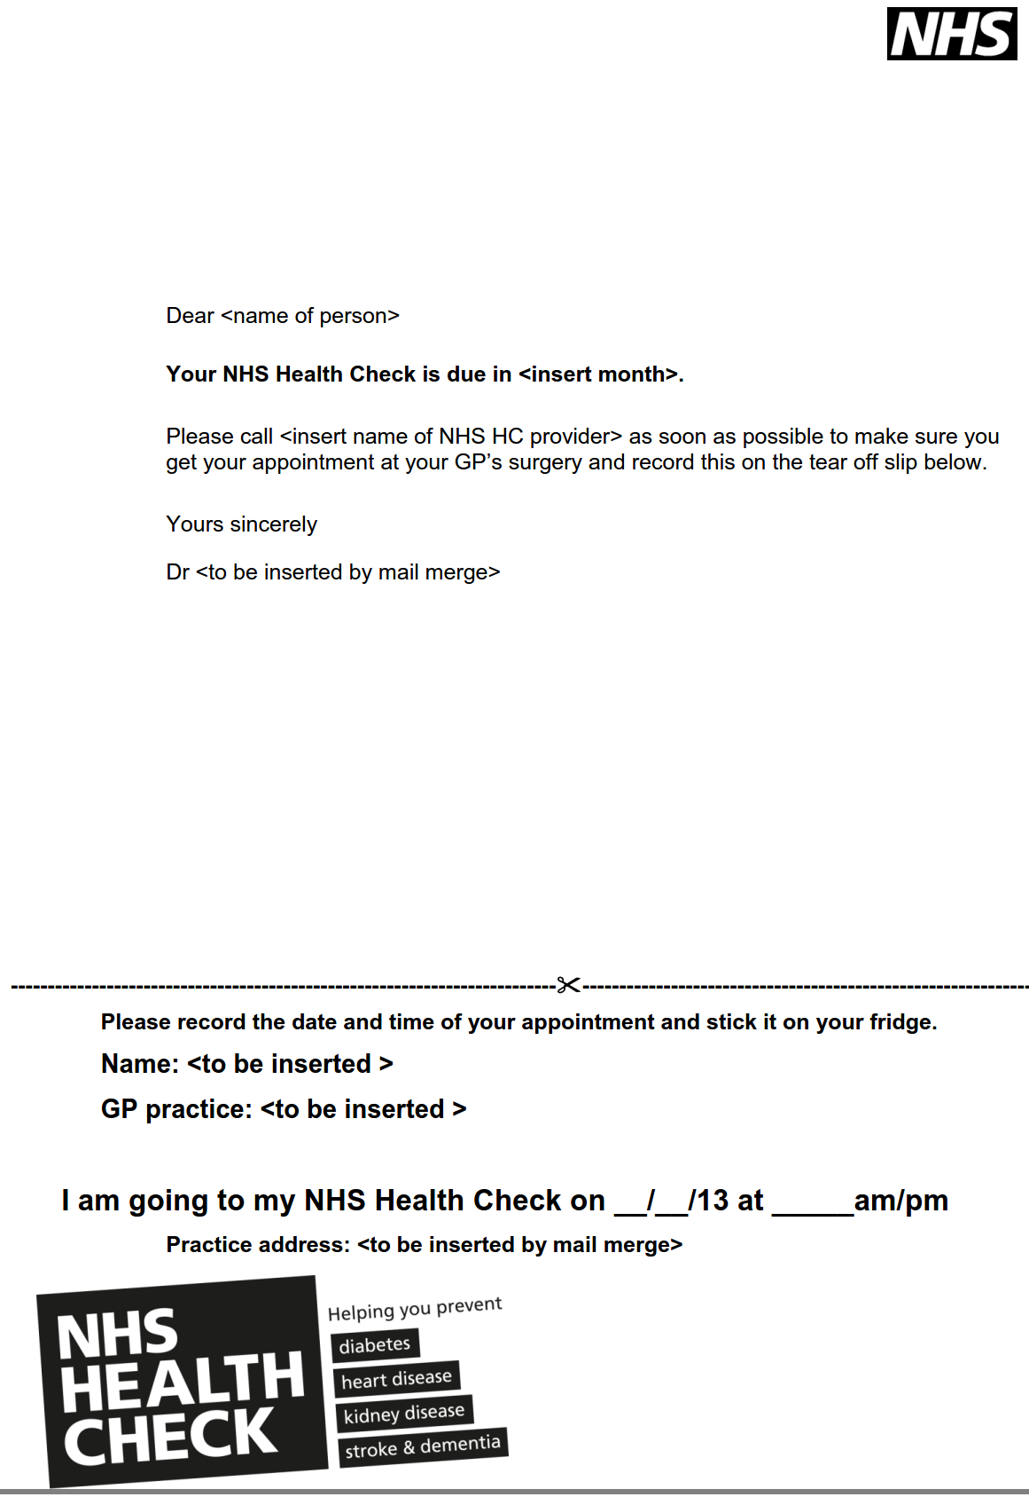

Appendix 3: Sample results leaflet. An updated version will be availabe in printed format from Cumbria County Council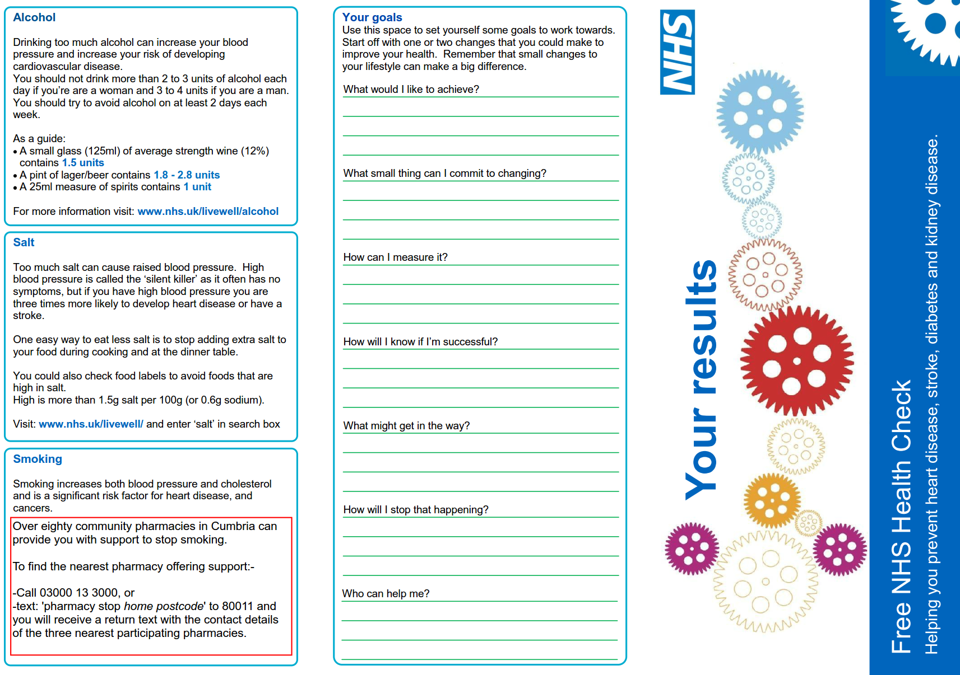

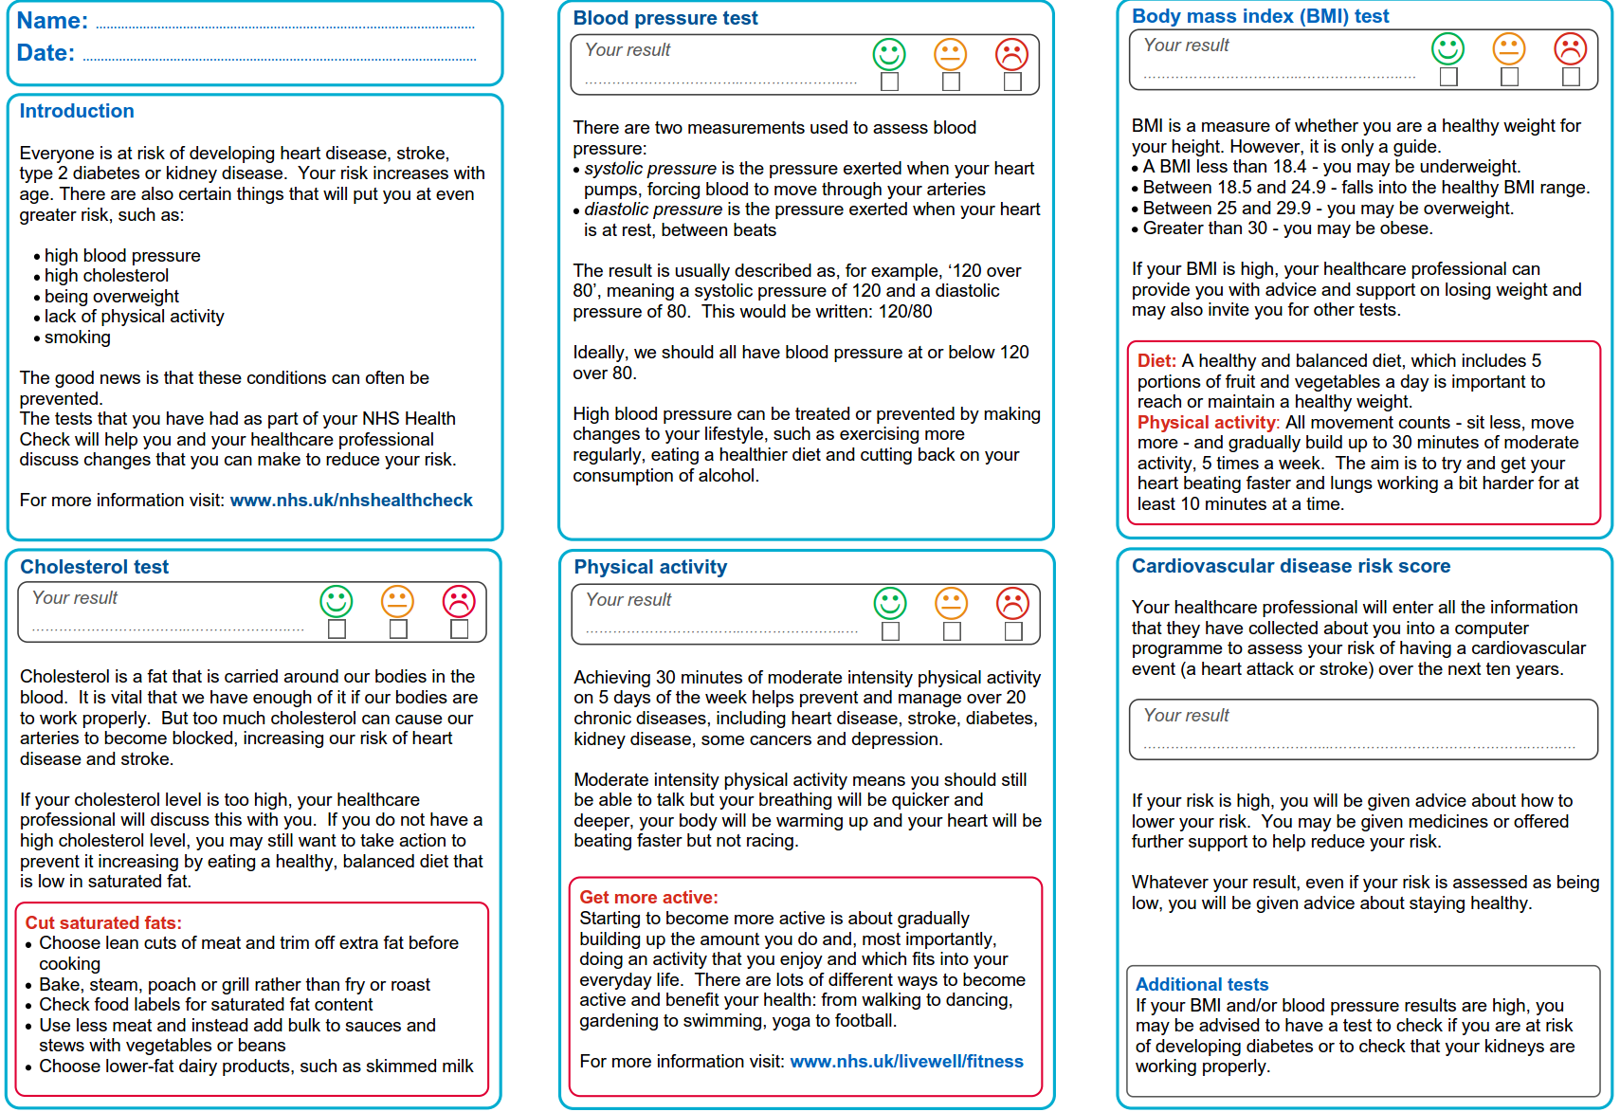

NHS (2005) Vascular Risk Assessment: Workforce Competences

