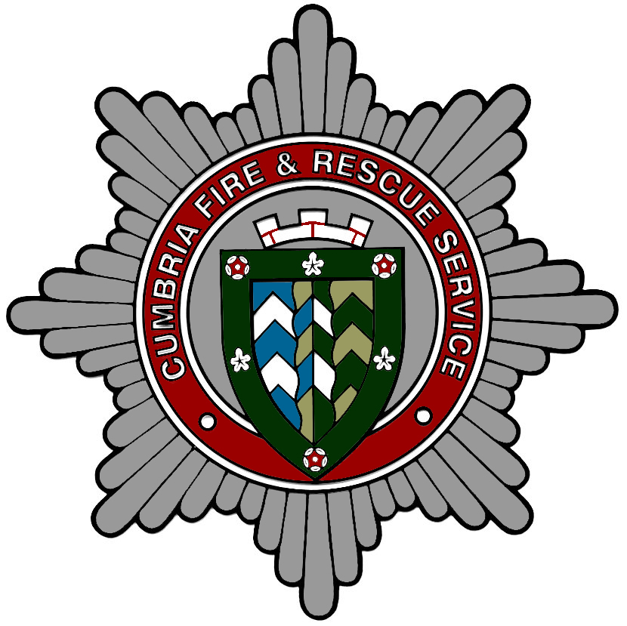

CUMBRIA FIRE & RESCUE SERVICE
ON-CALL FIREFIGHTER RECRUITMENT
Weekday ‘day’ 0600-1800 hours AND Weekends
(Friday 1800 – Monday 0600)

In order to apply YOU MUST live or work within 5 minutes of the station

Thank you for your request for an application pack for the post of On-call firefighter. Enclosed is:

1. Application Form – Please complete the enclosed Cumbria County Council application form and the form headed ‘Supporting information for On-call Application’. DO NOT send a Curriculum Vitae (CV), only completed application forms will be considered.

2. Availability Form (124a) – Please complete form 124a carefully following the instructions on the form. Please Note: It is important that you specify the actual number of hours available as this will become a contractual commitment if you are appointed.

3. Employer’s Consent Form - If you are employed and you wish to give cover during your working hours you must ask your employer to sign the Employer’s Consent Form.

4. Job Description and Person Specification – You will need to refer to this document when completing the application form.

5. Asylum and Immigration Act 1996 - for your information.

CUMBRIA FIRE & RESCUE SERVICE UNDERTAKE A ROLLING RECRUITMENT
CAMPAIGN AND WE WILL ADVERTISE FOR NAMED STATIONS AND RECEIVE APPLICATIONS AT SPECIFIC TIMES THROUGHOUT THE YEAR. IF THE SITUATION CHANGES AT YOUR LOCAL STATION BY THE CLOSING DATE, YOU MAY STILL BE INVITED TO ATTEND THE SELECTION PROCESS AND IF SUCCESSFUL, YOUR APPLICATION WILL BE HELD ON A RESERVE LIST FOR A SET PERIOD OF TIME – DEPENDENT ON WHAT STAGE OF THE PROCESS HAS BEEN COMPLETED.

Please return completed items 1, 2 and 3 (if applicable) to:

ON-CALL APPLICATIONS
People, Development, Assurance
Cumbria Fire & Rescue Service
Penrith Community Fire Station
Carleton Avenue
Penrith
CA10 2FA

Closing Date – the closing date for receipt of applications is 22nd May 2022.

If you are selected to go forward to the next stage, you will be invited to the physical tests/written tests week commencing 20th June 2022 at venues across the county, currently (but may change):

- Barrow Fire Station – Monday 20th June 2022
- Kendal Fire Station – Tuesday 21st June 2022
- Workington Fire Station – Wednesday 22nd June 2022
- Carlisle East Fire Station – Thursday 23rd June 2022

Please note that you must pass the physical/written tests to go forward to the next stage, which are the Interviews. These are expected to be held week commencing
4^{th-} 8th July, 2022 at venues across the county.

Fitness Guidance - Please take note of the fitness guidance, as you will be tested for your level of fitness. If you do not reach the required fitness standard at the physical tests then your application cannot be taken any further during this recruitment campaign and we would like to reapply in our next recruitment campaign in a few months time.

For further information:
https://www.fireservice.co.uk/fitness/

Medical Examinations for selected candidates will be held at Penrith Community Fire Station on
- Wednesday 27th July 2022
- Wednesday 3rd August 2022
- Wednesday 17th August 2022
NB: Please note that attendance at the above tests, interview and medical examination is purely voluntary and the Service will not pay any expenses.

If you are offered a position as an On-call firefighter you will be required to attend a Training Course and Induction Programme which takes place as follows:

Training Course
Induction Day – 8th September 2022

Week 1
Initial Training
12th-16th September 2022

Week 2
Breathing Apparatus Course
Fire Behaviour Training
19th-24th September 2022

We may offer other dates for inductions and training courses in September if have a large number of applicants.

On-call Firefighters
On-call firefighters are an essential part of the Fire & Rescue Service which serves rural communities. They respond to pagers when an emergency call is received and must live or work within five minutes of the fire station. Clearly, flexibility is key and you will need to be either at home, self-employed or have an employer who is supportive and willing for you to leave work at a moment’s notice to attend an emergency.

What's involved in being an On-call Firefighter?
As a firefighter you will be called upon to tackle a wide range of emergency situations where your problem solving skills and initiative will be vital to resolving issues quickly and calmly. Incidents vary from tackling fires and rescuing people from burning buildings to dealing with chemical spillages and road traffic collisions. A sensitive approach will be required when dealing with members of the public who may be distressed and confused.
There is also the opportunity to work closely with the community to increase the level of awareness and so prevent incidents from occurring in the first place. Being able to communicate effectively to schools, community groups, voluntary organisations and others is important, as is treating people with dignity and respect regardless of their background or culture.

FOUR STAGES TOWARDS BECOMING A FIREFIGHTER

Stage 1: Initial Application
The completion of the application form is your opportunity to describe the knowledge, experience, personal skills and attributes that you have for the role of ‘On-call’ Firefighter. The application form asks you to demonstrate how you meet the requirements of the role and you should tailor your responses to show how you meet the essential and desirable elements of the job as described in the person specification. When completing the application form, you should draw on any of your experiences from home life, leisure activities; work (paid or unpaid) voluntary work or education and provide examples to demonstrate how you meet each element described in the person specification.
The Fire & Rescue Service is guided by the Equality Act 2010 and has a legal duty to consider making reasonable adjustments for all applicants who declare any disability. The legislation is intended to ensure that disability should not debar an individual from a job unless it would genuinely and significantly impede that person from doing the work and there is nothing the employer could reasonably be expected to do to overcome this.
If you would find it helpful to have a copy of the Application Form in another language, please contact The Recruitment Team straightaway on 07795 521 942. NB. Returned Application Forms must be completed in English.

Stage 2: Physical Tests
Initially you will be asked to complete a 20 metre bleep test to level 8.8 or the 12 minute Chester Treadmill Test.
Please bring appropriate clothing and footwear.
The other tests which assess an applicant’s physical competence and their confidence and ability to follow instructions include: Ladder Climb, Ladder Lift, Enclosed Space, Equipment Assembly and Equipment Carry. Your grip strength will also be assessed.

Stage 3: Written tests
This section consists of mental agility tests.

Stage 4: Interview, References and Medical
You will be asked questions relating to your knowledge, skills and attributes to determine your suitability for the role of a Firefighter. At the interview stage, ensure you are well prepared, have done research into the Fire & Rescue Service and the post you hope to fill, turn up on time and in a presentable manner.
References will only be sent for if you are successful at interview, prior to your medical. You will need to supply one personal referee and details of your current or previous employer for references to be obtained. Please ensure you have the referee’s permission to provide their details on your application form. Where suitable references are not provided, an offer of employment will not be made.
Please note references cannot be from a spouse, partner or relative.

You will be asked to attend a medical where you will be examined by the Occupational Health Physician and we may request a copy of your medical records from your GP. You will be asked to complete a questionnaire covering your medical history and the medical will include a physical examination and a range of tests including: hearing test, lung function, blood pressure test. You must bring evidence of your eyesight standard to the medical examination.

Equal Opportunities
The Authority is an Equal Opportunities employer. The Service's policy is to ensure that no applicant or employee receives less favourable treatment on the grounds of sex, race, colour, nationality, ethnic origin, sexual orientation, religion/belief, age or marital status.

Positive Recruitment Action
We are working towards achieving a Fire and Rescue Service that is representative of our community and we will support and encourage applications from currently underrepresented groups such as women and black and minority ethnic groups.

Health and Fitness
You must be able to pass physical fitness tests. You must be able to pass the medical examination designed to ensure you can safely undertake firefighting duties.

Firefighter Eyesight Standards
Cumbria Fire and Rescue Service require candidates to meet the eyesight standards for the Fire Service and DVLA Group 2 licence.

Further information is available at https://www.fireservice.co.uk/recruitment/eyesight/

Normal colour vision or slightly abnormal red/green colour vision are acceptable. If a candidate does not pass the Ishihara test performed by the optician, then two further tests can be undertaken by Occupational Health to determine the severity and type of colour vision deficiency.

Refractive Eye Surgery
Successful laser eye surgery is compatible with working as an operational firefighter (except for Radial Keratotomy, which is NOT allowable). However, we would not allow you to join the fire service until at least 12 months have elapsed from the date of your surgery, and we would also expect you to provide us with the following information to ensure that the surgery has been successful:

- A statement from an optometrist stating that the surgery had been successful.
- A statement from an optometrist that a slit lamp examination is normal.
- Results of vision tests done in low lighting conditions (such as a LogMAR test or Pelli Robinson chart test).
- Results of your eye examination tests before you had the laser eye surgery performed. If your vision was very poor prior to the surgery (i.e. worse than -6.00 diopters for myopia and +4.00 diopters for hypermetropia), you remain at risk of certain eye problems and at these levels, we would not be able to accept you into the fire service.

If you do have concerns about your eyesight, we would highly recommend that you speak to your optician to discuss your eyesight standards and refer to the eye standards form enclosed. This is to avoid disappointment further into the recruitment process.

Alternatively, please call our Occupational Health Department on 01768 812556.

Hearing Standards

It is essential that you have a reasonable standard of hearing for this post. If you have ever been seen by a consultant because of your hearing, please provide us with full details so that we can consider if it is necessary to contact your consultant, with your consent.
Please note the Authority cannot be responsible for any cost incurred by individuals in this respect.

Training
The period of training is very arduous and requires stamina on your part to enable you to cope successfully with the many demanding aspects of initial training and you are advised to prepare yourself mentally and physically in advance. Training is an ongoing process and continues throughout your career to meet the ever changing problems and hazards handled by the Service; for example, lectures and practical demonstrations of, safety procedures and usage of newly developed specialist equipment. There are many specialist skills required in the Fire & Rescue Service and thorough training is always given.

Initially you will work on learning the skills and acquiring the necessary underlying knowledge to perform the role of firefighter. This is likely to include activity at a number of Service locations.

You must successfully complete a 2 year probationary period and demonstrate your suitability for the role to secure a permanent contract. Progression to competent firefighter status depends on you achieving and maintaining competent standards of performance. You will then be expected to undertake ongoing training and learning as described below in order to maintain your competence.

You will complete the required training in the core skills of the role in order to achieve competence plus other training courses as the Chief Fire Officer deems necessary which includes the satisfactory completion of a Breathing Apparatus Wearers’ Course and subsequent refreshers.

Availability Form (Form 124a)
This form is a contractual commitment and you will be expected to be available for the hours that you have stated (your Line Manager will monitor this). So, be realistic about the commitment you can give, bearing in mind the hours needed for your primary employment and that individuals normally welcome time out for family and other interests.

On-call Working Arrangements – Firefighters
Contract will be for limited (less than 120 hours) or full cover (120 hours) plus completion of 126 (128 if less than 5 years continuous service on this duty system) hours of training per year to cover core training requirements.

Fixed monthly pay will consist of retainer, core training and annual leave. Variable monthly pay will consist of turnouts, attendances, other duties payable at hourly rate.

Completion of core training – each On-call Firefighter must attend 94 hours of Core Training either at the scheduled Drill Nights at their employing station or alternative scheduled training event as part of their contractual requirement.( 96 hours if less than 5 years continuous service on this duty system)

In addition, the service will pay
A combined 32 hours of self-development to include Learnpro to prepare for training activity/courses/assessments, and then to record activities on PDRpro.

This gives a total of 126 hours (128 hours if less than 5 years)

Catch up drills are permissible providing that the hours are spent on training activities set out in the core training requirements which the individual has not already completed in the year. Catch up drills will not be permissible for any activity other than core training.

It is expected that the majority of the training will be delivered at an individual’s employing station. If an On-call Firefighter chooses to attend a learning event at a different location for their own convenience, no mileage or travel time will be payable. If the Service requires an On-call employee to carry out training at a location other than their employing station, travel time and reimbursement of mileage if the journey is made in employee’s vehicle will be payable (need to have business insurance).

Quarterly review of training completed and programmed will be carried out by the manager to check whether an individual has completed the expected training activity and number of hours. Any shortfalls will be discussed with the employee and remedial action (written letter setting out agreed approach to next 3 months and consequences of failure to meet this) will be taken.

Annual Leave
Four weeks paid leave a year on entry (including weekly training session) and five weeks after 5 years continuous service.

Pay
The rates of pay for a firefighter are as follows:

Role | Full Cover Retainer for providing 120 hours per year | Limited cover Retainer for providing less than 120 hours per year | Hourly rate
Firefighter  Trainee | £ 2,419 | £1,814.25 | £11.05
Firefighter Development | £2,520 | £1,890 | £11.51
Firefighter Competent | £3,224 | £2,418 | £14.72

Pension Scheme
Membership of the Firefighters’ Pension Scheme 2015 is automatic for all new entrants.

Health and Safety
Under the Health and Safety at Work Act 1974, the Authority, has a duty to ensure the safety, health and welfare at work of its employees. It has a duty to consult about arrangements for joint action on health and safety matters, to prepare and bring to the attention of all staff a written statement of its safety policy and, in certain circumstances, to establish safety committees.

The Act places certain duties on employees. Employees have a duty to care for the health and safety of themselves and of others that could be affected by their act or their negligence. In addition they are required to cooperate with the employer and carry out or comply with any duty imposed on them under statutory provisions.

The Authority aims to fulfil its legal obligations and expects its employees to do likewise. Certain requirements are imposed on firefighters for health and safety reasons. For example: hair must be styled such that it does not impair the air seal of the face mask of breathing apparatus; the use of make-up or hair preparations and the wearing of jewellery and watches is prohibited whilst you are on operational duty.

Further Useful Information Sources:

Contact recruitmentfire@cumbria.gov.uk for On-call firefighter recruitment and fitness advice.

National On-call recruitment campaign Need More? | On-call Firefighters (oncallfire.uk)

National Fire and Rescue Service http://www.fireservice.co.uk/recruitment

Firefit website http://www.firefitsteeringgroup.co.uk/nfst.htm

THANK YOU FOR YOUR INTEREST IN CUMBRIA FIRE & RESCUE SERVICE

