Environmental Services  Environmental Services  Central Operations  Temple Quay House  2 The Square  Bristol, BS1 6PN | Your Ref:  Our Ref:  Doc No:  Date: | APP/H0900/V/21/3271069  MKH.WES121.30  32382539v1  04 August 2021
By email:Environmentalservices@planninginspectorate.gov.uk
cc. Mark Kirkbride and Kevin Murphy WCM; developmentcontrol@cumbria.gov.uk; Paul.Haggin@cumbria.gov.uk; Erin.shearer@cumbria.gov.uk; niall.toru@foe.co.uk; mmcfeeley@richardbuxton.co.uk; Magnus Gallie <magnus.gallie@foe.co.uk> Humphrey, Elizabeth <ELIZABETH.HUMPHREY@planninginspectorate.gov.uk>
Dear Sirs

TOWN AND COUNTRY PLANNING (ENVIRONMENTAL IMPACT ASSESSMENT) REGULATIONS 2017 (‘THE 2017 EIA REGULATIONS’)

Application by: West Cumbria Mining Ltd

Site Address: Former Marchon Site, Kells, Whitehaven
We write further to our letter of 16 July and subsequent correspondence dated 28 July 2021 in which we enclose an extract of the Regulation 22 response to be issued by West Cumbria Mining Limited (WCM). As explained, the full response will be available at the beginning of September when it will be issued and advertised for formal consultation. This response deals with the eighth bullet point from the Inspector’s letter.
" • With regards to the description of the physical characteristics of the onshore mining area, this is described in Chapter 5 of the 2018 ES as being 302ha in size, while Chapter 1 of the 2018 ES describes it as being 187ha in size. The correct size of the onshore mining area, as well as the total site area for the application proposals, should be confirmed."
In the interests of transparency and co-operation WCM have voluntarily issued this early response to assist the Inspector and so as not to unnecessarily delay the Inquiry. The Council and Rule 6 parties are duly notified of this information by way of copy.

Yours faithfully
Ward Hadaway LLP

(enclosures)

+44 (0) 330 137 3532
kamran.hyder@wardhadaway.com

8. Regulation 22 – Area of Mining

8.1 Introduction – Regulation22 Requirement
With regards to the description of the physical characteristics of the onshore mining area, this is described in Chapter 5 of the 2018 ES as being 302ha in size, while Chapter 1 of the 2018 ES describes it as being 187ha in size. The correct size of the onshore mining area, as well as the total site area for the application proposals, should be confirmed.

8.2 WCM’s Response

WCM can confirm that the total red line boundary area is 570ha – Drawing 869/AP/001 Rev F (reproduced below) shows the total red line boundary area.
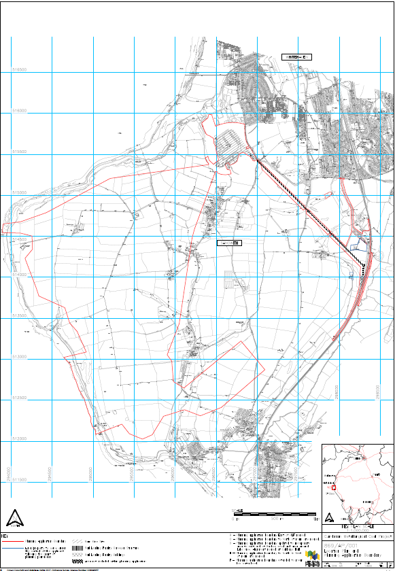
In the extract of the total red line boundary area shown below, the onshore area coloured orange and appropriately annotated shows the extent of the onshore mining area. This area is confirmed as being 302ha in extent.
The figures previously provided in Chapters 1 and 5 for the onshore mining area are different because the figures were calculated at different stages of the application. Chapter 5 was updated after the original submission date of May 2017, following requests for further information from Cumbria County Council. As part of these updates, WCM’s mining engineers had updated their proposed mine plan in relation to the onshore mining area. Whilst the figure in Chapter 5 was updated, unfortunately the figure in Chapter 1 was not updated, by omission.
All of the onshore mining area is incorporated in the red line boundary of the planning application.

