Consent for Information Sharing and Storage Appendix 1

I agree to the gathering and sharing of information on this form with agencies who are or may become a member of the Team Around the Family (TAF) so that they can help to provide the right support for my child, young person and family. If I am a young person and believed to be mature enough and can understand the implications of the assessment, I can consent to an EHA without parental consent (Gillick Competencies/Fraser Guidelines).

To consider an Education Health Care Plan (EHCP) this might include Education Services, Health and Social Care.

I agree that any personal information provided by me on this form will be treated in accordance with the provisions of the Data Protection Act 1998. My family’s details and the circumstances of the assessment will be held on the Cumbria County Council Databases for statistical monitoring, evaluation, and audit quality monitoring process. It may also be used to inform agencies if an Early Help Assessment is in place. I am aware that I can withdraw consent for this assessment at any time and request that my registration details be deleted from the data storage system.

If at any point people working with your family believe that the children or young people are at risk of significant harm they will follow the Cumbria Safeguarding Procedure and consider referring to Children’s Services for further assessment.

Comments

Family Assessment Co-ordinator
Signed
Name
Date

All Early Help Assessments – Signs of Well-being and Success need to be registered with the Early Help Team using the Online EHA Registration form on the Cumbria Safeguarding Children Partnership website. To request for a Local Authority specialist support service please complete the EHA and return the whole document including the Local Authority (LA) Specialist Support Request (Appendix 2)with any additional documentation to the address specified on the SEND in the EH process page on the CSCP website.

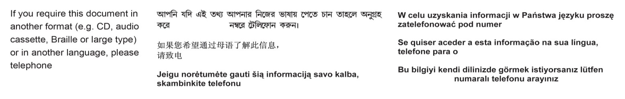
01228 606060

