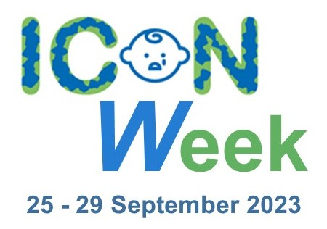

COMMUNICATIONS TOOLKIT

www.iconcope.org/iconweek2023

#ICONWeek2023

V1.0
Table of Contents
Background 3
About ICON 3
press release (please localise) 4
Website, Intranet and newsletter Copy 6
Webinar programme 7
Social media CALENDAR 8
Artwork and graphics 9
Microsoft Teams backgrounds 9
Email footer 10
Social media videos and graphics 10
Social media videos 11

Background

About ICON

The idea for the ICON programme and the different interventions within it was conceived by Dr Suzanne Smith PhD following a Winston Churchill Memorial Trust Travel Fellowship to the USA and Canada in 2016 which included the study of effective interventions and research into the prevention of Abusive Head Trauma (AHT). Research suggests that some lose control when a baby’s crying becomes too much. Some go on to shake a baby with devastating consequences.

Suzanne found that the most effective evidence-based programmes studied provide a simple message that supports parents/caregivers to cope with infant crying. Apart from preventing AHT, most people who have ever cared for a baby appreciate some advice about comforting a crying baby and coping when it goes on for a long time.

ICON is about helping people caring for babies cope with crying.

ICON stands for ….

I Infant crying is normal
C Comforting methods can help
O It’s OK to walk away
N Never, ever shake a baby

Speak to someone if you need support such as your family, friends, midwife, GP or health visitor.

More information and a wealth of resources are available on the ICON Cope website – www.iconcope.org

press release (please localise)

ICON Week 2023: Raising awareness of infant crying and how to cope.

“Babies cry, you can cope!” is the message from NHS, local authorities, and healthcare organisations across the country who have come together this September to promote lifesaving messages to parents.

Research shows that some parents and caregivers can lose control when a baby’s crying becomes too much. Some go on to shake a baby with devastating consequences.

Abusive Head Trauma (AHT) causes catastrophic brain injuries, which can lead to death, or significant long-term health and learning disabilities.

ICON is a programme adopted by health and social care organisations in the UK to provide information about infant crying, including how to cope, support parents/carers, reduce stress and prevent abusive head trauma in babies.

The third annual ICON week, spanning from 25 September – 29 September 2023, aims to raise awareness of infant crying and how to cope in a bid to support parents/carers and prevent serious injury, illness and even death of young babies as a result of these incidents.

The evidence-based programme consists of a series of brief interventions that reinforce the simple message making up the ICON acronym:

I Infant crying is normal and it will stop
C Comport methods can sometimes soothe the baby and the crying will stop
O It’s OK to walk away for a few minutes if you have checked the baby is safe and the crying is getting to you
N Never ever shake or hurt a baby

Most babies start to cry more frequently from two weeks of age, with a peak usually being seen around 6-8 weeks. Organisations coming together from 25 September – 29 September, aim to spread the messages to help normalise infant crying and share coping techniques to help parents to deal with the stress it can cause.

Nurse, health visitor and founder of ICON, Dr Suzanne Smith, said: “Abusive head trauma can occur in any environment when a parent or carer is on the edge due to infant crying.

“The pressure that families are under is only being exacerbated by added pressures of the cost-of-living increase and the impact can be far-reaching and have devastating consequences.

“ICON is about sharing messages of support and advice to parents and carers who might be struggling to cope. We want to normalise the fact that babies do cry and some aren’t easily soothed and we want to share information far and wide about what to do in these situations and how to stay calm.

“By sharing these vitally important messages and coping techniques to carers, we are working towards reducing the risk of harm to babies and protecting them from AHT which is utterly preventable.

“Anyone who needs help and is struggling to cope, don’t continue to struggle. Help is available from your midwife, health visitor, GP or go online and there are more resources on our ICON website.”

For more information visit www.iconcope.org/iconweek2023.

ENDS

Website, Intranet and newsletter Copy

ICON Week 2023

The third annual ICON week (25 to 29 September 2023) is here to raise awareness of infant crying and how to cope to support parents/carers and prevent serious injury, illness and even death of young babies as a result of Abusive Head Trauma that happens when someone shakes a baby.

ICON is a programme adopted by health and social care organisations in the UK to provide information about infant crying, including how to cope, support parents/carers, and reduce stress.

This year’s ICON Week is once again focussing on sharing ideas and best practices. Many webinars are taking place throughout the week and are open to everyone. For more information and joining instructions, please visit www.iconcope.org/iconweek2023

Webinar programme

Monday 25 September
10:30-10:35 | Sue Anslow, ICON Programme Manager - Welcome to ICON Week
10:35-10:50 | Dr Suzanne Smith PhD ICON Founder & Programme Advisor - Introduction
10:50-11:00 | Jane Scattergood – A few words from our Chair
11:00-11:15 | Sue Anslow - Feedback from Audit
13:00-13:30 | Joanna Garstang – Birmingham Videos
14:30-15:00 | Laura Kefford and Monica Davis - Raising awareness of ICON and abusive head trauma within the multi-agency
Tuesday 26 September
10:00-10:30 | Craig Johnson – SCPHN/Clinical Advisor for School Health for SSAFA, based in British Forces Cyprus Delivering ICON to the teenage audience
11:00-11:30 | Tilly Pillay and Vijay Jobanputra STORK Programme and ICON
13:30-14:00 | Eleanor Marcham - Team Leader 0-19 service Locala’s approach to ICON and male inclusivity
15:00-15:30 | Fran Acharya – ReachDeck - An accessible website for all
Wednesday 27 September
10:00-10:30 | James Footitt Account Director, Bauer Media - Get Our Message Heard
11:00-11:30 | Lois Fisher Deputy Clinical Lead- ICON - Update from 0-19 HCP across Cambridgeshire and Peterborough
13:30-14:00 | Dr Giles Haythornthwaite - Consultant Paediatrician - Why the Major Trauma network in the UK are stakeholders in parent advice at birth and support the ICON message
15:00-15:30 | Deborah Gibbons - Safeguarding Midwife, Carla Clarke – Named Midwife Safeguarding, and Karen Turzynski - Clinical Practice Lead ICON Developments in Lancashire
Thursday 28 September
10:30-11:00 | Krishnen Sawmynaden and Professor Anna Tarrant - Rethinking Dads
12:00-12:30 | Emma Davis - Senior Probation Officer Warrington - Probation and ICON
13:00-13:30 | Jonathan Hill Brown, Karen Tyson-Lee and Monica Davis - MECSH and ICON in Harrow Health Visiting
14:30-15:00 | Dr Rachael Jolley - ICON in General Practice
Friday 29 September
10:00-10:30 | Kieran Anders - Dad Matters and ICON
10:45-11:30 | Parents Ambassadors
11:30-12:00 | Final thoughts and close from Dr Suzanne Smith
All webinars are on Microsoft Teams and available at this link www.iconcope.org/webinar-iconweek2023

Full details are available on our website: www.iconcope.org/iconweek2023

Social media CALENDAR

MONDAY 25 September | It's finally here! #ICONweek2023.  Our exciting week of webinars includes speakers from the military, police, GPs, parent ambassadors, health visitors, and the education section.  Visit www.iconcope.org/iconweek2023 for more details  #ICONWeek2023 #ICONcope | 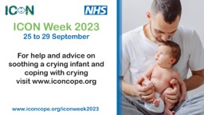
TUESDAY 26 September | If you have a baby that cries a lot, it can be exhausting and lonely. You are not alone.  Crying is normal. It is not your fault. It's ok to take a time out when you feel overwhelmed.  Keep baby safe, keep yourself safe.  #ICONcope  #ICONweek2023 | 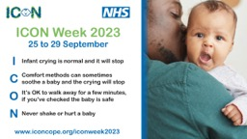
WEDNESDAY 27 September | Abusive head trauma can occur in any environment when a parent or carer is on the edge due to infant crying.  Make sure anyone looking after your child knows the ICON principles. https://iconcope.org/parentsadvice/  #ICONweek2023 #ICONcope | 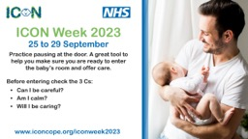
THURSDAY 28 September | There are lots of things you can do to help soothe your baby. Check out our top 5 tips to help with infant crying. The main thing to remember is to stay calm and never hurt or shake your baby. #ICONcope #ICONweek2023 | 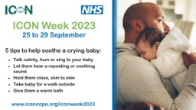
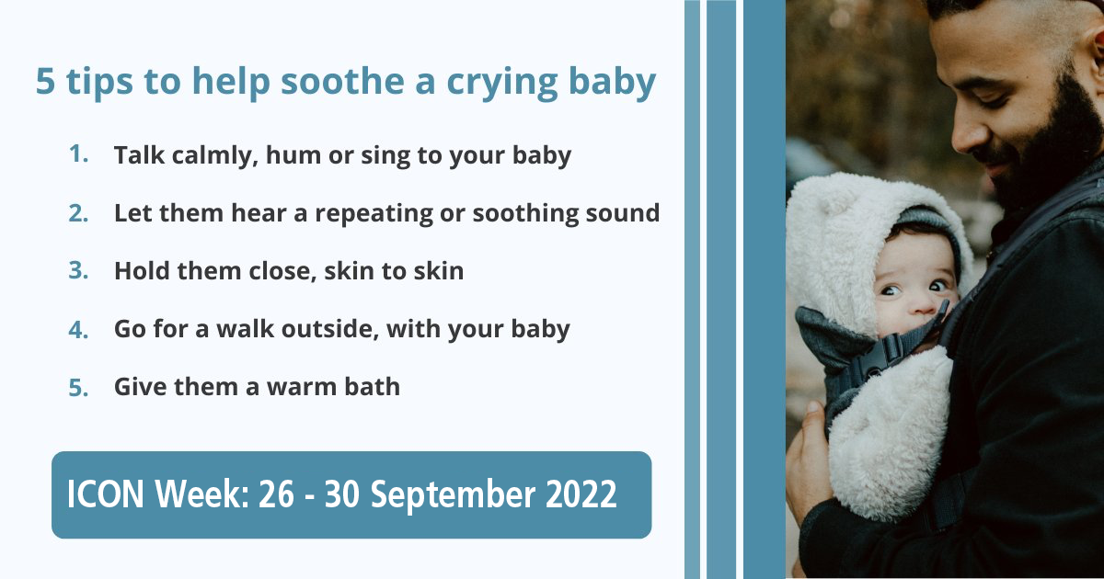FRIDAY 29 September | It’s tough when your baby won’t stop crying. You may worry something is wrong with your child, that you’ll lose your cool or that your parenting skills aren’t up to the job. But you can handle it!  * Take a break  * Ask for help  NEVER SHAKE YOUR BABY!  #ICONcope #ICONweek2023 | 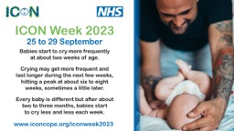

Artwork and graphics

Microsoft Teams backgrounds

Version 1
Version 2
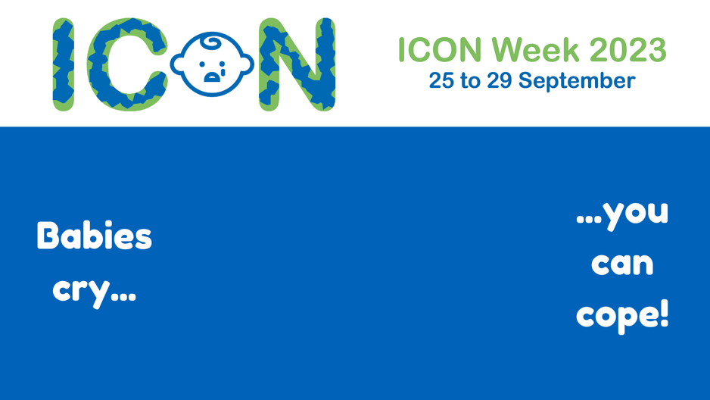

Email footer

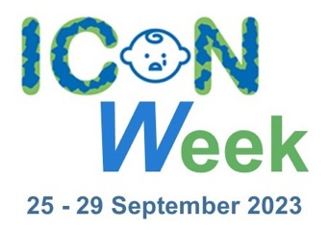

Social media videos and graphics

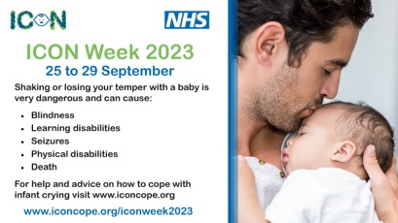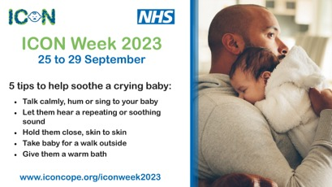

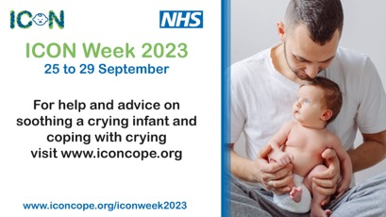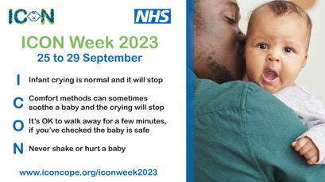

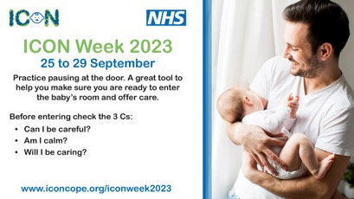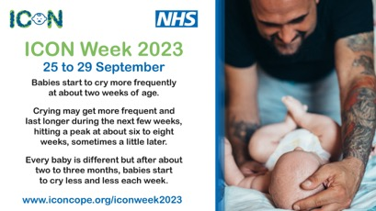

Included within the toolkit are all of the original ICON videos which can be used in addition to the graphics above.

Download all of the videos and graphics here

