R3 Topical Medication: Body Map

Topical Medicines Application Record

Service User Name | Date of Birth
Cream

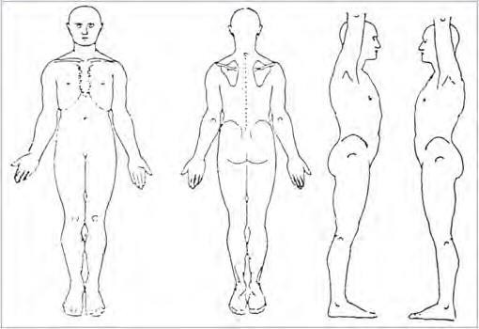
- Hands should be washed, and gloves worn for the application of topical medicines.
- According to the directions apply the medication to the areas marked on the diagram.
- Record on the MAR chart.
For information purposes:
  - Apply sparingly/thinly – means only a thin layer should be applied.
  - Apply liberally – means a more generous layer should be applied.

Report any concerns/issues to your RRO/SSW/Supervisor immediately and record in the communication record.

Where a product direction indicates that the cream / lotion / gel is flammable, the RRO/SSW/Supervisor must complete a Risk Assessment and add detail to the support plan.

