DIAG Workplace or Return to Work Assessment
Appendix 14
Name: | Date of Assessment
Area of Work

Assessors Details

Reason for Referral
History of Symptoms | Body Pain Chart  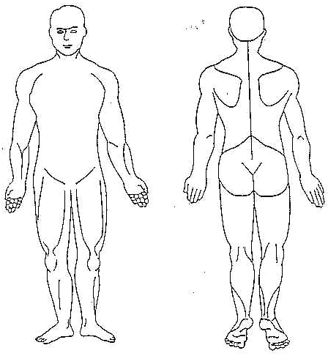
Limitations of Daily Living

Symptoms
Aggravate | Ease

Activity | Difficulties |  | Comments
 | Yes | No

Bending
Kneeling
Reaching
Tilting / Turning
Pushing / Pulling
Lifting / Carrying
Sitting
Standing
Walking
Hand / Wrist function
Other
Description of Job
Demands of Job
Environmental Factors
Recommendations | 1.  2.  3.  4.  5.  6.

Signatures Following Initial Risk Assessment
Assessors Signature: | Date:
Employee Signature: | Date:
Managers Signature: | Date:
Review Date:
Action Plan Following Recommendations

Signatures Following Action Plan Review
Assessors Signature: | Date:
Employee Signature: | Date:
Managers Signature: | Date:
Review Date:
Action Plan Review

Signatures Following Action Plan Review
Assessors Signature: | Date:
Employee Signature: | Date:
Managers Signature: | Date:
Review Date:
Action Plan Review

