Establishment: |  |  |  | Sheet Number:
Name of Service User:
Unit: |  | Start Date: |  |  | End Date:
Draw on the body map in black ink, firstly apply the number from the form on the reverse then using the following alphabetic code to indicate the different injury. (A ruler has been provided to assist with the measurement). Complete the form on the reverse.
Description of Injury / Marks using the code provided:
A: Pressure Ulcers B: Bruising C: Excoriation, red areas (not broken down) D: Cuts, wounds E: Scalds, burns F: Other (Specify)
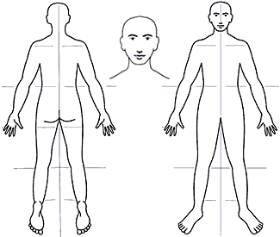

Date | Number | Code | Provide brief details for each mark / injury e.g measurement size, shape of wound, colour of wound bruise, etc. | Signature | ICASSS No if applicable
 | 1
 | 2
 | 3
 | 4
 | 5
 | 6
 | 7
 | 8
 | 9
 | 10
 | 11
 | 12
 | 13
 | 14
 | 15

