

**Wigton**

**Electoral Division Profile**

**2014**

# Overview of Electoral Division

# Wigton is a thriving market town in the district of Allerdale. The Electoral Division has a population of 6,653 and incorporates the parishes of Waverton, Woodside and Wigton which has a Town Council.

# The Electoral Division spans across the electoral wards of Waver and Wigton.

# Wigton is situated on the Solway Plain between the Solway coast and Caldbeck Fells, just south of Carlisle; it is often associated more with Carlisle, than with Workington, the largest town within the district of Allerdale.

# Wigton is home to a number of independent stores and small businesses, but also houses some larger firms including Innovia Films, Reays Coaches, VV Rouleaux and Hopes Auction Company. The largest employer within the ED is Innovia, known locally as ‘the factory’ Wigton is the global headquarters of the firm and employs 850 staff within the factory.

# The town has its own secondary school Nelson Thomlinson which was rated Outstanding in the Ofsted Report May 2013 and in 2012 the school achieved the International Schools award. The school attracts students from a wide area including Carlisle.

# Map

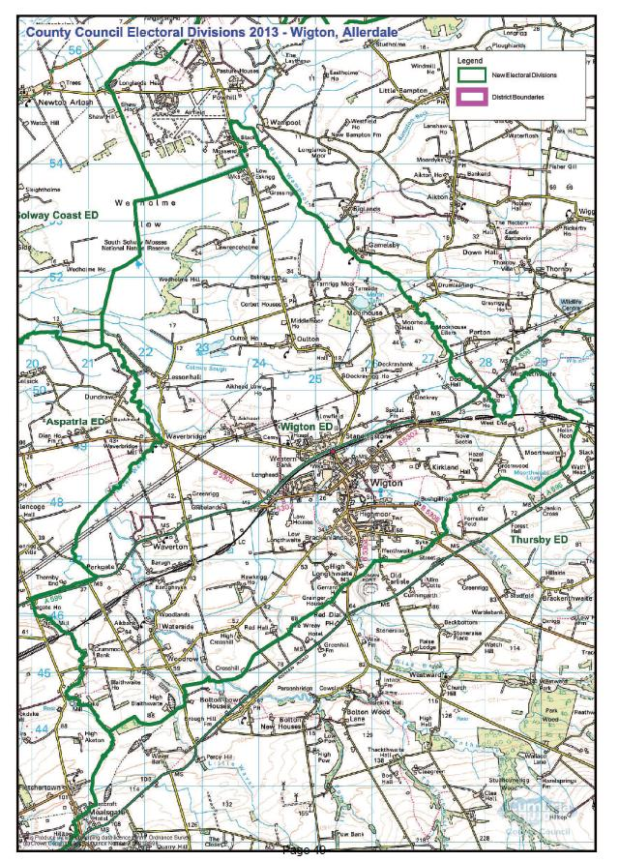

PDF copy of map: http://www.cumbria.gov.uk/Election2013/maps.asp

# Communities

# There are a number of villages and hamlets within the electoral division which are just outside of Wigton town these include:

# • Dockray

# • Lessonhall

# • Oulton

# • Tiffenthwaite

# • Waverton

# • Waverbridge

# • Waterside

# Statistical Profile

The 2011 Census estimated that the population of Wigton Electoral Division (ED) was 6653 persons.

The table below presents estimated numbers of residents in Wigton ED by age group:

|  |  |  |  |  |  |  |  |  |
| --- | --- | --- | --- | --- | --- | --- | --- | --- |
|  | **No. Persons by Age Group (Years)** | | | | | | | |
| **All Ages** | **0 - 14** | **15 - 29** | **30 - 44** | **45 - 59** | **60 - 74** | **75 - 84** | **85+** |
| *Wigton ED* | *6653* | *1102* | *1031* | *1260* | *1383* | *1241* | *455* | *181* |

*Source: Office for National Statistics, 2011 Census*

The chart below compares the proportion of Wigton ED’s population within each age group with the proportion of the population within each age group across Allerdale district, Cumbria and England & Wales:

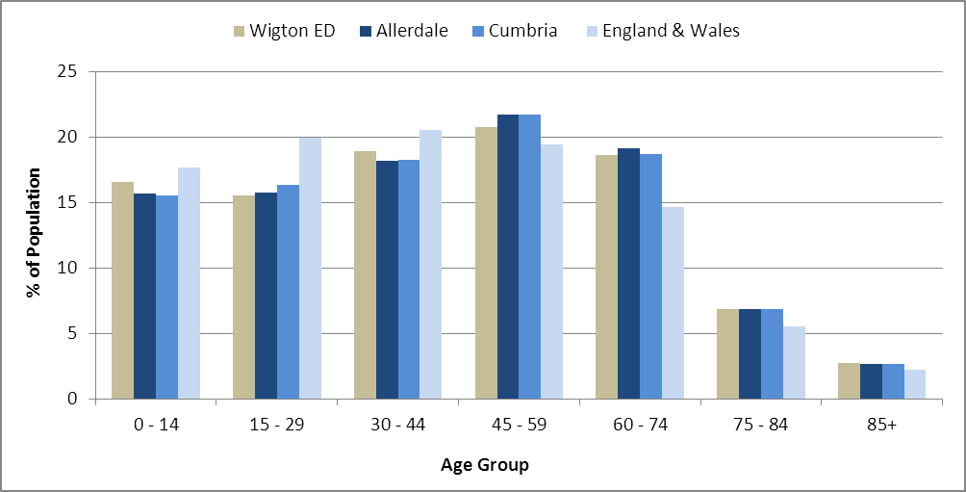

*Source: Office for National Statistics, 2011 Census*

County Council Electoral Divisions cover large spatial areas and so division averages can mask variation between communities within the division. Furthermore, beyond Census data, there is little statistical information available for Electoral Divisions. However, most statistical agencies produce data for Electoral Wards. Therefore, there is a very wide range of statistical information available for Electoral Wards. Furthermore, as Electoral Wards are generally smaller than Electoral Divisions, statistics at this level provide more insight into variations between communities.

The table below identifies which Electoral Wards are fully or partially within the boundaries of Wigton ED, and what proportion of Wigton ED’s population live within each ward:

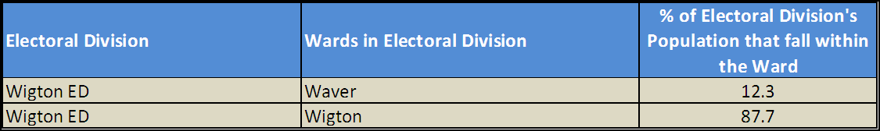

*Source: Cumbria Intelligence Observatory, 2013*

The map below overlays Electoral Ward boundaries on to Wigton ED’s boundary: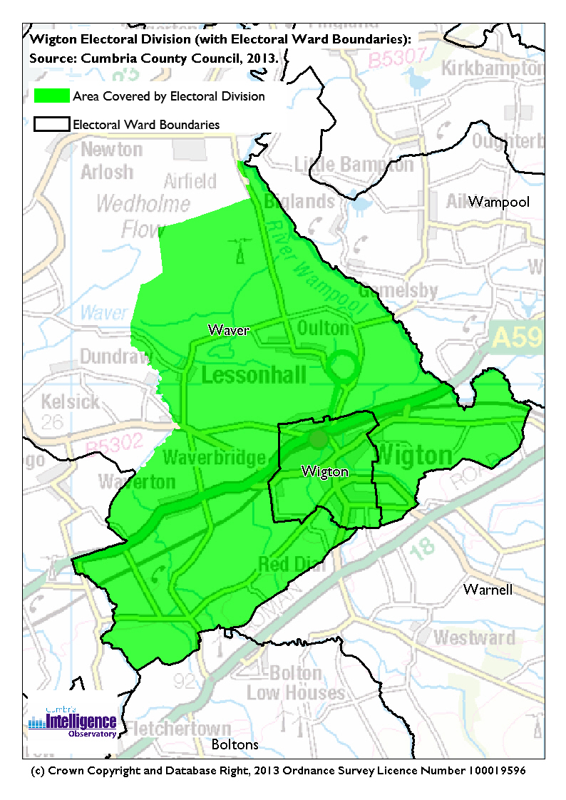The Cumbria Intelligence Observatory presents many Electoral Ward level statistics via the interactive ‘Cumbria Atlas’ tool. The Statistics provided within the Cumbria Atlas cover topics such as, but not limited to, population, housing, health, economy, poverty, ethnicity, language, and transport. The datasets within the Cumbria Atlas are regularly updated and expanded.

For simple step by step instructions to use the Cumbria Atlas to explore statistics for the wards within your Electoral Division, please visit the following web page:

<http://www.cumbria.gov.uk/eLibrary/view.asp?ID=56017>

The Information and Intelligence Team within Cumbria County Council are happy to talk you through using the Cumbria Atlas over the phone, or face to face. Training sessions can also be arranged for small groups.

To contact the team please call 01228 226309, or email [info@cumbriaobservatory.org.uk](mailto:info@cumbriaobservatory.org.uk)

# Parks, Open Spaces and Leisure Facilities

# Wigton Park

* Wigton Rugby Club
* Phoenix Park

# Wigton Pool

# The Millenium Walk

# Barton Laws Playing Fields

* Martin Tarn, Moorhouse
* Play areas at Wigton, Waverton, anywhere else?

# Active Community Organisations

# North Allerdale Development Trust

# Wigton Chamber of Trade

# Wigton Theatre Group

# Wigton Media Group

Pride In Wigton

Rotary Club of Wigton

St Mary’s Mothers Union

Wigton Children's Club

Wigton Community Centre

Wigton Theatre Club

Wigton Hospital League of Friends

# Sports Clubs:

# Wigton Swimming Club

# Wigton Rugby Union Football Club

Wigton AFC

# Wigton Wildcats Netball Club

# Wigton Hockey Club

# Wigton Bowling Club

# Wigton Cricket Club

# Wigton Boxing Club

Wigton Badminton Club

Wigton Gymnastics Club

Wigton Lawn Tennis club

Wigton Park Bowls Club

Wigton Road Runners Club

Wigton Trampoline Club

Wigton Squash Club

Wigton Stocksman FC

# Key Communication Networks

# Times and Star

# A weekly newspaper released on a Friday; with three main editions for Workington, Cockermouth and Maryport. Produced by CN Group

# Cumberland News

# A weekly newspaper released on a Friday bridging the east and west communities of north Cumbria. Produced by CN Group

# News & Star

# A daily newspaper for North Cumbria, produced by CN Group

# Cumberland & Westmorland Herald

# An independent weekly broadsheet newspaper covering a large area of East Cumbria, including the towns of Penrith, Appleby, Kirkby Stephen, Keswick and Alston.

Cumbria Crack

An online facility for News in Cumbria <http://www.cumbriacrack.com/>

# Radio Cumbria

# Local BBC Radio for the whole of Cumbria

# CFM Radio

# Local radio station produced by the Bauer Media Group, covering Cumbria and Southwest Scotland

ITV News, Border region

Programme news, weather and information provided by ITV Broadcasting Limited for the England/Scotland border region, covering the majority of Cumbria, Dumfries and Galloway, the Scottish Borders and parts of Northumberland.

<http://www.itv.com/news/border/story/2013-10-11/get-in-touch/>

BBC News – Look North (North East & Cumbria)

Look North is the BBC's nightly regional news programme for the North East of England and Cumbria

<http://www.bbc.co.uk/programmes/b0070g1d/faq>

# Wigton Town Council Website http://www.wigtontown.com/

Nelson Thomlinson School Newsletter

Parochial Parish Newsletters

# Community Assets

Schools:

Wigton Infant School

St Cuthberts Catholic Primary School

Thomlinson Junior School

Nelson Thomlinson School

Churches:

The Christ Church Waverton

Lowmoor, Evangelical Church

St Cuthberts Catholic Church

Wigton Methodist Church

The Friends’ School, Wigton

United Reformed Church, Wigton

St Mary’s Anglican Parish Church

Other:

Local Links Office

Wigton Market Hall

Wigton Fire Station

Wigton Public Swimming Pool

Wigton Library & Registration Office

Wigton Community Hospital (Highfield Hospital)

Wigton Youth Station building

Wigton Train Station

Wigton Theatre

Masonic Hall

Wigton Bowling Club

Wigton Monument Fountain

# Local Cumbria County Council Service Hubs

|  |  |
| --- | --- |
| **Service Type** | **Service Point** |
| Adult Education Centres | Wigton Adult Ed |
| CCC Swimming Pools | Wigton Public Swimming Pool |
| Childrens Centres | North Allerdale Children's Centre |
| Doctors Surgeries | Wigton Group Medical Practice |
| Fire Stations | Wigton |
| Hospitals | Wigton Community Hospital (Highfield) |
| Household Waste Recycling Centres | Wigton HWRC |
| Libraries | Wigton Library |
| Local Links | Wigton |
| Registration Offices | Wigton Register Office |
| Primary Schools | Thomlinson Junior School |
| Primary Schools | Wigton Infant School |
| Primary Schools | St. Cuthbert's Catholic Primary School |
| Secondary Schools | The Nelson Thomlinson School |

# Community Engagement

Wigton forms part of the North East Allerdale Neighbourhood Forum which includes the areas of Bothel & Wharrells; Thursby and Wigton. The Forum will meet up to three times a year to discuss local concerns and issues. For more information please contact Allerdale Area Support Team (see key contacts)

|  |
| --- |
| Key Community Contacts |
| Councillor Roger Liddle, Wigton, Cumbria County Council   * Address: Holme Cultram House, Abbeytown, Wigton, CA7 4SP * Phone: 016973 61665 * Email: Roger.Liddle@cumbria.gov.uk * Web: www.cumbria.gov.uk |
| Allerdale Area Support Team, Cumbria County Council   * Address: Workington Library, Vulcans Lane, Workington, CA14 2ND * Phone: 01900 706015 * Email: allerdaleteam@cumbria.gov.uk * Web: www.cumbria.gov.uk |
| Wigton Town Council   * Address: Community Office, Market Hall, Church Street, Wigton, CA7 9AA * Phone: 016973 44106 * Email: wigtontown.council@btinternet.com * Web: http://www.wigtontown.com/ |
| Allerdale Borough Council   * Address: Allerdale House, Workington, Cumbria, CA14 3YJ * Phone: 01900 702702 * Email: enquiries@allerdale.gov.uk * Web: http://www.allerdale.gov.uk/ |
| Waverton Parish Council   * Address: Allandale, Waverton, Wigton, CA7 0AE * Phone: 016973 43805 * Email: wavertonpc@btinternet.com |
| Woodside Parish Council   * Address: 16 Solway Drive, Anthorn, Wigton, CA7 5AW * Phone: 016973 51687 * Email: mike_anthorn38@hotmail.com |
| Local Links Wigton   * Community Office, Market Hall, Church Street, Wigton, Cumbria CA7 9AA * Phone: 01900 702890 * Web: http://www.cumbria.gov.uk/locallinks/wigton.asp |
| Barnados Childrens Centre   * Address: The Family Place, 10/12 Wampool Place, Wigton, CA7 9SA * Phone: 016973 49555 * Web: www.cumbriasurestartchildrenscentres.co.uk |