

SDOL USER MANUAL

Contents

VAT Guidance
Accessing SDOL
Navigating in SDOL
Reviewing Transactions in SDOL
Nominal Codes on SDOL
Funding Sources on SDOL
Project Codes on SDOL

1
VAT GUIDANCE

TAX INVOICES

A tax invoice is simply a document which contains information about supplies.
Tax invoices must be provided by a VAT registered person for standard-rated
supplies made to another VAT registered person. It is preferable that VAT invoices are the original documents and not photocopies. If you do not receive an original invoice, ask the supplier to issue a corresponding credit note, cancelling the original invoice, and issue a new invoice with a new number. These receipts must be retained and sent into the Payment card administrator on a monthly basis.

Information required:

To be valid, a tax invoice must clearly show the following:
- An identifying number.
- Suppliers name, address, and VAT registration number.
- Time of supply (taxpoint).
- Customers name and address.
- Type of supply i.e. whether sale, hire purchase, credit sale, conditional.
- sale, loan, exchange, hire, lease or rental, or sale on commission.
- Description of goods or services supplied.
- Quantity of goods / extent of services.
- Charge made, excluding VAT, for each item.
- Total charge made, excluding VAT.
- Rate of any cash discount offered.
- Rate and amount of VAT payable.
- Date of issue of different to time of supply.

Pro-forma Invoice
You cannot use a pro-forma invoice to claim a VAT refund. You should ask for
a full tax invoice instead. Pro-forma invoices are usually marked with either
‘Pro-forma Invoice’, ‘This is not a tax invoice’, ‘Not an invoice for VAT’. Should
you have to pay on a pro-forma invoice you must not reclaim the VAT at that
point. All the cost must be debited to the budget code. When a proper tax
invoice or VAT receipt is subsequently received as proof of payment then this can be amended on the budget by a journal transfer. This would be undertaken by Finance.

Invoices
In order to claim VAT the VAT invoice must be retained locally. The amount of VAT must be clearly shown on the invoice. It is the budget holder’s responsibility to retain evidence of VAT and send it into the payment card administrator. Claiming VAT on a transaction means that sufficient evidence must be retained in order to justify this to HMRC should a VAT investigation take place.

NB All VAT invoices should be retained for six years plus current financial year.
2
VAT GUIDANCE

Example of completed tax invoice

Sales Invoice No 123 05.01.2011 ABLE TRADING (UK)LTD VAT REGD. No GB 987 6543 21 Unit 1, Mills Trading Estate West Road, Malvern Worcester. WO1 8CE Customer A. N. Other Ltd Taxpoint 05.01.11 Maple House North Road London W1 Sale
Quantity | Description and Price | Amount Ex VAT £ | VAT Rate % | VAT Amount £
6  4  6 | Radios, SW15 @ £25.20 Cartridges @ £23.60 Lamps @ £ 15.55  Delivery (strictly net) | 151.20 94.40 93.30 | 20 20 20 | 30.24 18.88 18.66
6  4  6 |  | 338.90 9.00 | 20 20 20 | 67.78 1.80
 | Terms; Cash discount 5% If paid in 30 days | 347.90 | 20 | 69.58
 | VAT | 69.58
 | TOTAL | 417.48

Reconciling Payment Card Spend in the Smart Data Online System

Within the SDOL system, each card holder has been set up as a ‘Level Manager’. This means that any reviewer in your department can complete the review process for either their own card or for cards held within the department. Budget holders will need to decide, in agreement with their scheme of delegation, who will be responsible for keeping SDOL up to date, ensuring purchase documentation is retained to support all transactions.
These guidance notes explain how to complete the monthly reconciliation process. This process must be completed by the 20th of the month. You will receive an email on the 4th of the month, reminding them of the requirement for all transactions to have been reviewed by the 20th of the month.
After the 20th of the month, all transactions are locked down ready for upload into the E5 ledger system and to appear in the monthly E5 budget monitoring reports (transactions will appear in the month following the month of payment). Where transactions have not been reviewed, these will default to the departments cost centre and to nominal 39000 (misc supplies and services). You will need to arrange with Finance for these costs to be recoded to the correct nominal.
Failure to reconcile transactions by the deadline of the 20th of the month may result in a payment card being suspended.
Accessing SDOL
Cardholders will automatically be set up in SDOL and will receive two separate emails to the nominated email address – one containing a cardholder’s user id (from purchasetopay@cumbria.gov.uk) and one containing a activation code (from Natwest).
Go to https://businesscard.natwest.com/ to access SDOL

- Click on ‘Activate account’ account as below bottom right

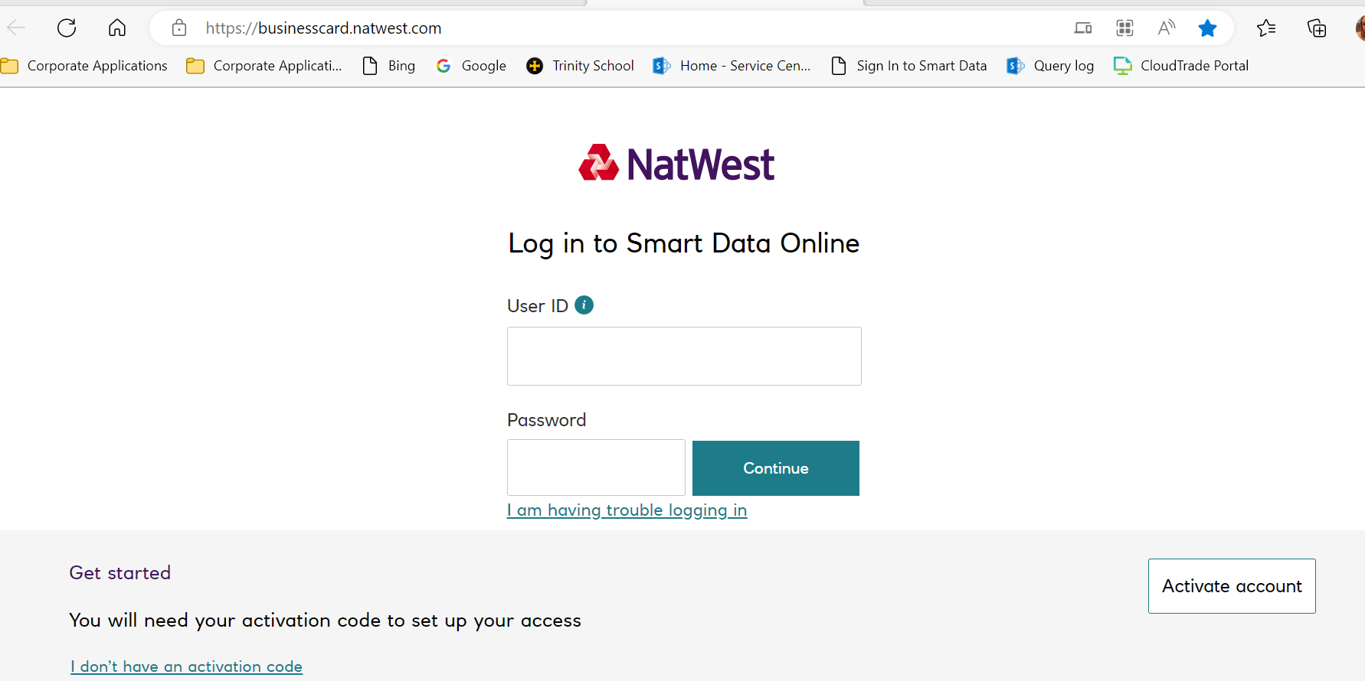

- You will then need to enter your User ID, this is on the email and should be the same as your previous User ID, then press continue;

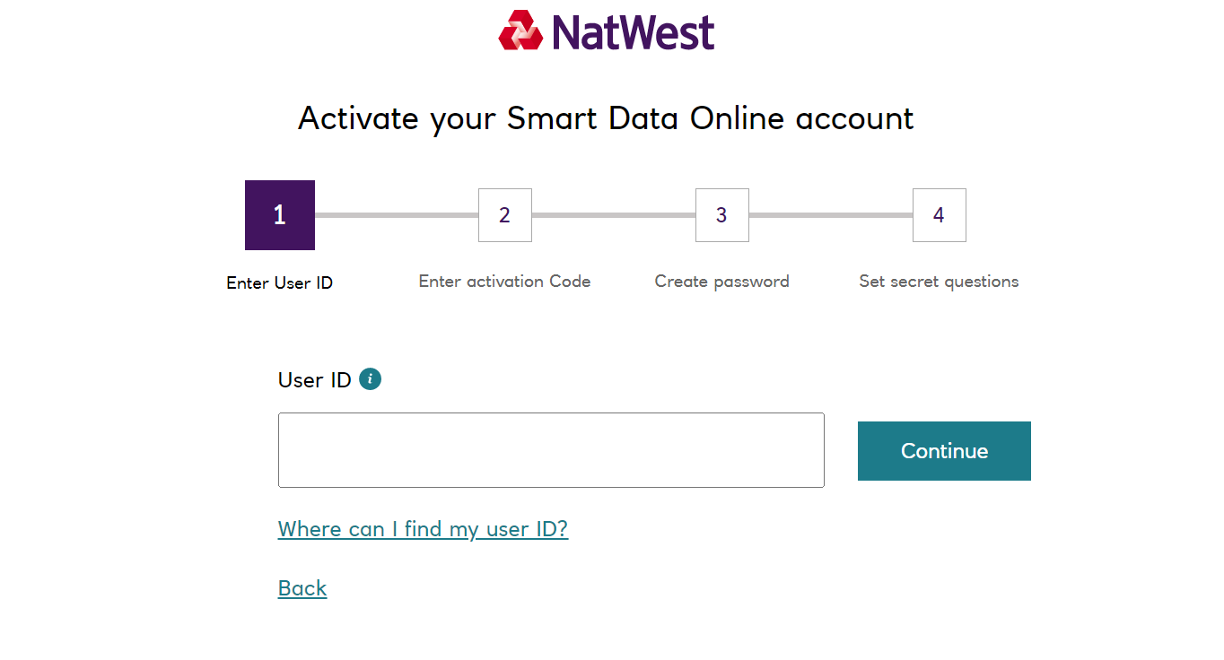
- Enter the activation code you have received in the email (this can be copied and pasted) then click continue;

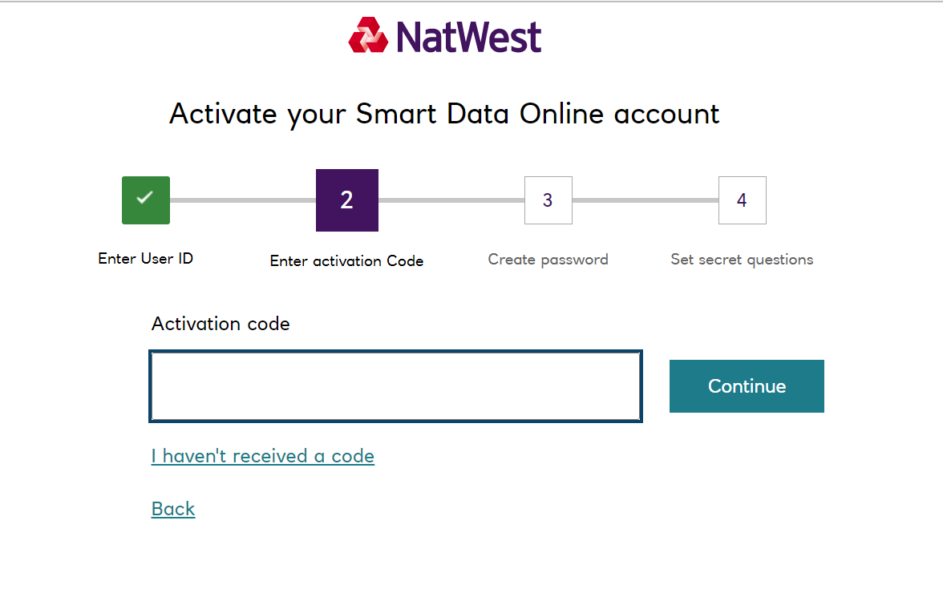

- When logging in for the first time, you will be asked to create a new password, complete both boxes and click continue;
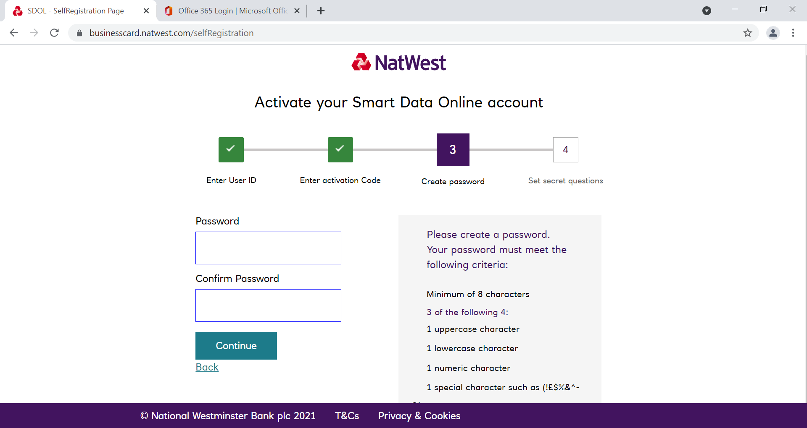

- At this point you will be asked to set up 3 security questions, these will be needed if you ever forget your password. Select an option from the drop down box on the left hand side and enter your answer in the corresponding box on the right, once done click Register;
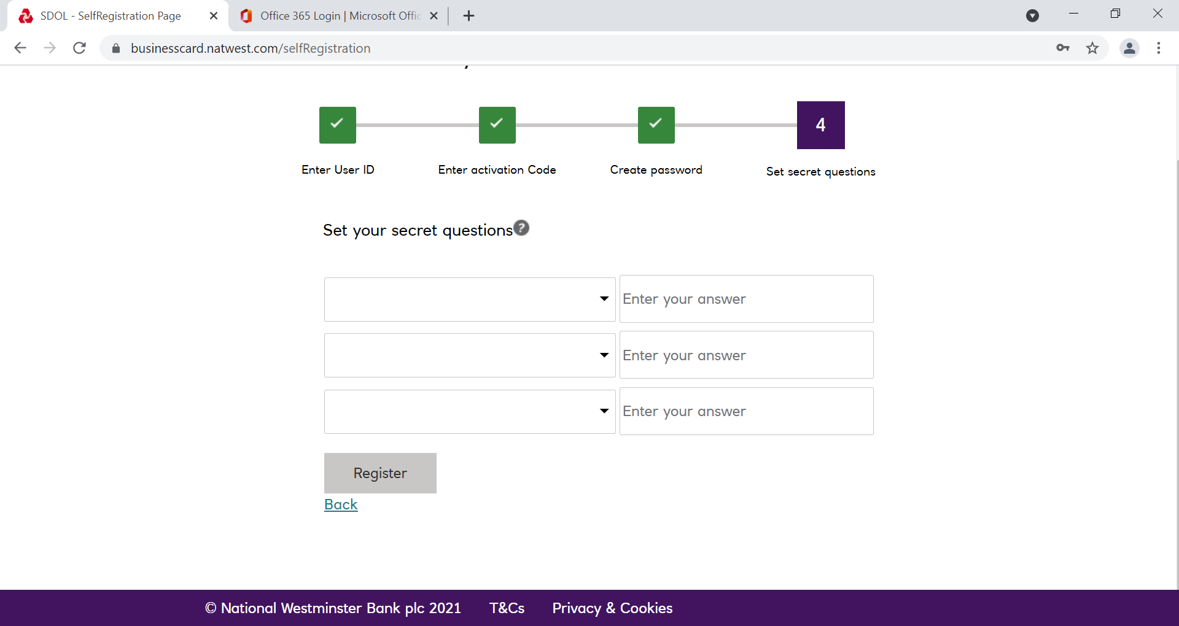

- You will then be able to log in using your User ID and the Password you have set up;

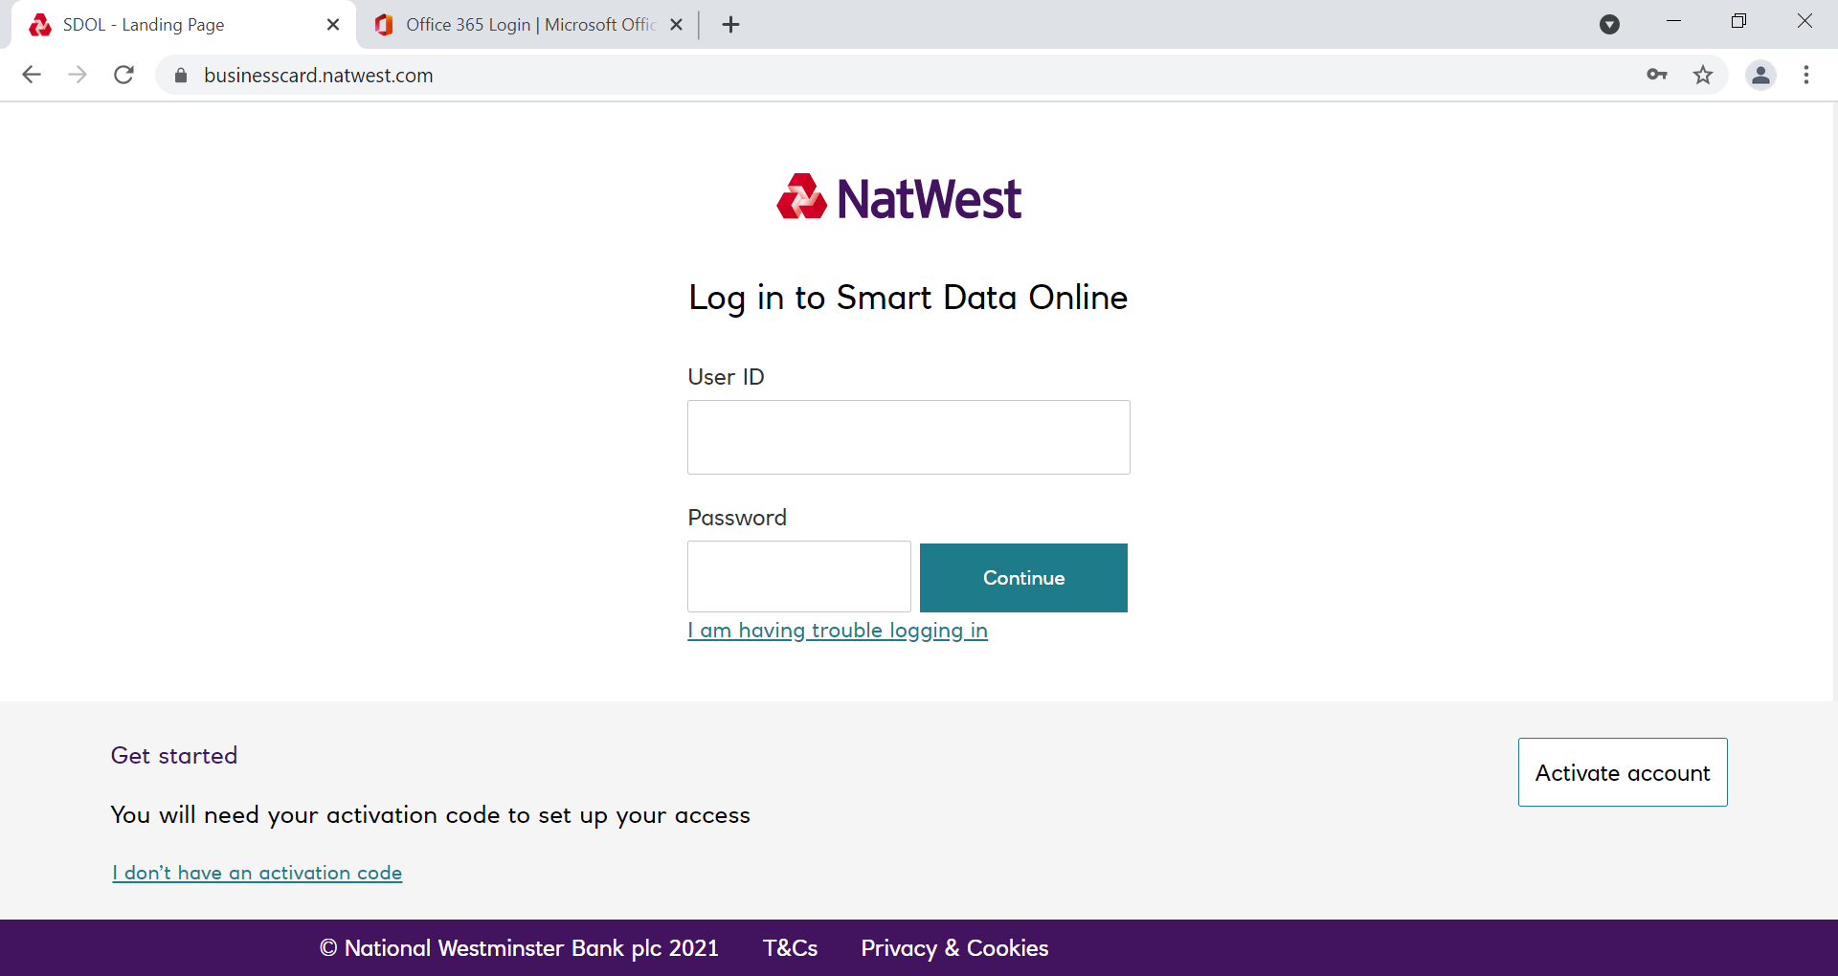

- As a new security measure you will be sent a secure code to the email address on your account everytime you log in to SDOL, enter this code in to the box shown below (you can copy and paste) then click log in;
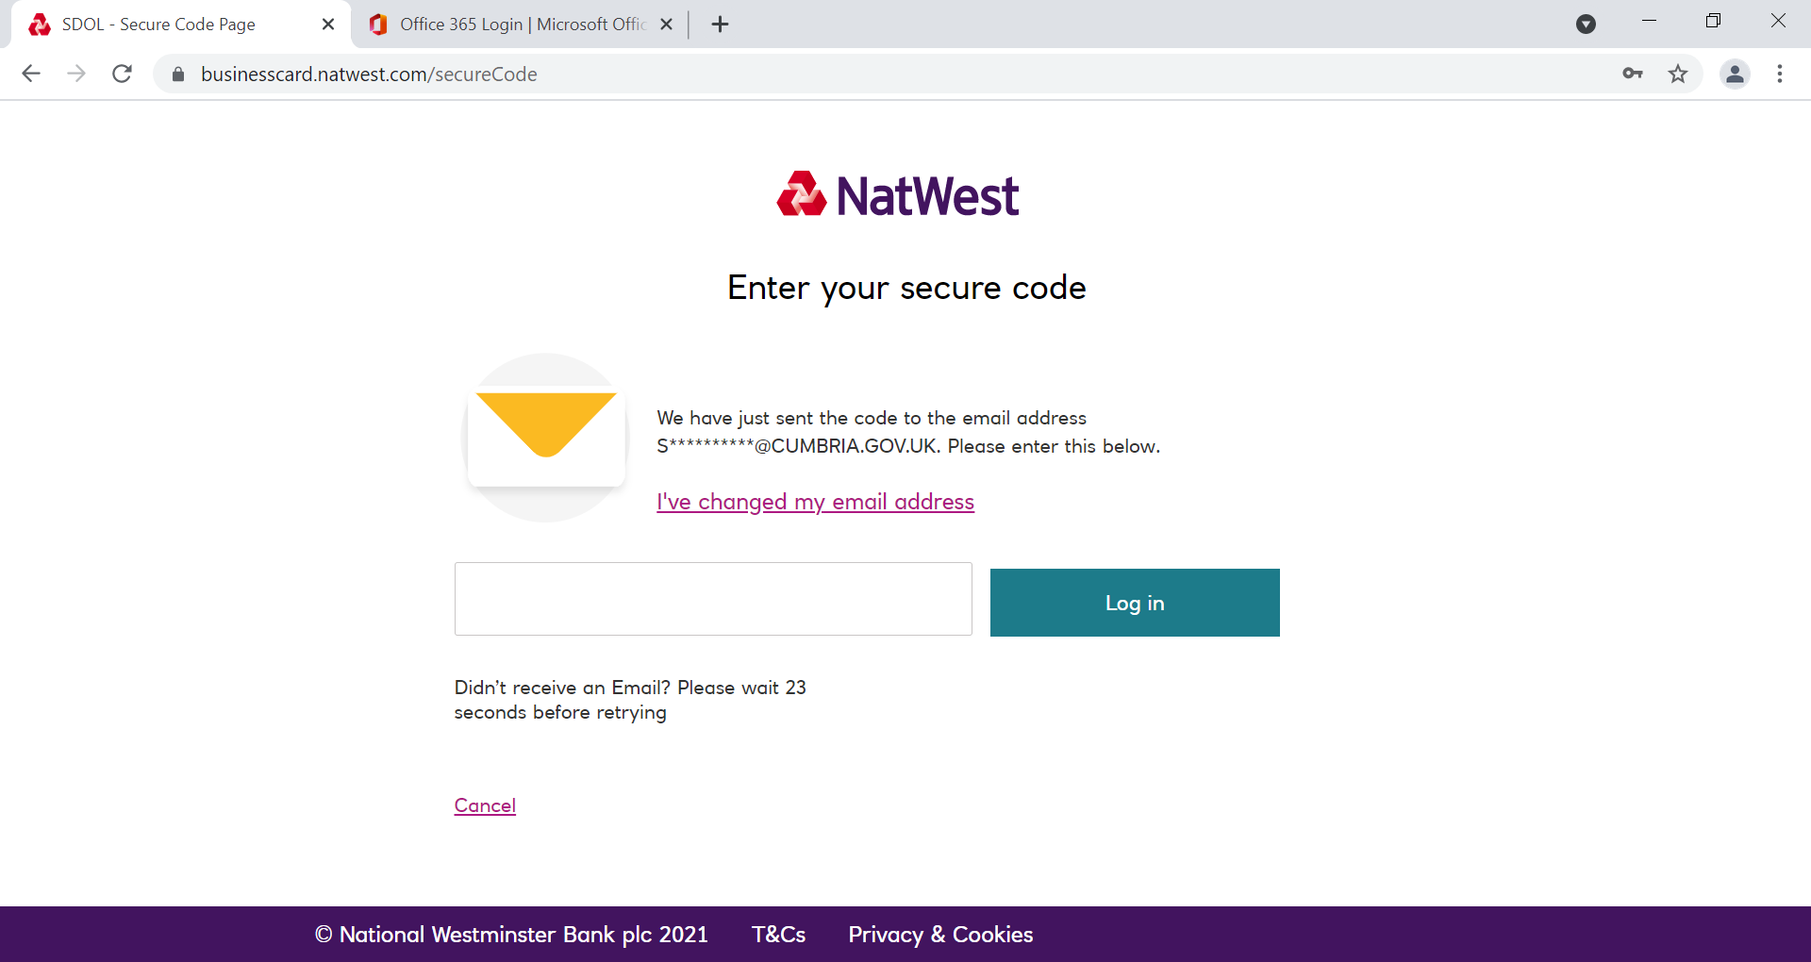

- After logging in the home page will appear. The home page is your starting place and offers a quick summary of information that may be important to you, including transactions reviewed, system news and the status of any reports you are running.
- Mastercard detailed Help guides are also available for viewing or download in the resource centre section. A copy of this manual is also available in the Resource Centre.
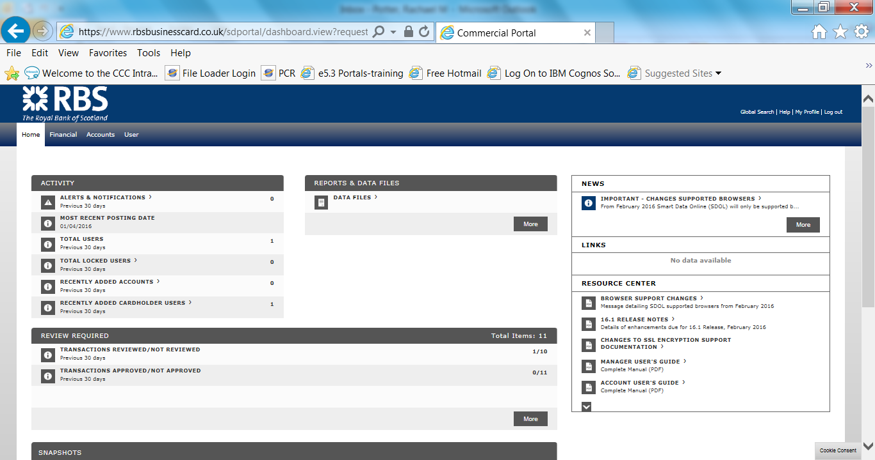

- At the top of the page, the following tabs will be showing
- Financial – main tab used for searching / locating and approving transactions
- Reports – ability to schedule reports
- Accounts – view the cardholders assigned to you (this will be all cardholders in school)
- User – view user assigned to you

Navigating in SDOL
- Navigate in SDOL by using either the main tabs (explained in paragraph 5) or the breadcrumb trail. Breadcrumbs trail is a navigation aid used in user interfaces. It allows users to keep track of their locations within programmess or documents. Below the Account Summary outlined in red is the breadcrumb in use.

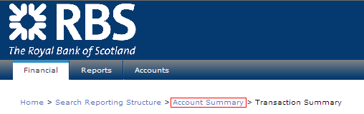
Never select the Back button.  as this will log you out of the system.

Reviewing Transactions
- Click on the Financial Tab at the top of the page and then Account Summary from the drop down menu that appears.
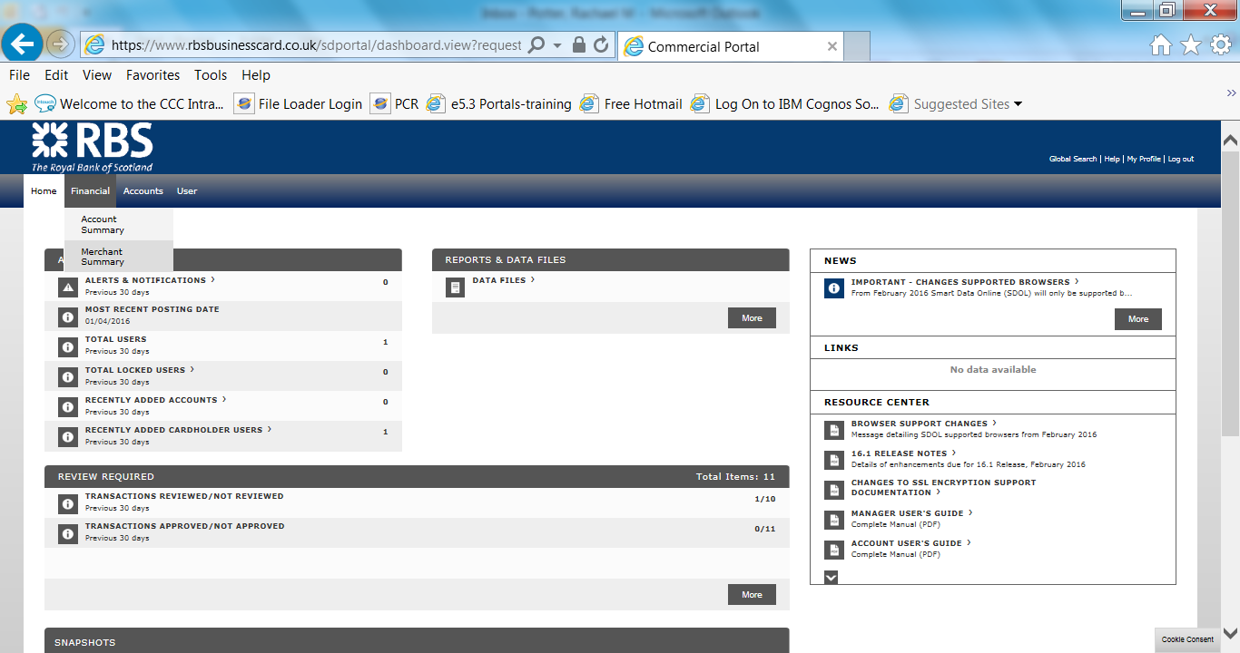

- Search for the cardholder(s) you are undertaking the review process for. You can select all of your cardholders by clicking on your Approval Group /Hierarchy name in the Quick Link box.
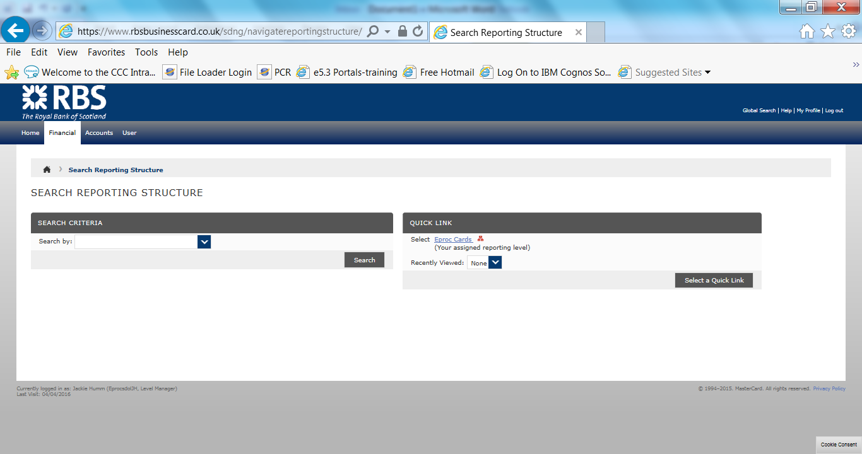
Search Function – search for individual cardholders.
Quick Link Box – click on link to access all cardholders

- Select the Reporting Cycle you require eg April 2016. Please note the reporting cycles run from the 4th of the month to the 3rd of the next month.

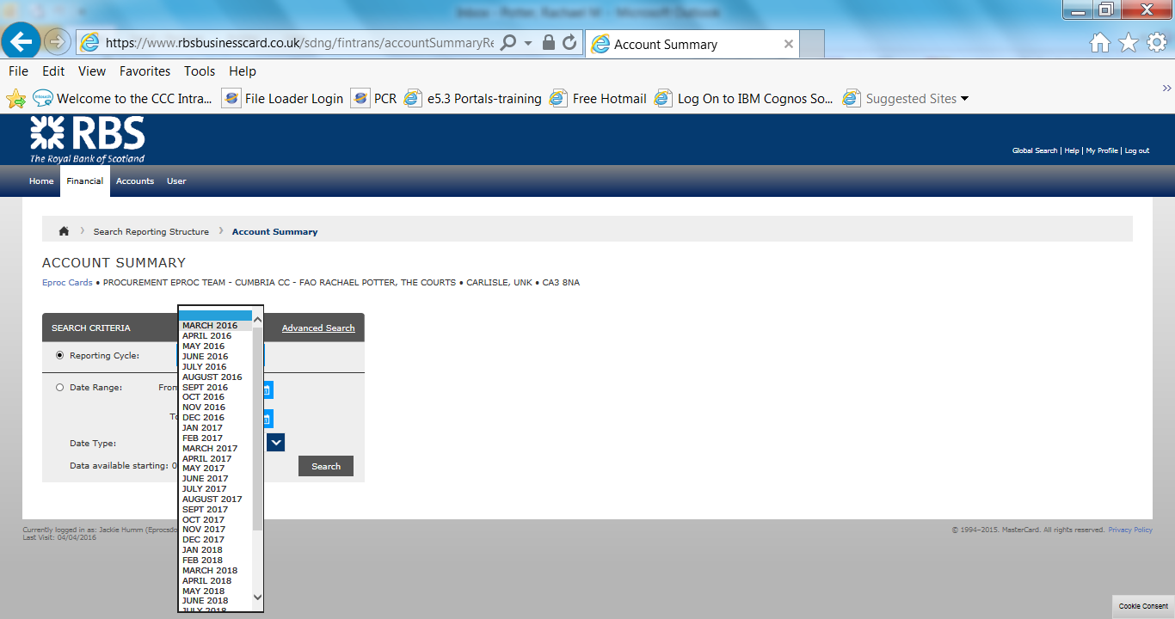

- Advanced Search filters are also available – e.g. review status. This automatically defaults to ‘ALL’ but you can specify to view transactions that have not been reviewed, or those that have just been reviewed. Additional filters are also available.
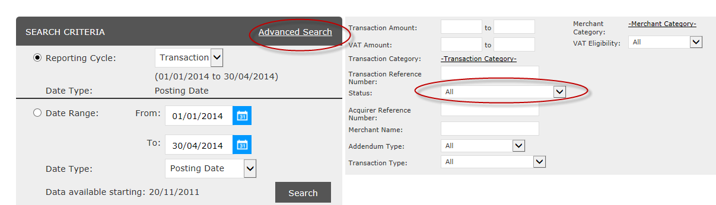

- You will see a list of your cardholders which have transactions during the selected date range.

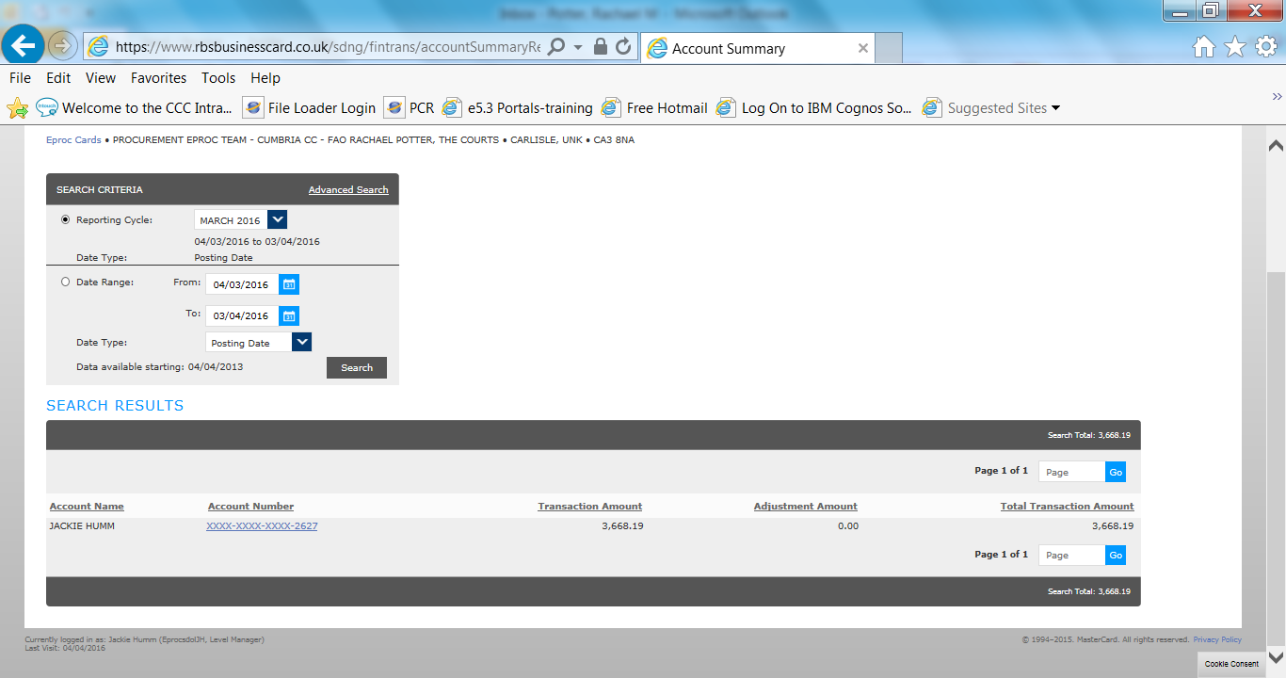

- Click on the account number of the cardholder whose transactions you wish to review

Click here to view this cardholder’s transactions

- The Transaction Summary for that cardholder for the period you have selected will now appear with a single line for each transaction.

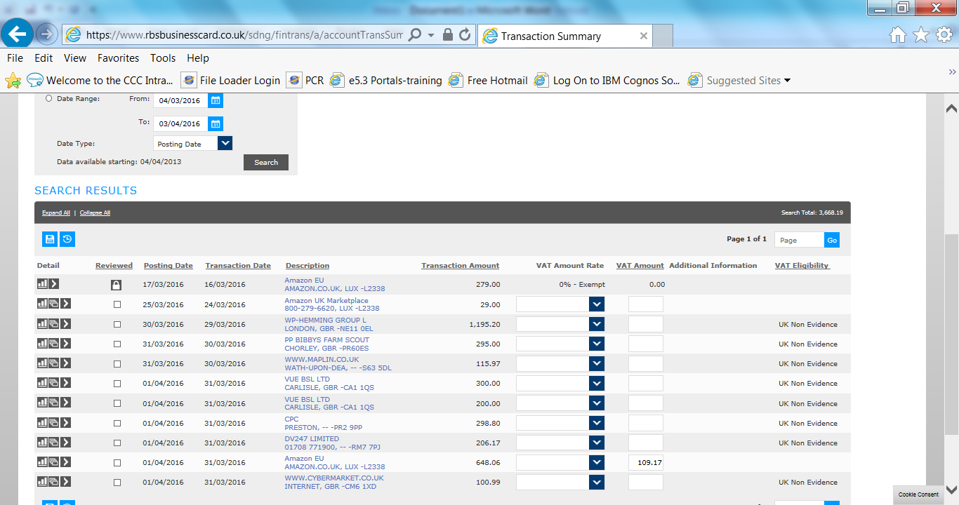
- Add the VAT for the transaction into the VAT Amount field (NB some transactions may have VAT pre-populated and fixed depending on the merchant used). The drop down should be used to select the category of VAT eg 5%, 20% etc. and there is a box to include the amount. Any VAT amounts entered must have a receipt to substantiate this. This must be retained for six years plus the current financial year. If these is no robust evidence to support VAT, enter 0.00 and 0.00% exempt in the drop down box.
VAT drop down
VAT Amount box

- Once the VAT has been completed, it is now time to allocate the transaction to the appropriate nominal codes. Click on the third icon from the left on the transaction line.

Icon to click to apply nominal codes

- The following screen will appear. Complete with the relevant codes. The cost centre will automatically default to your cost centre.
- Select an appropriate nominal code from the drop down list. They are listed with the name of the code first. A list of the nominal codes included in the drop down is found on page 41 and 42 of this manual. If a transaction needs to be split across more than one nominal code, please read point 20 below.
- Select an appropriate funding source if relevant (eg formula capital, sports funding). If this is not applicable, the default is 0.
- Select an appropriate project code (eg formula capital). If this is not applicable, the default is 0.
- Enter a description. This is limited to 40 characters and must be meaningful. This description will appear on your monthly E5 budget reports. A suggested format is Merchant Name, Brief Description eg, 1234567, Amazon, Books
- If VAT has been entered, you must confirm that the VAT receipt is held by completing the box and then monthly post these to the card administrator.
- The above fields are mandatory

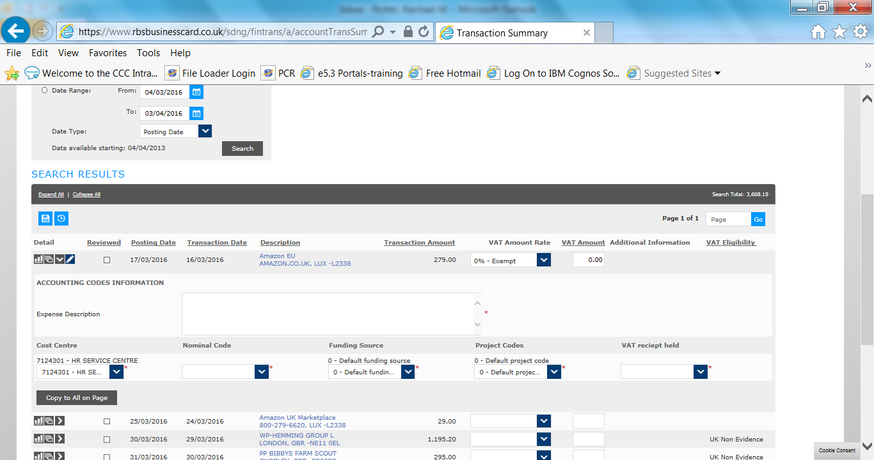
Expense Description
VAT receipt held
Cost Centre – this defaults and cannot be changed

Funding Source – defaults to 0
Nominal code – to be completed
Project Code – defaults to 0

- Click Save Accounting Codes  to save the codes for each transaction.

- When you are satisfied no further changes are required, click on the “Reviewed” box for each completed transaction

- Click on Save to lock all transactions. The check box will turn into a padlock and no further changes can be made. This should be completed by the 20th of the month.

Splitting a Transaction

- If a transaction needs to be allocated to multiple nominal codes/Cost centres, the SDOL system can enable this.
- It is important to add the total VAT amount before splitting the transaction
- Select the transaction you wish to split and click on the ‘split’ icon The split transaction screen appears.

23. Select the number of splits that you want to create and click ‘Add’. The screen will refresh and display the split lines



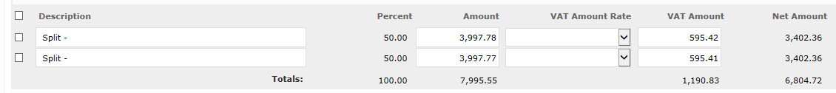

- Enter the amount or percentage for each split line

- If you have entered a VAT amount, or one is there by default, the tax amount for each split line will be entered automatically. Please check this is correct and if not amend. The system balances both the total amount and vat amount and will show a message if the lines do not balance. It will not allow you to save if the lines do not balance

- The split totals line calculates the splits as each line is entered. When the amounts do not balance the total displays in red text

- Add a description to each line
- Click on Save

- Once you have saved the splits you can allocate nominal codes in the normal way (see paragraph 16 above). Click on ‘next split’ to apply further account codes.

- Click on Transaction Summary on the breadcrumb trail at the top of the screen to return to the Transaction Summary screen

Codes on SDOL

Nominal Codes

group description | category description | nominal | nominal description
Employee | indirect costs | 17800 | OTH EMPLOYEE COSTS
 | indirect costs | 17810 | MEDICAL EXPS STAFF
 | indirect costs | 18020 | RECRUITMENT COSTS
 | indirect costs | 18027 | EMPLOYMENT CHECKS
 | indirect costs | 18140 | SUBSISTENCE OF STAFF
 | learning & development | 18240 | L&D-QUAL BELOW NVQ2
 | learning & development | 18270 | L&D-OTHR QUALS
 | learning & development | 18420 | L&D-CPD
 | learning & development | 18440 | L&D-PERSONAL SKILLS DEVT
 | learning & development | 18450 | OTH CORP TRAIN PROG COSTS
 | other employee costs | 19200 | EMPLOYEE INSURANCE
 |  | 19204 | SUPPLY TEACHER INSURANCE
premises | property alteration/improvmnt | 20100 | LEASE DILAPIDATION COSTS
premises | property alteration/improvmnt | 20110 | CONTRACTUAL PAYMENTS (MAIN)
premises | property alteration/improvmnt | 20200 | FEASIBILITY STUDIES
premises | property alteration/improvmnt | 20210 | PROPERTY SECURITY
premises | property alteration/improvmnt | 20250 | BUILDING REPAIRS
premises | repairs & maintenance | 20402 | BUILDING CONTROL FEES
premises | repairs & maintenance | 20403 | PLANNING FEES
premises | repairs & maintenance | 20404 | PROPERTY SURVEYS
premises | repairs & maintenance | 20405 | BLDING CONSULTANTS FEES
premises | repairs & maintenance | 20406 | CONSULTANTS FEES-TIME CHG
premises | repairs & maintenance | 20408 | HEALTH & SAFETY
premises | repairs & maintenance | 20420 | DOORS,WINDOWS AND GLAZING
premises | repairs & maintenance | 20422 | ELECTRICAL TESTING
premises | repairs & maintenance | 20425 | EXTERNAL GROUND COVER
premises | repairs & maintenance | 20452 | REPAIRS & MAINTENANCE
premises | repairs & maintenance | 20467 | SANITARY WARE
premises | energy costs | 20810 | ELECTRICITY
premises | energy costs | 20820 | GAS (INCL LPG)
premises | energy costs | 20830 | HEATING OIL
premises | energy costs | 20835 | SOLID FUEL
premises | energy costs | 20840 | OTHR ENERGY COSTS
premises | rents | 21050 | ANNUAL RENTS/LEASES
premises | rents | 21060 | CASUAL HIRE-PREMISES/VENUES
premises | rents | 21065 | GRND RENTS,WAYLEAVES & EASMNTS
premises | rates | 21010 | BUSINESS / NON-DOMESTIC RATES
premises | water services | 21075 | METERED WATER/ WATER RATES
premises | fixtures & fittings | 21210 | INST & MTCE-FIRE EXT & SEC SYS
premises | fixtures & fittings | 21220 | GENERAL FITTINGS
premises | fixtures & fittings | 21230 | PROPERTY CONSUMABLES
premises | cleaning & domestic supplies | 21505 | CLEANING MATERIALS
premises | cleaning & domestic supplies | 21510 | SWIMMING POOL CHEMICALS
premises | cleaning & domestic supplies | 21515 | PEST CONTROL
premises | cleaning & domestic supplies | 21520 | REFUSE COLLECTION
premises | cleaning & domestic supplies | 21525 | SEPTIC TANKS EMPTYING
premises | cleaning & domestic supplies | 21535 | TOILET REQUISITES
premises | cleaning & domestic supplies | 21540 | CLEANING SERVICES
premises | cleaning & domestic supplies | 21550 | FACILITIES MANAGEMENT SERVICES
premises | grounds maintenance | 21640 | CAR PARKS CONTRACT
premises | grounds maintenance | 21690 | GROUNDS MAINTENANCE
premises | premises insurance | 21810 | PREMISES INSURANCE
premises | structural maintenance | 23001 | FOOTWAYS AND CYCLEWAYS
premises | structural maintenance | 23002 | DRAINAGE / REM EARTHWORKS
premises | structural maintenance | 23003 | FENCES / BARRIERS
premises | structural maintenance | 23022 | NP DRAINAGE / REM EARTHWORKS
premises | structural maintenance | 23040 | BRIDGES
premises | structural maintenance | 23050 | PRIVATE WORKS
premises | structural maintenance | 23051 | ACCIDENT DAMAGE
premises | structural maintenance | 23080 | SM FEES
premises | routine maintenance | 23201 | MINOR CARRIAGEWAY REPAIRS
premises | routine maintenance | 23202 | RESPONSE TEAMS
premises | routine maintenance | 23203 | VERGE MAINTENANCE
premises | routine maintenance | 23204 | CLEANSING
premises | routine maintenance | 23205 | SWEEPING
premises | routine maintenance | 23206 | NON ILLUMINATED TRAF SIGNS
premises | routine maintenance | 23222 | NP RESPONSE TEAMS
premises | routine maintenance | 23223 | NP VERGE MAINTENANCE
premises | routine maintenance | 23224 | NP CLEANSING
premises | routine maintenance | 23226 | NP NON ILLUMINATED TRAF SIGNS
premises | routine maintenance | 23280 | RM FEES
premises | winter maintenance | 23401 | SALTING AND SNOW CLEARING
premises | winter maintenance | 23421 | NP SALTING AND SNOW CLEARING
premises | winter maintenance | 23480 | WM FEES
premises | street lighting | 23601 | LIGHTING MAINTENANCE
premises | street lighting | 23602 | UTC
premises | street lighting | 23603 | PAINT LIGHTING COLUMNS
premises | street lighting | 23604 | REPLACE LIGHTING COLUMNS
premises | street lighting | 23605 | TRAFFIC SIGNAL MAINTENANCE
premises | street lighting | 23606 | SIGNS / BOLLARDS MAINTCE
premises | street lighting | 23607 | ENERGY SIGNALS, SIGNS
premises | street lighting | 23608 | ENERGY LIGHTING
premises | street lighting | 23621 | NP LIGHTING MAINTENANCE
premises | street lighting | 23680 | SL FEES
transport | veh & plant repair & maintnce | 25210 | TYRES
transport | veh & plant repair & maintnce | 25230 | VEHICLE MAINTENANCE & REPS
transport | veh & plant running costs | 25410 | VEHICLE FUEL
transport | veh & plant running costs | 25430 | MAINTENANCE EXPENSES
transport | veh & plant running costs | 25432 | WORKSHOP TOOLS PCH & MAINT
transport | veh & plant running costs | 25440 | VEHICLE ROAD FUND LICENCES
transport | veh & plant running costs | 25450 | PLANT-RUNNING COSTS (RECHARGED
transport | veh & plant contract hire | 25630 | HIRED TRANSPORT CNTRCT ROUTE
transport | veh & plant contract hire | 25640 | HIRED TRANSPORT NOT CNTRCT
transport | veh & plant contract hire | 25642 | HIRED TRANSPORT EDUC VISITS
transport | veh & plant contract hire | 25645 | CONTRACT HIRE OF VEHICLES
transport | veh & plant contract hire | 25655 | VOLUNTEER EXPENSES
transport | veh & plant contract hire | 25660 | VOLUNTEER CAR SERVICE
transport | veh & plant contract hire | 25670 | FOSTER PARENT TRAVEL CLAIMS
transport | veh & plant contract hire | 25680 | GENERAL HIRE OF MOBILE PLANT
transport | veh & plant contract hire | 25690 | OPERATING LEASES VEHICLES
transport | veh & plant contract hire | 29040 | HOME TO SCHOOL/COLLEGE
transport | veh & plant contract hire | 29050 | HOME TO SCHOOL RESERVED SEATS
transport | public transport | 25810 | PUBLIC TRANS FOR SERVICE USERS
transport | public transport | 25820 | PUBLIC TRANSPORT-STAFF/MEMBERS
transport | transport insurance | 26010 | VEHICLE INSURANCES
transport | transport insurance | 26020 | SCHOOL JOURNEY INSURANCES
transport | travel expenses | 25675 | TRAVEL CONTACT VISITS
transport | travel expenses | 27025 | MILES/FARES GENERAL
transport | travel expenses | 27040 | CAR ALLOWANCES
transport | travel expenses | 27044 | CAR LEASING CHARGES
transport | travel expenses | 27050 | TRAVEL EXPS AGENCY STAFF
transport | travel expenses | 27060 | CAR HIRE
transport | travel expenses | 27070 | CAR HIRE STAFF (WITH CCC INS)
transport | travel expenses | 27074 | CAR HIRE AGENCY STAFF(CCC INS)
transport | contn to trnsprt reltd provisn | 29060 | HOME TO SCHOOL GRANTS
transport | contn to trnsprt reltd provisn | 29080 | ESCORT DUTY PAY(RECHARGED)
supplies and services | equipmt/furniture / materials | 30010 | PURCH/REPAIR -FURNITURE ADMIN
 | equipmt/furniture / materials | 30015 | PURCH/REPAIR -FURN SRV USE REV
 | equipmt/furniture / materials | 30017 | PURCH/REPAIR -FURN EDUC USE
 | equipmt/furniture / materials | 30035 | TEXT BOOKS
 | equipmt/furniture / materials | 30036 | LIBRARY BOOKS
 | equipmt/furniture / materials | 30037 | NEWSPAPERS & MAGAZINES
 | equipmt/furniture / materials | 30041 | INFO INVESTMENT- ON LINE
 | equipmt/furniture / materials | 30042 | INFO INVESTMENT- NON BOOK IIF
 | equipmt/furniture / materials | 30045 | BOOK/INFORMATION FUND
 | equipmt/furniture / materials | 30050 | PURCHASE OF CD/DVDS
 | equipmt/furniture / materials | 30060 | SPORTS&P.E.EQUIP-PURCH, REPAIR
 | equipmt/furniture / materials | 30061 | SPORTS & P.E.EQUIP-MTCE CONT
 | equipmt/furniture / materials | 30062 | SPORTS & P.E.EQUIP- CONT HIRE
 | equipmt/furniture / materials | 30065 | RETAIL PRODUCTS
 | equipmt/furniture / materials | 30071 | EDUC EQUIP PURCH&REPAIR REV
 | equipmt/furniture / materials | 30073 | SIGNS AND NOTICES
 | equipmt/furniture / materials | 30075 | PURCH OP TOOLS & MATLS
 | equipmt/furniture / materials | 30076 | HIRE OP TOOLS, MTLS
 | equipmt/furniture / materials | 30080 | EDUC STATIONERY & MATERIALS
 | equipmt/furniture / materials | 30083 | OTHR PUBLICATIONS
 | equipmt/furniture / materials | 30100 | OPERATIONAL MATERIALS OTHR
 | equipmt/furniture / materials | 30110 | EXHIBITS,MATLS & EXBN STANDS
 | equipmt/furniture / materials | 30115 | OTHR EQUIP,TOOLS & MATERIALS
 | equipmt/furniture / materials | 30116 | ATC MATERIALS OBSOLETE
 | equipmt/furniture / materials | 31005 | SPECIALIST EQUIPT
 | equipmt/furniture / materials | 31015 | SP EQUIP FIRE TOOLS & SMALL GE
 | equipmt/furniture / materials | 31019 | SMOKE ALARMS
 | domestic supplies | 31060 | CLEANING EQUIPMENT
 | domestic supplies | 31061 | GENERAL CLEANING EQUIPT
 | domestic supplies | 31062 | BEDDING LINEN AND TOWELS
 | domestic supplies | 31064 | TOWELS & DISPENSERS/HAND DRYER
 | domestic supplies | 31066 | OTHR DOMESTIC EQUIPMENT
 | catering | 32015 | CATER EQUIP- PURCH (REVENUE)
 | catering | 32025 | CONSOLIDATED INVS
 | catering | 32040 | VEND MACH RENTAL
 | catering | 32041 | VENDING MACHINE RENTAL
 | catering | 32043 | WATER/VENDING MACHINE SUPPLIES
 | catering | 32045 | MILK PURCHASES
 | catering | 32048 | GEN FOOD CONFECTIONERY
 | catering | 32050 | GENERAL FOOD
 | catering | 32053 | DRINKS (BAR)
 | catering | 32056 | CATERING CONTRACT MANAGEMENT
 | catering | 32062 | MEAL COSTS
 | catering | 32068 | MISC CATERING SUPPLIES
 | clothing/uniforms/laundry | 32210 | STFF PROTECTIVE CLOTH/UNIFRM
 |  | 32211 | HIGHWAYS PPE
 |  | 32215 | CLOTHING FOR USE BY CLIENTS
 |  | 32220 | OTHR CLOTHING AND UNIFORM
 |  | 32225 | GENERAL LAUNDRY COSTS
 | print/stat/office expenses | 32405 | MISCELLANEOUS OFFICE EXPENSES
 | print/stat/office expenses | 32410 | PHOTOCOPIER RENTAL
 | print/stat/office expenses | 32412 | PHOTOCOPIER USAGE
 | print/stat/office expenses | 32415 | PRINTING COSTS
 | print/stat/office expenses | 32417 | CURRICULUM PHOTOCOPIER RENTAL
 | print/stat/office expenses | 32418 | CURRICULUM PHOTOCOPIER USAGE
 | print/stat/office expenses | 32420 | PUBLICATIONS FOR OFFICE USE
 | print/stat/office expenses | 32422 | OFFICE SUPPLIES&EXPS(EX PAPER)
 | print/stat/office expenses | 32424 | PRINTER/PHOTOCOPIER PAPER
 | print/stat/office expenses | 32430 | STAMP DTY&LEGAL COSTS NOT CPTL
 | print/stat/office expenses | 32440 | DISPOSAL OF CONFIDENTIAL WASTE
 | print/stat/office expenses | 32453 | POSTAGE
 | print/stat/office expenses | 32455 | POSTAGES STAMPS INC RECORDED
 | print/stat/office expenses | 32460 | ADV/PUBLICITY (NOT RECRUITMT)
 | services - financial charges | 32803 | EXTERNAL INTEREST PAYABLE
 | social care/medical supplies | 31070 | SOCIAL CARE PERS SUPPLIES
 | social care/medical supplies | 31075 | DRUGS AND MEDICAL EQUIPT
 | social care/medical supplies | 31085 | OTHR PERSONAL & MEDICAL EXES
 | csdp aids and equipment | 31079 | CSDP EQUIP HOISTS & SLINGS
 | csdp aids and equipment | 31080 | CSDP EQUIPMENT
 | csdp aids and equipment | 31082 | CSDP EQUIP RAILS & RAMPS
 | csdp aids and equipment | 31083 | CSDP EQUIP COMMUNICATION AIDS
 | csdp aids and equipment | 31084 | PRESCRIPTION EQUIPMENT
 | csdp aids and equipment | 31090 | CSDP ASSISTIVE TECHNOLOGY
 | csdp aids and equipment | 31092 | CSDP EQUIP MAINTENANCE CONTRCT
 | csdp aids and equipment | 31094 | CSDP EQUIP REPAIRS
 | other professional fees/servcs | 32818 | MANAGEMENT & ADMIN FEES
 | other professional fees/servcs | 32825 | LECTURERS FEES
 | other professional fees/servcs | 32826 | CONSULTANTS FEES
 | other professional fees/servcs | 32827 | EXPERT FEES (EXCL LEGAL)
 | other professional fees/servcs | 32828 | VETERINARY EXAMINATIONS FEES
 | other professional fees/servcs | 32829 | ANALYSTS FEES
 | other professional fees/servcs | 32831 | LABORATORY TEST FEES
 | other professional fees/servcs | 32832 | LEGAL/COUNSELS/SOLICITORS FEES
 | other professional fees/servcs | 32833 | EXT L&D CONSULTANTS FEES
 | other professional fees/servcs | 32836 | OTHR PYTS TO INSTITUTIONS
 | other professional fees/servcs | 32838 | BUSINESS & PROFESSIONAL SERV
 | other professional fees/servcs | 32840 | OTHER PROFESSIONAL SERVICES
 | other professional fees/servcs | 32845 | EXAM FEES SCHOOLS
 | other professional fees/servcs | 32860 | RECRUITMENT AGENCY FEES
 | other professional fees/servcs | 32884 | BODY REMOVAL UNDERTAKERS FEES
 | other professional fees/servcs | 32886 | MORTUARY & POST MORTEM FEES
 | other professional fees/servcs | 32890 | OFFICE REMOVAL EXPENSES
 | surveys | 33030 | SURVEYS
 | surveys | 33050 | SURVEYS(HIRED/CONTRACTED)
 | computing | 33205 | INTERNET/DATA COMMUNICATIONS
 | computing | 33210 | COMPUTERS & EQUIPT HARDWARE
 | computing | 33211 | EDUC COMPUTERS & EQPT HARDWARE
 | computing | 33212 | COMPUTER ACCESSORIES
 | computing | 33215 | COMPUTERS & EQUIP SOFTWARE
 | computing | 33216 | EDUC COMPUTERS & EQPT SOFTWARE
 | computing | 33230 | MAINTCE COMPUTER H/WARE
 | computing | 33240 | MAINTCE OTHER COMP EQUIP
 | computing | 33245 | COMP ACCESSORIES/CONSUMABLES
 | computing | 33246 | EDUC COMP ACCESSOR/CONSUMABLES
 | computing | 33250 | SUPPORT CHARGES COMPUTING
 | computing | 33255 | SOFTWARE LICENSING CHARGES
 | computing | 33280 | DATA COMMUNICATIONS
 | communications | 33405 | TELEPHONE LINE CHARGES
 | communications | 33407 | TELEPHONE USAGE CHARGES
 | communications | 33430 | OTHER COMMUNICATION COSTS
 | communications | 33462 | COMMUNICATIONS EQUIP PURCHASE
 | communications | 33560 | MOBILE TELEPHONES
 | members expenses | 33710 | MEMBERS ALLOWANCES
 | members expenses | 33720 | MEMBERS EXPS EXCLDG TRAVEL
 | members expenses | 33724 | MEMBERS EXPS TRAVEL
 | members expenses | 33730 | MEMBERS COURSES & CONFERCES
 | members expenses | 33740 | MEMBERS OTHR EXPENDITURE
 | subscriptions | 33802 | SUBSCRIPTIONS
 | grants | 33810 | GRANT PAYMENTS
 | expenses | 34500 | STAFF HOTELS & ACCOM (NON L&D)
 | miscellaneous expenses | 34005 | MUSIC/THEATRICAL PERFORMANCES
 | miscellaneous expenses | 34010 | PROJECT DEVELOPMENT ACTIVITY
 | miscellaneous expenses | 34014 | EDUC BOARDING
 | miscellaneous expenses | 34018 | EDUC- INDIVIDUAL TUITION
 | miscellaneous expenses | 34020 | EDUCSPECIAL NEEDS COSTS
 | miscellaneous expenses | 34021 | EDUC- MUSIC SERVICE
 | miscellaneous expenses | 34022 | EDUC- SWIMMING
 | miscellaneous expenses | 34025 | ADULT EDUCATION
 | miscellaneous expenses | 34026 | EDUC VISITS
 | miscellaneous expenses | 34027 | EDUC SPECIAL FACILITIES
 | miscellaneous expenses | 34030 | OTHR INSURANCES
 | miscellaneous expenses | 34035 | LICENCES & FEES
 | miscellaneous expenses | 34040 | EXPENSES NOT EMPLOYEES
 | miscellaneous expenses | 34050 | DAMAGE TO PERSONAL POSSESSIONS
 | miscellaneous expenses | 34051 | FIRE DAMAGE CONTENTS
 | miscellaneous expenses | 34055 | COURT AND PUBLIC INQUIRY COSTS
 | miscellaneous expenses | 34082 | CUT FLOWERS (BOUQUETS ETC)
 | miscellaneous expenses | 34090 | PAT ELECTRICAL TESTING
 | miscellaneous expenses | 34092 | FIRST AID SUPPLIES
 | miscellaneous expenses | 39020 | CLIENTS PERSONAL MONEY REFUNDE
 | contributions to other bodies | 34102 | CONTRIBUTIONS TO OTHER BODIES
 | contributions to other bodies | 34106 | CONT TO OTHR BODY-OPER'L STFF
 | waste disposal | 32022 | CIVIC AMENITY CONTRACT FEES
 | waste disposal | 35002 | LANDFILL MAIN CONTRACT FEES
 | waste disposal | 35004 | PERFORMANCE DEDUCTIONS
 | waste disposal | 35005 | LANDFILL COSTS
 | waste disposal | 35006 | WASTE CONTRACT GAIN-SHARE COST
 | waste disposal | 35007 | CONTRACT GAIN SHARE BLKY WASTE
 | waste disposal | 35017 | CLOSED LANDFILL SITES CCS
 | waste disposal | 35020 | DISPOSAL OF ITEMS
 | waste disposal | 35052 | WASTE DISPOSAL LANDFILL TAX
 | waste disposal | 35057 | RECYCLING CREDITS
 | waste disposal | 35062 | WASTE MINIMISATION
 | waste disposal | 35067 | FINES
 | elections | 38010 | ELECTIONS
 | discounts receivable | 38101 | DISCOUNTS RECEIVABLE
transfer payments | pupils and students awards | 50003 | CLOTHING GRANT
transfer payments | pupils and students awards | 50070 | DISCRETIONARY AWARDS
transfer payments | pupils and students awards | 50130 | CYP PREVENT&SUPP-S17 OTH PYMT
transfer payments | educational assistance | 50345 | ASST PUPILS COURSES EXPS
transfer payments | educational assistance | 50360 | ASST NEC CLOTHING & FOOTWEAR
transfer payments | educational assistance | 50370 | ASST OTHR TO PUPILS
transfer payments | direct paymnts to servce users | 50900 | DIRECT PAYMENTS TO SERVICE USE
transfer payments | direct paymnts to servce users | 50910 | INDIVIDUAL SERVICE FUNDS
transfer payments | pway services | 51090 | PWAY SERV SUBSISTENCE / MAINTE
transfer payments | pway services | 51091 | PWAY SERV RENTS
transfer payments | pway services | 51092 | PWAY SERV PATHWAYS PLUS
transfer payments | pway services | 51097 | PWAY SERV HOLIDAY ALLOWCE
transfer payments | pway services | 51101 | PWAY SERV EDUC/TRAIN MAT'LS
transfer payments | pway services | 51104 | PWAY SERV SUPPORT COSTS
transfer payments | pway services | 51105 | PWAY SERV SET UP HOME ALL'CE
transfer payments | pway services | 51106 | PWAY SERV OTHR NEEDS
transfer payments | pway services | 51107 | PATHWAY FE TRAINING EXPS
transfer payments | purchases for servce users | 51400 | EQUIPMT PURCH FOR SERVICE USER

