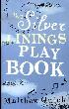 | QUICK, Matthew  Silver Linings Playbook  'The Silver Linings Playbook' is the riotous and poignant story of how one man regains his memory and comes to terms with the magnitude of his wife's betrayal.
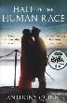 | QUINN, Anthony  Half the Human Race  Summer of 1911. The streets of London ring with cheers for a new king's coronation and the cries of increasingly violent suffragette protests. Connie Callaway wants more than the conventional comforts of marriage - she is determined to fight for the greatest cause the world has ever known.
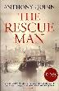 | QUINN, Anthony  The Rescue Man  With writing that is both immediate & deeply steeped in its time, Anthony Quinn recreates wartime Liverpool with emotional intensity & fidelity. His writing will carry you through the streets of 'the Venice of the North' in a powerful, unforgettable story of love found & lost.
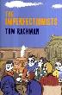 | RACHMAN, Tom  The Imperfectionists  'The Imperfectionists' interweaves the stories of 11 unusual and endearing characters who depend on the newspaper. Often at odds, they are united when the focus of their lives begins to fall apart.
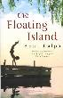 | RALPH, Anna  The Floating Island  They say it's coming back. It was a year ago - the day Tom died. A year after they rowed out to the island Tom's older brother, Matt is still haunted by nightmares. He can't remember what happened. Only when Sarah Bell takes up the position of Matt's carer, do things begin to change for him. But Sarah's attention is firmly fixed on Robert.
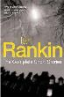 | RANKIN, Ian  The Complete Short Stories  Over the years, Ian Rankin has amassed an incredible portfolio of short stories. This title brings together Rankin's two short story collections - 'A Good Hanging' and 'Beggars Banquet' - along with 'Atonement', a new Inspector Rebus story, written especially for this collection.
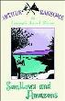 | RANSOME, Arthur  Swallow and Amazons  To John, Susan, Titty and Roger, simply being allowed to use the boat to go camping on the island is adventure enough. They find themselves under attack from the fierce Amazon Pirates, Nancy and Peggy. And so begins a summer of battles and discovery.
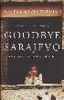 | REID, Atka  Goodbye Sarajevo  This is a moving and compelling true story about two sisters fighting for survival in Sarajevo during the Bosnian war.
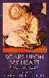 | REILLY, Catherine  Scars upon my Heart  This anthology of women war poets shows that women were writing protest poetry before Wilfred Owen and Siegfried Sassoon. Many of the poems come out of direct experiences of nursing the victims of trench warfare, or the pain of lovers, brothers, sons, lost.
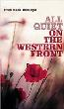 | REMARQUE, Erich  All Quiet on the Western Front  This story is told by a young soldier in the trenches of Flanders during the First World War. Through his eyes we see the realities of war. Incidents are vividly described, but there is no sense of adventure, only the feeling of youth betrayed.
 | REYNOLDS, Matthew  Designs for a Happy Home  While Alizia has a 'design' for everything from relationships to work to motherhood, the people who matter most to her refuse to fit. As the gloss she has put on her life begins to crack she realises there may not, after all, be a Magic Motto for everything. So where can she find happiness?
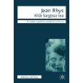 | RHYS, Jean  Wild Sargasso Sea  Antoinette, like most of Jean Rhys's other female characters, is a woman that hovers between two worlds: black and white, English coldness and tropical warmth,sanity (accepted behaviour) and madness. Although given a poignant voice, she is helpless because she doesn't know how to use it. She goes mad insofar as madness is silencing her voice and retreating more and more...
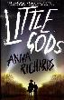 | RICHARDS, Anna  Little Gods  These enjoyable and varied short stories share the context of the village with its country church and are by many of the greatest short story writers of all time.
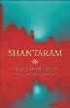 | ROBERTS, Gregory  Shantaram  In 1978 Greg Roberts turned to heroin, feeding his addiction with a string of robberies. Sentenced to prison, he escaped and fled to Bombay. Based on his life in Bombay, this is a tale of slums and mansions, Mafia and movies, and much more.
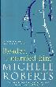 | ROBERTS, Michele  Reader, I Married him  When Aurora decides to take herself off to Italy to visit her old friend, Leonora, after her third husband's demise, she discovers a rather dangerous lust for sex and food. Could this be the scenario that reveals the real Aurora?
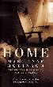 | ROBINSON, Marilynne  Home  'Home' takes up the story of the wayward son Jack who, after decades away, edgily and uneasily, but finally, returns home. He is the prodigal son and his family believe against all evidence, that if they love him enough, if they welcome him back, he will change and he will stay.
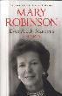 | ROBINSON, Mary  Everybody Matters  Told with the same calm conviction and modest pride that has guided her life, 'Everybody Matters' will inspire anyone who reads it with the belief that any one of us can, in our own way, help to change the world for the better.
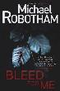 | ROBOTHAM, Michael  Bleed for me  When Sienna Hegarty turns up at his family home covered in blood and frozen in shock, psychologist Joe O'Loughlin finds himself drawn deep into her world, trying to unearth the dark secrets her mind has buried. The cops find a major piece of the puzzle at Sienna's house: her father is face-down in a pool of his own blood.
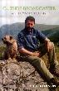 | ROBSON, Eric  Outside Broadcaster  In this blunt, humorous and indiscreet memoir Eric Robson bites the hand that feeds him in a canter through the stupidities of broadcasting which he still can't bring himself to think of as a proper job.
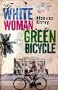 | ROFFEY, Monique  The White Woman on the Green Bicycle  This novel tells how when George and Sabine Harwood arrive in Trinidad from England George instantly takes to their new life but Sabine feels isolated, heat-fatigued, and ill at ease with the racial segregation and the imminent dawning of a new era. George eventually finds out that Sabine has been keeping secrets from him.
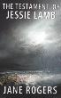 | ROGERS, Jane  The Testament of Jessie Lamb  Jane Rogers creates an extraordinary character in Jessie Lamb, determined to make her life count in a self-destructing world as the certainties of her life are ripped apart.
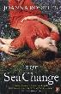 | ROSSITER, Joanna  The Sea Change  Yesterday was Alice's wedding day. She is thousands of miles away from the home she is so desperate to leave, on the southernmost tip of India, when she wakes in the morning to see a wave on the horizon, taller than the height of her guest house on Kanyakumari beach. Her husband is nowhere to be seen. On the other side of the world, unhappily estranged from her daughter, is Alice's mother, Violet. Forced to leave the idyllic Wiltshire village, Imber, in which she grew up after it was requisitioned by the army during World War Two.
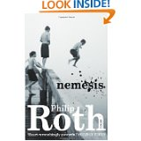 | ROTH, Philip  Nemesis  Summer, 1944. In the 'stifling heat of equatorial Newark', a terrifying epidemic is raging, threatening the children of the New Jersey city with maiming, paralysis, life-long disability, even death.
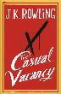 | ROWLING, JK  A Casual Vacancy  When Barry Fairbrother dies unexpectedly in his early 40s, the little town of Pagford is left in shock. The empty seat left by Barry on the parish council soon becomes the catalyst for the biggest war the town has ever seen. Who will triumph in an election fraught with passion, duplicity and unexpected revelations?
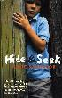 | SAMBROOK, Clare  Hide and Seek  Meet Harry Pickles - aged nine-years old, he is the fastest runner in the world (probably) and the first son of the best looking parents in the school car park. Harry's life is good - at least, it was until the school trip.
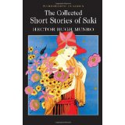 | SAKI  Collected Short Stories  Saki’s extraordinary stories are a mixture of humorous satire, irony and the macabre, in which the stupidities and hypocrisy of conventional society are viciously pilloried
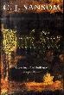 | SANSOM, C  Dark Fire  1540. Shardlake has been pulled, against his better judgement, into defending Elizabeth Wentworth, charged with murdering her cousin. He is powerless to help the girl, yet she is suddenly given a reprieve - courtesy of Cromwell. The cost of the reprieve to Shardlake is two weeks once again in his service.
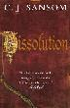 | SANSOM, C  Dissolution  Henry VIII has ordered the dissolution of the monasteries and England is full of informers. At the monastery of Scarnsea events have spiralled out of control with the murder of Commissioner Robin Singleton. Matthew Shardlake, a lawyer, and his assistant are sent to investigate.
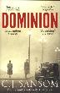 | SANSOM, C  Dominion  At once a startling, sinister reimagining of 1950s Britain and a gripping, humane spy thriller, with 'Dominion' C.J. Sansom once again asserts himself as the master of the historical thriller.
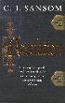 | SANSOM, C  Revelation  Spring, 1543. King Henry VIII is wooing Lady Catherine Parr, whom he wants for his sixth wife. But this time the object of his affections is resisting. Archbishop Cranmer and the embattled Protestant faction at court are watching keenly, for Lady Catherine is known to have reformist sympathies.
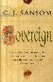 | SANSOM, C  Sovereign  Following the uncovering of a plot against his throne in Yorkshire, King Henry VIII has set out on a Progress to the North, to overawe his rebellious subjects there once and for all. This is the latest book from Sansom whose novel 'Dark Fire' won the CWA Ellis Peters Historical Dagger.
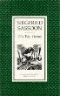 | SASSOON, Siegfried  The War Poems  The poems gathered here and chronologically ordered, thereby tracing the course of the war, are an extraordinary testimony to the almost unimaginable experiences of a combatant in that bitter conflict.
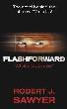 | SAWYER, Robert  Flashforward  The Hadron Collider is turned on and everyone in the world goes to sleep for a few moments. In those few moments everyone's consciousness is catapulted forward more than 20 years into the future. When it awakes the world must live with the knowledge of what is to come.
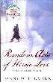 | SCHEINMANN, Danny  Random Acts of Heroic Love  In this debut novel, Danny Scheinmann paints a dramatic portrait of two men sustaining their lives through the memory of love; two men whose hidden connections are revealed in a stunning climax that lives long in the heart.
 | SCHLINK, Bernard  The Reader  "The Reader cannot be ignored. It challenges core definitions of good and evil...The Reader brings us face to face with how little we know about the people around us" (Norman Lebrecht EVENING STANDARD )
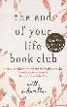 | SCHWALBE, Will  The End of Your Life Book Group  When Mary Anne Schwalbe was diagnosed with pancreatic cancer, her publisher son Will accompanied her to her treatments. As they had all their lives, they discussed books and the End of Your Life Book Club was born. Through the books we come to know Mary Anne and her lifelong love affair with books.
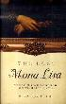 | SCOTTI, R  The Lost Mona Lisa  Late on the afternoon of Sunday, August 20th 1911, three men strolled through the Louvre. Disguising themselves as museum staff they hid until nightfall. 16 hours later the most famous painting in the world, the Mona Lisa, had vanished. This text tells the true story of the theft.
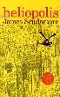 | SCUDAMORE, James  Heliopolis  'Heliopolis' is a rags-to-riches tale, reminiscent of Dickens. It is the follow-up to the award-winning 'The Amnesia Clinic'.
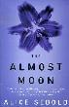 | SEBOLD, Alice  The Almost Moon  Unfolding over 24 hours, this novel explores the ties between mothers and daughters, wives and lovers, the meaning of devotion and the line between love and hate.
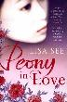 | SEE, Lisa  Peony in love  'Peony in Love' is a powerful and haunting love story steeped in the richness and magic of 17th century China by the best-selling author of 'Snow Flower and the Secret Fan'.
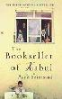 | SEIERSTAD, Asne  The Bookseller of Kabul  In the spring of 2002, journalist Asne Seierstad went to Afghanistan to live with a family for several months. Here she reveals her experiences, telling the story of Sultan Khan - who defied the authorities for 20 years to supply books to the people of Kabul - and his family.
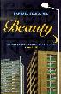 | SELBOURNE, David  Beauty  Beauty, in name and appearance, is a 20 year-old Bangladeshi, back in England having shocked her family by fleeing an abusive marriage. Now she is forced onto the jobseekers' treadmill. With honesty and compassion, Beauty moves ever closer towards resolving her dilemma about family duty and parental care.
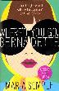 | SEMPLE, Maria  Where’d you go Bernadette  Bernadette Fox has disappeared and her 15-year-old daughter Bee must take a trip to the end of the earth to find her. A touching novel about misplaced genius and a mother and daughter's place in the world.
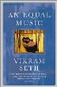 | SETH, Vikram  An Equal Music  Set in the present day, with flashbacks, An Equal Music is a story about deafness, the perils of excessive love, the curious matter of nationality and how it affects lives and relationships.
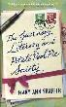 | SHAFFER, Mary  Guernsey Literary and Potato Peel Society  It's January, 1946, and writer Juliet Ashton sits at her desk, vainly seeking a subject for her next book. Out of the blue, she receives a letter from one Dawsey Adams of Guernsey - by chance, he's acquired a secondhand book that once belonged to Juliet - and, spurred on by their mutual love of Charles Lamb, they begin a correspondence.
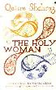 | SHAHRAZ, Qaisra  The Holy Woman  A powerful and compelling family drama, this is a romantic story of love and betrayal set in a wealthy Muslim community, with all the pressures and conflicts that modern life and old traditions bring.
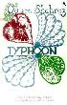 | SHAHRAZ, Qaisra  Typhoon  Chiragpur is a traumatised village, warped in time, space and guilt. Haunted by what happened some 20 years earlier in a courtroom in Kacheri. This is a tragic tale of three young women, each one demonised by her past.
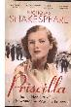 | SHAKESPEARE, Nicholas  Priscilla  When Nicholas Shakespeare stumbled across a box of documents belonging to his late aunt he was completely unaware of where this discovery would take him. The Priscilla he remembered was very different from the glamorous, morally ambiguous young woman who emerged from the many love letters and journals, surrounded by suitors and living the dangerous existence of a British woman in a country controlled by the enemy. He had heard rumours that Priscilla had fought in the Resistance, but the truth turned out to be far more complicated
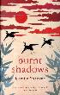 | SHAMSIE ,Kamila  Burnt Shadows  'Burnt Shadows' is a powerful, sweeping epic crossing generations, cultures and continents.
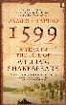 | SHAPIRO, James  1599  Here is an intimate history of Shakespeare, following him through a single year that changed not only his fortunes but the course of literature as we know it.
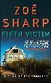 | SHARP, Zoe  Fifth Victim  Bodyguard and ex-Special Forces soldier Charlie Fox would do anything to take her mind off her partner; shot, left for dead and now lying in a coma. Now she must protect a naive daughter of an investment banker from a ruthless gang of kidnappers who prey on the children of the wealthy Long Island set.
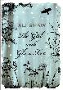 | SHAW, Ali  The Girl with Glass Feet  Strange things are happening on the remote & snowbound archipelago of St Hauda's Land. Unusual winged creatures flit around icy bogland; albino animals hide themselves in the snow-glazed woods; jellyfish glow in the ocean's depths - and Ida MacLaird is slowly turning into glass.
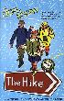 | SHAW, Don  The Hike  Structured in twelve chapters covering the months of the year, ‘The Hike’ follows the adventures of three retired friends as they undertake a weekly hike of at least ten miles, engaging in verbal sparring and bickering all the way.
 | SHELLEY, Mary  Frankenstein  Atmospheric line drawings recreate the legendary tale of Frankenstein in this retelling of Mary Shelley’s gothic tale of terror. Suitable for ages 9 and up.
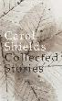 | SHIELDS, Carol  Collected Stories  For the first time all of Carol Shields’ remarkable short stories – some previously unpublished – are gathered together in one volume.
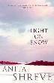 | SHREVE, Anita  Light on Snow  Another story of love and passion by the author of 'All He Ever Wanted'.
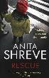 | SHREVE, Anita  Rescue  The car crash should have killed her. But rookie paramedic Peter Webster takes the emergency call, and helps the young woman, Sheila Arsenault, to survive. After the accident, she haunts his thoughts, despite his misgivings about getting involved with a patient.
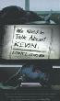 | SHRIVER, Lionel  We Need to talk about Kevin  Who is to blame for teenage atrocity? Narrator Eva Khatchadourian's son, Kevin, murdered seven of his fellow high school students, a cafeteria worker, and the much-loved teacher who tried to befriend him. This novel is an examination of the effect tragedy has on a town, a marriage and a family.
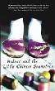 | SIJI, Dai  Balzac and the little Chinese Seamstress  Without betraying the truth of what happened, Dai Sijie transforms the bleak events of China's Cultural Revolution into an enchanting and unexpected story about the resilience of the human spirit and the magical power of great storytelling.
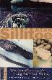 | SILLITOE, Alan  The Loneliness of the Long Distance Runner  The stories in this collection introduce the defiant young rebel, the war-veteran Uncle Ernest, and the school teacher Mr Raynor who relies on voyeurism to reward his exasperated, solitary existence
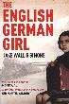 | SIMONS, Jake  The English German Girl  Kristallnacht, November 1938. After the Nazis run rampage in Berlin, killing Jews and ransacking and destroying their homes, 15-year-old Rosa manages to escape from the city and head, alone, to England. Her objective: to secure work permits for her family and enable their release.
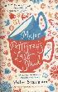 | SIMONSON, Helen  Major Pettigrew’s Last Stand  'Major Pettigrew's Last Stand' is an enchanting, humorous and heart-warming novel set in an English village.
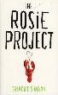 | SIMSION, Graeme  The Rosie Project  Meet Don Tillman. Don is getting married. He just doesn't know who to yet. But he has designed a very detailed questionnaire to help him find the perfect woman. One thing he already knows, though, is that it's not Rosie. Absolutely, completely, definitely not.
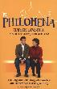 | SIXSMITH, Martin  Philomena  'Philomena' is the tale of a mother and a son whose lives were scarred by the forces of hypocrisy on both sides of the Atlantic and of the secrets they were forced to keep. A compelling narrative of human love and loss, Martin Sixsmith's moving account is both heartbreaking yet ultimately redemptive.
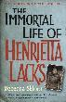 | SKLOOT, Rebecca  The Immortal Life of Henrietta Lacks  Her name was Henrietta Lacks, but scientists know her as HeLa. She was a poor Southern tobacco farmer whose cancer cells became one of the most important tools in medicine. Rebecca Skloot takes the reader on an extraordinary journey in search of Henrietta's story.
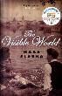 | SLOUKA, Mark  The visible world  This is a story about memory and concealed histories, and about the way that the most fiercely-held secrets of the past eventually force their way to the surface.
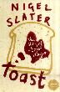 | SLATER, Nigel  Toast  This is Nigel Slater's truly extraordinary story of his childhood remembered through food. Nigel's likes and dislikes, aversions and sweet-toothed weaknesses form a fascinating and often amusing backdrop to this incredibly moving and evocative memoir of childhood, adolescence and sexual awakening.
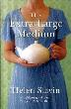 | SLAVIN, Helen  The Extra Large Medium  Annie Colville talks to the people who wear chocolate brown. They come to her to tell of the lost key behind the sofa, the Crown Derby coffee sets, the clematis that needs a good prune. Annie Colville has long since learned that death does not a philosopher of Auntie Mabel make.
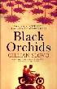 | SLOVO, Gillian  Black Orchids  When the gentile impoverished and rebellious Evelyn marries the charming Emil, scion of a privileged Sinhalese family, she thinks her dream of a life in England can now come true. But this is England in the 1950s, where people don't take kindly to strangers, especially families who are half black and half white.
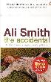 | SMITH, Ali  The Accidental  'The Accidental' is the follow-up novel to 'Hotel World', which was shortlisted for the Booker and Orange prizes in 2002. Ali Smith's other novels include 'Free Love', 'Like', 'Other Stories and Other Stories' and 'The Whole Story and Other Stories'.
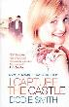 | SMITH, Dodie  I Capture the Castle  This is the journal of Cassandra Mortmain. First, there is her eccentric father. Then there is her sister, Rose - and her stepmother, Topaz. Finally, there is Stephen, who is in love with Cassandra. Cassandra records her feelings on all of them.
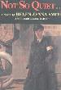 | SMITH, Helen  No so Quiet  Published in London in 1930, this is a novel in autobiographical guise that describes a group of British women ambulance drivers on the French frontlines in WWI
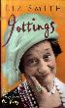 | SMITH, Liz  Jottings  'Jottings' is a collection of the stories that much-loved actress Liz Smith has written over the years. Sometimes they explore the darker side of life and what may occur out of the public gaze and other stories are more amusing
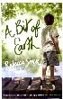 | SMITH, Rebecca  A Bit of Earth  Susannah was gazing up at the brightness of the blue sky when the deer leapt in front of the car. She never knew what happened. Guy hides from his grief in his greenhouse, and broods on the mystery of why his wife died in another man's car. Without Susannah, everything is lost.
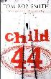 | SMITH, Tom  Child 44  Set in the Soviet Union in 1953, Tom Rob Smith's debut novel is both a thriller and a harrowing portrayal of the terror inflicted upon people by their own governments. An officer of the Ministry of State Security risks everything - even becoming an enemy of the state - to find a killer.
 | SMITH, Zadie  NW  Hobbes, Smith, Bentham, Locke and Russell. Five identical blocks make up the Caldwell housing estate in North West London. Caldwell kids Leah, Natalie, Felix and Nathan have all moved on. They occupy separate worlds in an atomized city. Then one afternoon a stranger comes to Leah's door, forcing her out of her isolation.
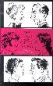 | SMITH, Zadie  The Book of Other People  The Book of Other People' is just that - a book of other people. Open its covers and meet a whole host of new acquaintances. It features new stories from over 20 of the best writers of their generation from both sides of the Atlantic.
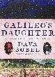 | SOBEL, Dava  Galileo’s Daughter  Dava Sobel recreates the lives of Galileo and his daughter, Virginia, who at the age of 13 became a nun. She uses Virginia's letters as her inspiration to give the reader an impression of what life was like in the Italy of the 1600s.
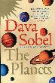 | SOBEL, Dava  The Planets  Dava Sobel traces the lives of each member of our solar family, from myth and history, astrology and science fiction, to information from the modern era's robotic space probes.
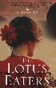 | SOLI, Tatjana  The Lotus Eaters  As the fall of Saigon begins in 1975, two lovers make their way through the streets, desperately trying to catch one of the last planes out. Spurred on by the moral imperative of documenting the horror of war, Sam and Helen's passionate and all-consuming love is tested to the limit.
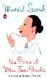 | SPARK, Muriel  The Prime of Miss Jean Brodie  Miss Brodie is a teacher who exerts a powerful influence over the group of 'special girls' at the Marcia Blaine School. Each is famous for something & are initiated into a world of adult games & extra-curricular activities they will never forget.
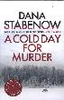 | STABENOW, Dana  A Cold Day for Murder  Kate Shugak is a native Aleut working as a private investigator in Alaska. She's 5 foot 1 inch tall, carries a scar that runs from ear to ear across her throat and owns half-wolf, half-husky dog named Mutt. Resourceful, strong-willed, defiant, Kate is tougher than your average heroine and she needs to be to survive the worst the Alaskan wilds can throw at her.
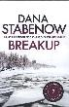 | STABENOW, Dana  Breakup  Kate Shugak is a native Aleut working as a private investigator in Alaska. She's 5 foot 1 inch tall, carries a scar that runs from ear to ear across her throat and owns half-wolf, half-husky dog named Mutt. Resourceful, strong-willed, defiant, Kate is tougher than your average heroine - and she needs to be to survive the worst the Alaskan wilds can throw at her. Breakup is the season of early Spring, when the rivers thaw and the bears wake up. Kate looks into the death of a woman by a bear that doesn't quite add up.
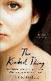 | STAINCLIFFE, Cath  The Kindest Thing  When Deborah reluctantly agrees to help her beloved husband, Neil, end his life, she is arrested and charged with murder. As the trial unfolds, Deborah, still reeling with grief, fights to defend her actions in committing a crime that divides social opinion and creates painful schisms in her own family.
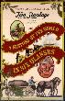 | STANDAGE, Tom  A History of the World in Six Glasses  Written by Tom Standage, author of ‘The Turk’, ‘The Neptune File’ and ‘The Victorian Internet’, this multilayered book tells the story of humanity from the Stone Age to the 21st century through the lens of beer, wine, spirits, coffee, tea and cola.
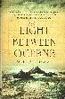 | STEDMAN, M.L  The Light Between the Oceans  Would you accept a chance for happiness even if it wasn't yours to have? This is a story about a lighthouse keeper and his wife, who live on a lonely island with just seagulls, stars and buffeting winds for company. It's a story about right and wrong, and how sometimes they look the same.
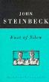 | STEINBECK  East of Eden  Set in the rich farmland of California's Salinas Valley, this powerful, often shocking, story follows the intertwined destinies of two families - the Trasks and the Hamiltons.
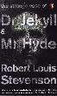 | STEVENSON, Robert Louis  The Strange Case of Dr Jekyll and Mr. Hyde  This dark psychological fantasy is more than a moral tale. It is also a product of its time, drawing on contemporary theories of class, evolution and criminality and the secret lives behind Victorian propriety, to create a unique form of urban Gothic.
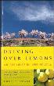 | STEWART, Chris  Driving over Lemons  At age 17, Chris Stewart retired as the drummer of Genesis, his schoolboy band, and launched a new career as a sheep shearer and travel writer. This book describes his idyllic life on a remote mountain farm in Andalucia.
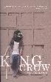 | STEWART, Michael  King Crow  Paul Cooper is an outsider. When he looks at people he wonders what bird they are. He finds making friends difficult especially when he has to move from school to school, so he obsesses about ornithology until he meets Ashley. Ashley is everything Cooper isn't.
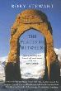 | STEWART, Rory  The Places in Between  In 2001 Rory Stewart set off from Herat to walk to Kabul via the mountains of Ghor in central Afghanistan. This is literary travel writing, but with a greater element of adventure and danger. It is an account of what it is like to travel painfully and slowly on foot in an alien and hostile landscape.
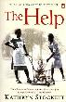 | STOCKETT, Kathryn  The Help  Aibileen is a black maid, raising her 17th white child, but with a bitter heart after the death of her son. Minny is the sassiest woman in Mississippi. Skeeter is a white woman with a degree but no ring on her finger. Seemingly as different as can be, these women will come together for a clandestine project that will put them all at risk.
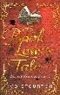 | STOURTON, Ivo  The Booklover’s Tale  Interior designer for the rich and powerful, Matt de Voy lends his tasteful eye to the households of his wealthy female clients. He begins to fall in love with Claudia - modest, clever and married to a nouveau riche husband who arouses a visceral and all-consuming hatred in Matt. But is he a murderer?
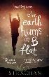 | STRACHAN, Mari  The Earth Hums in B Flat  When a neighbour mysteriously vanishes, young Gwenni Morgan resolves to uncover the secret of his disappearance and return him to his children. She truthfully records what she sees and hears, but are her deductions correct? What will be the consequences - for Gwenni, her family and her community - of finding out?
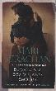 | STRACHAN, Mari  Blow on a Dead Man’s Embers  With her husband shattered by the war, does one young woman have the strength to bring him back to life.
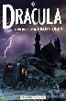 | STOKER, Bram  Dracula  This is an illustrated retelling of Bram Stoker's terrifying horror story of Count Dracula. Atmospheric artwork recreates the legendary world of the undead in all its ghoulish glory.
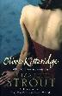 | STROUT, Elizabeth  Olive Kitteridge  Elizabeth Strout gives us 13 narratives centred on a singular and formidable heroine, Olive Kitteridge.
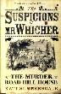 | SUMMERSCALE, Kate  The Suspicions of Mr. Whicher  In the village of Road in Wiltshire during the summer of 1860, a family awakes to discover that a gruesome murder has taken place in their home. The guilty party is surely still among them. Jack Wilcher of Scotland Yard, the most celebrated detective of his day, has the unenviable task of conducting the investigation.

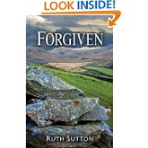 | SUTTON, Ruth  Forgiven  Set in the immediate aftermath of World War 2, a gloomy time of rationing, shortages and the worst winter in living memory. Secrets and lies are still part of Jessie's life, and her career as a village schoolteacher is threatened by the return of the servicemen. In the coalmines of Whitehaven we also meet the remarkable women who work on the pit-head screens, sorting and grading the coal. These are the settings of the unfolding drama in the post-war years, for Jessie and her estranged son John.
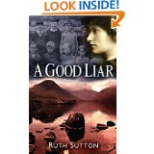 | SUTTON, Ruth  A Good Liar  Jessie Whelan has always been a good liar, trying to protect her independence and her career as a teacher. But she risks everything when, after years of discreet loneliness, she embarks on a love affair. In the meantime, her secret past draws ever closer.  Ruth Sutton's powerful novel is the first part of a trilogy set in the north-west corner of England, 'Between the Mountains and the Sea'. She creates an intimate picture of interconnected lives in Cumbria in the early twentieth century.
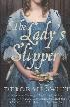 | SWIFT, Deborah  The Lady’s Slipper  It is 1660. In rural Westmorland, artist Alice Ibbetson has become captivated by the rare Lady's Slipper orchid. She is determined to capture its unique beauty for posterity, even if it means stealing the flower from the land of Richard Wheeler. Alice is not the only person eager to lay hands on the flower.
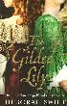 | SWIFT, Deborah  The Gilded Lily  Winter 1661. Sadie Appleby has never left rural Westmorland. But one night she is woken by her sister, Ella. She has robbed her employer and is on the run. Together the girls flee for London. But the dead man's relatives are in pursuit, and soon a game of cat and mouse ensues amongst the freezing warren that is London in winter.
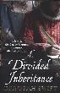 | SWIFT, Deborah  Divided Inheritance  London 1609. Elspet Leviston's greatest ambition is to continue the success of her father Nathaniel's lace business. But her dreams are thrown into turmoil with the arrival of her mysterious cousin Zachary Deane - who has his own designs on Leviston's Lace.
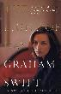 | SWIFT, Graham  The Light of Day  Sarah is in prison. Every fortnight she is visited by George, the private eye she employed to observe the final stage of her husband's affair. The visits - and the days between - lead George back into Sarah's past and into events he can picture only too well.
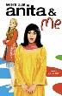 | SYALL, Meera  Anita and Me  This novel is based on Syal's childhood, growing up in the '60s as part of the only coloured family living in a Wolverhampton mining village. It is filled with warmth, good humour and eccentric characters. The book ties-in with the film.
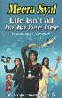 | SYALL, Meera  Life isn’t all ha ha hee hee  'Life Isn't All Ha Ha Hee Hee' is a hilarious, thoughtful and moving novel about friendship, marriage and betrayal which focuses on the difficult choices that contemporary women have to make.
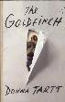 | TARTT, Donna  The Goldfinch  Aged 13, Theo Decker, son of a devoted mother and a reckless, largely absent father, survives an accident that otherwise tears his life apart. Alone and rudderless in New York, he is taken in by the family of a wealthy friend. He is tormented by an unbearable longing for his mother, and down the years clings to one thing that reminds him of her: a small, strangely captivating painting that ultimately draws him into the criminal underworld.
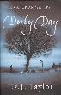 | TAYLOR, D.J  Derby Day  In the heat of June, all England seems to head for Epsom Downs. For months before, people have been waiting and plotting for this day. Everywhere money jingles and plans are laid. As the months pass the pace quickens and dastardly deeds are done, foxing even the stalwart police detective Captain MacTurk.
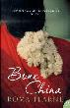 | TEARNE, Roma  Bone China  An epic novel of love, loss and a family uprooted, set in the contrasting landscapes of war torn Sri Lanka and immigrant London.
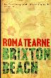 | TEARNE, Roma  Brixton Beach  Opening dramatically with the horrors of the 2005 London bombings, this is the profoundly moving story of a country on the brink of civil war and a child's struggle to come to terms with loss.
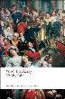 | THACKERAY, William Makepeace  Vanity Fair  Set during the time of the Napoleonic Wars, this classic gives a satirical picture of a worldly society. The novel revolves around the exploits of the impoverished but beautiful and devious Becky Sharp.
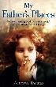 | THOMAS-ELLIS, Aeronwy  My Father’s Places  'My Father's Places' is a beautiful, evocative memoir of growing up in the shadows of Dylan and Caitlin Thomas in Laugharne.
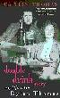 | THOMAS, Caitlin  My Life with Dylan Thomas – Double Drink Story  Painfully honest about Dylan Thomas and their relationship, Caitlin Thomas provides a memoir of a life dedicated to drink. The book reveals the affairs, the poetry, the thwarted ambitions, the passions and the rage.
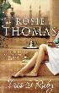 | THOMAS. Rosie  Iris & Ruby  A story of love, loss and the distance between three generations of one family, this novel centres on Iris and Ruby - a grandmother and her granddaughter - as they try and make sense of their respective lives.
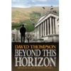 | THOMPSON, David  Beyond This Horizon  An emotionally-charged story that plots the relationships of a close knit group of individuals who irrevocably change one another's destiny. Wonderfully crafted, this explores the timeless themes of friendship, art, love, loss and the endurance of the human spirit.
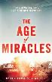 | THOMSON WALKER, Karen  The Age of Miracles  It is never what you worry over that comes to pass in the end. The real catastrophies are always unimagined, unprepared for, unknown. What if our 24-hour day grew longer, first in minutes, then in hours, until day became night and night became day? What effect would that slowing have on the world?
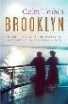 | TOIBIN, Colm  Brooklyn  In a small town in the south-east of Ireland in the 1950s, Ellis Lacey is among many of her generation who cannot find work at home. So when she is offered a job in America, she leaves her family to start a new life in Brooklyn, New York.
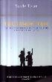 | TOLAN, Sandy  The Lemon Tree  'The Lemon Tree' is the true story of a friendship spanning religious divisions and four decades of Israeli-Palestinian conflict.
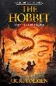 | TOLKIEN, J.R.R.  The Hobbit  The Hobbit is the unforgettable story of Bilbo, a peace-loving hobbit, who embarks on a strange and magical adventure.
 | TOLSTOY, Leo  War and Peace  Napoleon’s invasion of Russia forms the backdrop for Tolstoy’s literary masterpiece. Often considered the greatest novel in any language, ‘War and Peace’ is also a philosophical meditation on the tension between free will and fate.
 | TOMALIN, Claire  Charles Dickens: a life  Claire Tomalin paints an unforgettable portrait of Dickens, capturing brilliantly the complex character of this great genius.
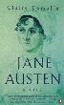 | TOMALIN, Claire  Jane Austen : A Life  The six great novels of Jane Austen picture a world of civility and reassuring stability. But, as Tomalin demonstrates in this fascinating biography, this was not quite the world Austen herself lived in.
 | TOMALIN, Claire  Samuel Pepys  A full-scale biography of naval administrator Samuel Pepys, who was well-known for being the friend of the famous and powerful. This text, which draws on Pepys' own personal diary, covers his childhood and young adulthood. It goes beyond the source material to explore the inner man.
 | TOMALIN, Claire  The Invisible Woman  This is the story of someone who – almost – wasn’t there; who vanished into thin air. Her names, dates, family and experiences very nearly disappeared from the record for good …’ Claire Tomalin’s multi-award-winning story of the life of Nelly Ternan and Charles Dickens is a remarkable work of biography and historical revisionism.
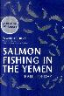 | TORDAY, Paul  Salmon Fishing in the Yemen  An extraordinary, beguiling tale of fly-fishing and political spinning, of unexpected heroism and late-blooming love, and of an attempt to prove the impossible, possible.
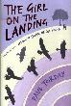 | TORDAY, Paul  The Girl on the Landing  Is Michael ill, or could the disturbing events he is witnessing possibly be real? A thrilling novel about identity and love from the author of 'Salmon Fishing in the Yemen'.
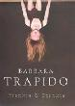 | TRAPIDO, Barbara  Frankie and Stankie  Dinah and her sister Lisa are growing up in South Africa in the fifties. It is at school that Dinah first learns about racism. As we follow Dinah from childhood, through adolescence and marriage, to voluntary exile in London, we get a vivid glimpse of one of the darker passages of 20th century history.
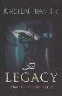 | TRANTER, Kirsten  The Legacy  Julia is hopelessly in love with her best friend Ralph, who in turn is tormented by desire for his cousin Ingrid. Ralph is devastated when Ingrid leaves to start a new life, marrying a much older art dealer in New York. On September 11, 2001, she has an appointment in Manhatten and is never seen again.
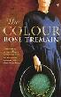 | TREMAIN, Rose  The Colour  'The Colour' is a sweeping saga of sacrifice and greed set during the mid-nineteenth century gold rush in New Zealand.
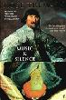 | TREMAIN, Rosie,  Music and Silence  When the King of Denmark is in the mood to listen to music, he opens the trapdoor between his favourite room and the cellar where he keeps his orchestra and when he wants silence, he kicks the trapdoor shut.
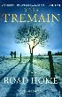 | TREMAIN, Rosie  The Road Home  Lev is on his way to Britain to seek work, so that he can send money back to eastern Europe to support his mother and little daughter. He struggles with the mysterious rituals of 'Englishness', and the fashions and fads of the London scene. We see the road Lev travels through his eyes, and we share his dilemmas.
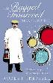 | TRESSELL, Robert  The Ragged Trousered Philanthropists  This novel tells the story of a group of working men who are joined one day by Owen, a journeyman-prophet with a vision of a just society. Owen's spirited attacks on the greed and dishonesty of the capitalist system rouse his fellow men from their political quietism.
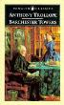 | TROLLOPE, Anthony  Barchester Towers  'Barchester Towers', Trollope's most popular novel, is the second of the six Chronicles of Barsetshire. Trollope continues the story, begun in 'The Warden', of Mr Harding and his daughter Eleanor, introducing Mr Slope, Dr Proudie and the Stanhope family.
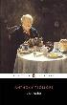 | TROLLOPE, Anthony  The Warden  When John Bold decides to challenge corruption in the Church of England he sets the whole town of Barchester ablaze with the consequences. This book is the study of conflicting loyalties and principles in a cathedral city where the gentle warden becomes an unwilling focus of national controversy.
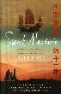 | TSE, Helen  Sweet Mandarin  'Sweet Mandarin' follows the lives of three generations of Chinese women from the same family, all of whom have struggled to pull themselves out of the most horrific situations, and have succeeded in turning their fortunes around.
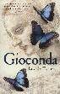 | TURNER, Lucille  Gioconda  From the glittering court of the Medici to the mortuaries of Milan and the battlefields of the Po valley, this novel vividly imagines Leonardo's lonely struggle to convince others of his vision of the world.
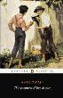 | TWAIN, Mark  Adventures of Tom Sawyer  Tom Sawyer and his friends play truant from school and set off for an island near their home town. Here they decide to play pirates but their game is interrupted when they witness a murder. Tom has to grow up very quickly and do the right thing.
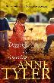 | TYLER, Anne  Digging to America  Dealing with themes such as belonging, pride, prejudice and love, this is the story of two extended families who are brought together thanks to the birth of two tiny Korean babies on the same night.
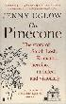 | UGLOW, Jenny  The Pinecone  In the village of Wreay, near Carlisle, stands the strangest and most magical church in Victorian England. This vivid, original book tells the story of its builder, Sarah Losh, strong-willed and passionate and unusual in every way.
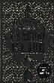 | VANN, David  Caribou Island  Gary, driven by 30 years of diverted plans, and Irene, haunted by a tragedy in her past, are trying to rebuild their life together on Caribou Island. Across the water on the mainland, their daughter Rhoda is fantasizing about her perfect wedding day, whilst her betrothed, Jim the dentist, wonders about an altogether different future.
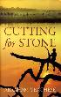 | VERGHESE, A.  Cutting for Stone  The unforgettable story of twin brothers born in Ethiopia of the secret union between a beautiful Indian nun and a British doctor, and the choices each of them must face as they grow to manhood.`
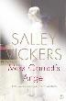 | VICKERS, Salley  Miss Garnett’s Angel  Miss Garnet's Angel is a voyage of discovery, a novel of Venice but also a rich story of the explosive possibilities of change in all of us at any time.
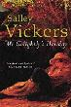 | VICKERS, Salley,  Mr Golightly’s Holiday  Golightly Enterprises is now somewhat in decline and Mr Golightly needs to rethink the whole operation. He decides to reconsider the dwindling appeal of the international bestseller which made his company what it once was.
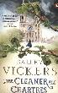 | VICKERS, Salley  The Cleaner of Chartres  A compelling story of darkness and light, of traumatic loss and second chances, 'The Cleaner of Chartres' tells of the mysterious and elusive Agnes Morel whose little acts of kindness around a rural French cathedral touch the lives of others with consequences both good and ill. But when her tragic past is exposed, Agnes must face up to the truth of her origins.
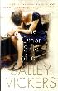 | VICKERS, Salley  The Other Side of You  David McBride is a psychiatrist unusually drawn to death. When he meets a failed suicide, he finds a haunting sense that the ‘other side’ of his elusive patient has a strange resonance for him too. Salley Vickers traces the boundaries of life and death and the difficult possibilities of repentance.
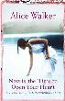 | WALKER, Alice  Now is the Time to Open your Heart  Kate has always been a wanderer. A well-published author, she has lived a life full of exploration. Now, as she begins to feel the first ravages of age, she wants to find a sense of meaning in her life. She sets out on a journey down the Colorado river - a journey that will force her to re-explore her past and future.
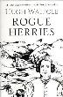 | WALPOLE, Hugh  Rogue Herries  'Rogue Herries' tells the story of Francis Herries who uproots his family from Yorkshire and brings them to live in Borrowdale where their life is as dramatic as the landscape surrounding them. Proud, violent and impetuous he despises his first wife, sells his mistress at a county fair and forms a great love for the teenage gypsy Mirabell Starr
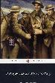 | WALTER, George ed  Penguin Book of First World War Poets  This anthology reflects the diversity of experiences of those who lived through the war, not just the soldiers, but those left behind as well. In addition, there are poems rarely anthologised and a selection of soldiers' songs to reflect the voices of the soldiers themselves.
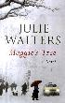 | WALTERS, Julie  Maggie’s Tree  As their friend Helena is the toast of Broadway, comedienne Cissie O'Brien takes beautiful actress Maggie Salt to see her. But Maggie is troubled, & on arrival disappears into the winter night. As the search for their friend continues, cracks occur in the lifelong relationships of Cissie, Helena & her husband Mark.
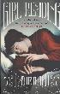 | WARD, Katie  Girl Reading  Seven portraits. Seven artists. Seven girls and women reading. Each chapter of this richly textured debut takes us into a perfectly imagined tale of how each portrait came to be, and as the connections accumulate, the narrative leads us into the present and beyond.
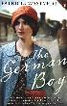 | WASTVEDT, Patricia  The German Boy  In 1947 a 16-year-old German orphan, Stefan Landau, comes to England. A traumatized boy in a shabby Hitler Youth uniform, he is sent to live with his aunt, Elisabeth, and her family. But Elisabeth is troubled by her sister's son.
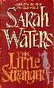 | WATERS, Sarah  Little Stranger  In a dusty post-war summer in rural Warwickshire, a doctor is called to a patient at Hundreds Hall. Home to the Ayres family for over two centuries, the Georgian house, once grand and handsome, is now in decline. But are the Ayreses haunted by something more sinister than a dying way of life?
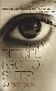 | WATSON, S.J  Before I Go to Sleep  Memories define us. So what if you lost yours every time you went to sleep? Your name, your identity, your past, even the people you love - all forgotten overnight. And the one person you trust may only be telling you half the story. Welcome to Christine's life.
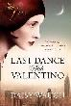 | WAUGH, Daisy  Last Dance with Valentino  As Rudolph Valentino lay on his deathbed calling for an unknown lover, the world wondered who she was, and only one woman knew the truth. Jennifer Doyle began working at the Box in New York after leaving war-ravaged London with her father in 1916. She began an affair with dancer Rodolfo, but then one tragic day, their lives changed forever.
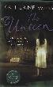 | WEBB, Katherine  The Unseen  Reverend Albert Canning leads a happy existence with his wife in a sleepy Berkshire village. But two new arrivals change all that - Cat, the new maid, and Robin Durrant, a leading expert in the occult. During a long spell of oppressive summer heat, the rectory becomes charged with ambition, love and jealousy; leading, ultimately, to murder.
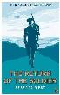 | WEST, Rebecca  The Return of the Soldier  Rebecca West's penetrating perspective on the huge social changes that were triggered by the Great War concerns an aristocrat who returns from the conflict traumatised by the shelling and unable to return to a normal lifestyle.
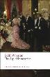 | WHARTON, Edith  Age of Innocence  'The Age of Innocence' is a love story, and a minute dissection of old New York society in the 1870s. Newland Archer, Wharton's protagonist, is a thorough product of this society; he accepts his standards and abides by its rules, but he also recognizes its limitations.
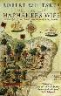 | WHITAKER, Robert  The Mapmaker’s Wife  Drawing on writings of French mapmakers, as well as his own experience retracing Isabel Grameson's journey in search of the man she loved, Whitaker weaves a tale rich in adventure against the backdrop of what is regarded by many as 'the greatest expedition the world has ever known'.
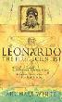 | WHITE, Michael  Leonardo  Weaving the history of early scientific endeavour into the colourful story of Leonardo's personal life, this volume presents a study of the definitive amalgamation of art and science.
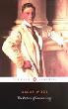 | WILDE, Oscar  The Picture of Dorian Gray  First published to scandalised protest in 1890, Oscar Wilde's fantastic melodrama was widely condemned by his contemporaries as an affront to the values of polite society. It is the story of a man willing to sell his soul for eternal beauty.
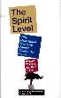 | WILKINSON, Richard  The Spirit Level  It is common knowledge that, in rich societies, the poor have worse health and suffer more from almost every social problem. This book explains why inequality is the most serious problem societies face today.
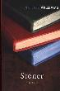 | WILLIAMS, John  Stoner  The son of a midwestern farmer, William Stoner comes to the University of Missouri in 1910 to study agriculture. Stoner tells of love and conflict, passion and responsibility against the backdrop of academic life in the early 20th century.
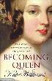 | WILLIAMS, Kate  Becoming Queen  Kate Williams begins by relating the heartbreaking story of Princess Charlotte, the Queen who never was, and her impact on the young Victoria. She also documents the Byzantine machinations behind Victoria's quest to occupy the throne, and shows how her struggles did not end when finally the crown was placed on her head.
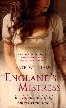 | WILLIAMS, Kate  England’s Mistress  Aged only 12, Emma Hamilton set off for London as a domestic servant, and, within a very short space of time, this indomitable woman became the mistress of an aristocrat. Based on many letters, this a story of high drama and glittering society, and of one woman's overwhelming determination to be a star.
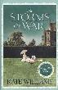 | WILLIAMS, Kate  The Storms of War  In the idyllic early summer of 1914, life is good for the de Witt family. Rudolf and Verena are planning the wedding of their daughter Emmeline, while their eldest son, Arthur, is studying in Paris and Michael is just back from his first term at Cambridge. Celia, the youngest of the de Witt children, is on the brink of adulthood, and secretly dreams of escaping her carefully mapped-out future and exploring the world. But the onslaught of war changes everything,
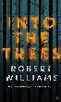 | WILLIAMS, Robert  Into the Trees  Harriet Norton won't stop crying. Her parents, Ann and Thomas, are being driven close to insanity and only one thing will help. Mysteriously, their infant daughter will only calm when she's under the ancient trees of Bleasdale forest. The Nortons sell their town-house and set up home in an isolated barn.
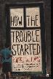 | WILLIAMS, Robert  How the Trouble Started  Donald Bailey is 16. He can't forget the trouble that happened when he was eight, when the police were called. His mother can't forget either and even leaving their home town doesn't help. Then Donald befriends Jake, who is eight years old and terrifyingly vulnerable.
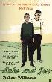 | WILLIAMS, Robert  Luke and Jon  'Luke and Jon' is an arresting novel about friendship, grief and how lives can change forever in a single second.
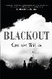 | WILLIS, Connie  Blackout  Oxford, England in 2060. A trio of time traveling scholars prepare to depart for various corners of the Second World War. Their mission: to observe, from a safe vantage point, the day-to-day nature of life during this critical historical moment.
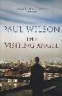 | WILSON, Paul  The Visiting Angel  Patrick is a care worker at a halfway house. He's a good man who's lost his compass while carrying the weight of the world - and he's shattered when a resident with learning difficulties is arrested and accused of abducting a girl from a local estate.
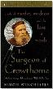 | WINCHESTER, Simon  The Surgeon of Crowthorne  This inspiring tale of literary brilliance and dangerous madness recounts the invaluable role played in the creation of the Oxford English Dictionary by a deranged American Civil War hero who was also a millionaire and a murderer.
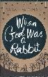 | WINMAN, Sarah  When God Was A Rabbit  This novel is a mesmerising portrait of childhood and growing up; the loss of innocence, eccentricity and familial bonds. Stripped down to its bare bones, it's the story of the unbreakable bond between a brother and sister.
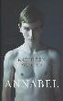 | WINTER, Kathleen  Annabel  Born into the beautiful wilderness of north-eastern Canada, Wayne was raised as a boy despite not being born fully male nor female. But as Wayne grows, and as he becomes aware of the hyper-masculine culture of his family, his emotional demands to be a woman begin to cry out.
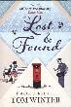 | WINTER, Tom  Lost and Found  Carol is unhappily married to a man she doesn't love and mother to a daughter she doesn't understand. Stuck in a life she doesn't want and crippled with guilt, she can't shake the feeling that she has wasted her life. So she puts pen to paper and writes a letter to the Universe.
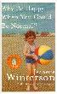 | WINTERSON, Jeanette  Why Be Happy When You Could Be Normal?  This book is the story of a life's work to find happiness. It is the story of how the painful past Jeanette Winterson thought she had written over and repainted returned to haunt her later life, and sent her on a journey into madness and out again, in search of her real mother.
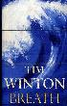 | WINTON, Tim  Breath  A young man learns what it is to be extraordinary, how to push himself, mind and body, to the limit in terrible fear and exhilaration, and how to mask the emptiness of leaving such intensity - in love and life - behind.
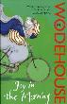 | WODEHOUSE, P G  Joy in the Morning  Bertie Wooster is trapped in the rural community of Steeple Bumpleigh with a strange assortment of characters. The biggest blot on the social landscape is Edwin the boy scout whose acts of kindness are akin to sheer malevolence.
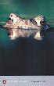 | WODEHOUSE, PG  Heavy Weather  Distraught when an author withdraws his manuscript from publication, the publisher, Lord Tilbury, sets about retrieving his fortunes, never guessing that his final obstacle would be in the rotund form of a prize pig.
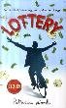 | WOOD, Patricia  Lottery  Perry's IQ is only 76, but he's not stupid. His grandmother taught him everything he needs to know to survive. When Gram dies, Perry is left orphaned and bereft at the age of 31. Then he wins 12 million dollars with his weekly Washington State Lottery ticket, and he finds he has more family than he knows what to do with.
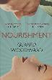 | WOODWARD, Gerard  Nourishment  With her children evacuated and her husband at the front, Tory Pace is grudgingly sharing the family home with her irascible mother. Her quiet life is thrown into turmoil, however, when her prisoner-of-war husband, Donald, makes an outrageous demand for sexual gratification. He wants a dirty letter, by return of post!
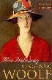 | WOOLF, Virginia  Mrs. Dalloway  This novel explores the hidden springs of thought and action in one day of a woman's life. Virginia Woolf is direct and vivid in her account of the details of Clarissa Dalloway's preparation for a party. The novel was first published in 1925 by the same Hogarth press that Woolf and her husband founded.
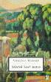 | WOOLF, Virginia  Selected Short Stories
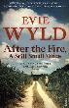 | WYLD, Evie  After the Fire a still Small Voice  After the breakdown of a turbulent relationship, Frank moves from Canberra to a shack on the east coast once owned by his grandparents. He wants to put his violent past and bad memories of his father behind him. But he soon finds it's not easy for him to let go of the past.
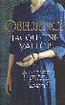 | YALLOP, Jacqueline  Obedience  Sister Bernard has lived in a grey-stone convent in rural France for more than seventy years. The quiet monotony of the religious life has protected her from memories of the past: the disgrace of when she was a young woman in wartime France, when her devotion to God faded in the face of her desire for a young Nazi solider.
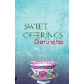 | YAP, Chan Ling  Sweet Offerings  "Sweet Offerings" is not just a fictional story of the events that ripped one family apart, but a taste of Malaysia's historical political and cultural changes during its transition from colonial rule to independence and beyond.
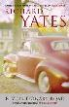 | YATES, Richard  Revolutionary Road  Frank and April Wheeler, a bright, beautiful and talented couple, are desperate to maintain their dreams of greatness and distinction against the inexorable pressure of their suburban life.
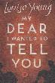 | YOUNG, Louisa  Mr Dear I Wanted to tell You  London, April 1916, Riley Purefoy was walking across Kensington Gardens in the sun, coming up from Victoria station, going home. He hadn't been in London for two years. It seemed very peculiar to him. There were no shells going off. No one was shooting. No gas-gong. It was quiet. There were women.
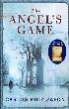 | ZAFON, Carlos Ruiz  The Angel’s Game  In an old mansion in the heart of Barcelona, a young man, David Martin, an aspiring writer, receives a mysterious letter from a French editor, promising literary stardom if he will fulfil just one task. But the character is not all that he seems, and soon David has entered into a pact that will lead him to question everything he values.
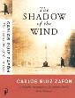 | ZAFON, Carlos Ruiz  The Shadow of the wind  Hidden in the heart of the old city of Barcelona is a labyrinthine library of obscure & forgotten titles that have long gone out of print. A man brings his 10-year-old son to the library & allows him to choose one book to keep. But as he grows up, several people seem inordinately interested in his find.
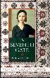 | ZIMLER, Richard  The Seventh Gate  Set in 1930s Berlin, during the Nazis' rise to power, 'The Seventh Gate' brings together Sophie Riedesel, an intelligent, artistic, and sexually adventurous 14-year-old with Isaac Zarco and his friends, most of whom are Jews, ex-circus performers and underground activists.
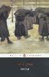 | ZOLA, Emile  Germinal  'Germinal' is the compelling portrait of life in a mining community. Zola examines the problems of industrial strife and traces the growing influence of socialism and anarchism.
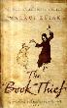 | ZUSAK, Markus  The Book Thief  Narrated in the all-knowing matter-of-fact voice of Death, witnessing the story of the citizens of Molching. By 1943, the Allied bombs are falling, and the sirens begin to wail. Liesel shares out her books in the air-raid shelters. But one day, the wail of the sirens comes too late.

