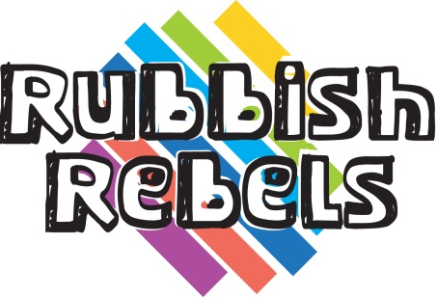Evaluation & Award Application

To gain the Rubbish Rebels Bronze, Silver or Gold Awards, please complete and return this form to Cumbria County Council.

It should be emailed to Judith Bradshaw: judith.bradshaw@cumbria.gov.uk.

By filling in this form, you’re also helping to evaluate the effectiveness of this Rubbish Rebels programme, so thank you for collecting this evidence.

**Your details**

|  |  |
| --- | --- |
| Your name | Click here to enter text. |
| Name of school | Click here to enter text. |
| Address of school (inc postcode) | Click here to enter text. |
| Your email address | Click here to enter text. |
| Your phone number | Click here to enter text. |

**Lesson 1: Where does our waste go?**

|  |
| --- |
| Please state what common mistakes the students made about recycling. |
| Click here to enter text. |
| How effective was this lesson in teaching them how to recycle correctly? |
| Click here to enter text. |
| Please send photographs of the completed homework page from the Rubbish Rebels Action Pack of a handful of students (page 4). |
| Silver Award - Please describe in a few sentences what was covered in the assembly, how it was presented and what action will be taken: |
| Click here to enter text. |
| Gold Award - Please submit a copy of the waste audit sheet(s) and the graphed results and give a few sentences on any change of behaviour or practice that has reduced waste in school. |

**Lesson 2: Sharing Swapping**

|  |  |
| --- | --- |
| How many books were swapped? | Click here to enter text. |
| What was the water saving of this? | Click here to enter text. |
| What was the carbon dioxide savings of this? | Click here to enter text. |
| Silver Award – Please summarise what was swapped and an estimated weight of swapped material: | |
| Click here to enter text. | |
| Gold Award – Please summarise what was swapped and an estimated weight of swapped material: | |
| Click here to enter text. | |

**Lesson 3: Freegle and Reuse**

Please enclose either a scan or photo of the completed Freegle poster, showing the items that were freegled.

Silver Award – Please submit the list of items freegled on the classroom Freegle noticeboard. (You can submit a photo of the noticeboard, or a sheet with the items listed on it.)

Gold Award - Please submit the list of items freegled on the school Freegle noticeboard. (You can submit a photo of the noticeboard, or a sheet with the items listed on it.)

**Lesson 4: Upcycling**

Please submit a photograph of the items (either mascots or instruments) the class has created.

Please submit some photographs of page 11 of the Rubbish Rebels Action Pack to give an idea of what items the students are thinking of upcycling.

|  |
| --- |
| Silver Award - Please outline what the students made, why that item was chosen and how the sale went. A photograph of the upcycled items should be included as well as a total of sale money. |
| Click here to enter text. |

Gold Award - Please submit a record of what items were brought in, and whether they were repaired. Any photos should be included.

**Lesson 5: Food Waste**

Please submit some photos of leftover meals made for the homework activity from the Rubbish Rebels Action Pack.

Silver Award - Submit a copy of the recipe book you have made.

|  |
| --- |
| Gold Award - Submit a copy of the waste audit you conducted.  Please outline any change in behaviour or practices that have reduced food waste in school: |
| Click here to enter text. |

**Lesson 6: Composting**

Please submit a selection of compost critter graphs the students created after analysing their compost samples.

Please submit a selection of copies of the students’ homework activities from the Rubbish Rebels Action Pack booklet.

|  |
| --- |
| Silver Award – Please describe what was covered in the talk, what the students learnt and any actions as a result: |
| Click here to enter text. |
| Gold Award – Please describe in a few sentences what actions you have taken and include some photographs: |
| Click here to enter text. |
| How many parents intend to or have ordered one of the Cumbria County Council food digesters or compost bins? |
| Click here to enter text. |